KLE Society’s College of MCA RLSI Belgaum
Department of Master of Computer Application
A PROJECT REPORT ON
HOTEL BOOKING ANALYTICS &
CANCELLATION PREDICTION
A Flask-based analytics portal for booking patterns, customer segments,
revenue metrics and machine-learning cancellation prediction
Submitted in partial fulfilment of the requirements for the award of the degree of
Master Of Computer Application
Submitted by
Salmankhan N Desai
Register / Roll No.: P15AW25S126020
Under the guidance of
Prof. Vikram
Professor, MCA
Academic Year: [2026 – 2027]

CERTIFICATE
This is to certify that the project report entitled “Hotel Booking Analytics & Cancellation Predic-
tion” is a bonafide record of the work carried out by Salmankhan N Desai (Register / Roll No.
P15AW25S126020) in partial fulfilment of the requirements for the award of the degree of Master Of Computer Application at KLE Society’s College of MCA RLSI Belgaum during the academic year [2026 –2027].
The project work was carried out under my supervision. The software described in this report has
been developed, executed and tested by the student, and the results presented are those produced by
that software. To the best of my knowledge the work has not been submitted to any other university or
institution for the award of any degree or diploma.

_______________________
Project Guide
_______________________
Internal Examiner
Date: ______________
Place: ______________

_______________________
Head of the Department
_______________________
External Examiner

i

DECLARATION
I, Salmankhan N Desai, hereby declare that this project report entitled “Hotel Booking Analytics & Cancellation Prediction” is an original work carried out by me under the guidance of Prof. Vikram, in partial fulfilment of the requirements for the award of the degree of Master Of Computer Application.
I further declare that:
• The software was designed, implemented and tested by me using Python, Flask, SQLite, pandas,
scikit-learn and Chart.js.
• The dataset used in this report is simulated. It was produced by the project's own data-generation
script (seed.py, fixed random seed) because no real hotel records were available. It is not present-
ed as real hotel data.
• All tables, charts, model metrics, screenshots and test results in this report were produced by run-
ning the project code on that dataset; none of them has been copied from another source or in-
vented.
• Published work that influenced the project is acknowledged in the Bibliography.
• This report has not been submitted to any other university or institution for any degree or diplo-
ma.
Date: ______________
Place: ______________
_______________________
Salmankhan N Desai
P15AW25S126020

ACKNOWLEDGEMENT
I express my sincere gratitude to my project guide, Prof. Vikram, for the guidance, regular feedback
and encouragement given throughout the work. The suggestions on structuring the analytics and on
evaluating the machine-learning models were especially valuable.
I am thankful to the Head of the Department and to the faculty members of Department of MCA for providing the laboratory facilities and a supportive academic environment, and to the
management of the institution for the opportunity to take up this project.
I also acknowledge the open-source communities behind Python, Flask, pandas, NumPy, scikit-learn,
SQLite and Chart.js. Their freely available software and documentation made it possible to build a
complete working system with no licence cost.
Finally, I thank my family and friends for their patience and moral support during the development of
this project.
Salmankhan N Desai
iii

ABSTRACT
Cancellations are one of the main sources of uncertainty in hotel revenue management. A room that
was counted as sold can return to inventory days before arrival, and managers who look only at con-
firmed bookings overestimate future occupancy. This project develops a web-based hotel manage-
ment analytics portal that records bookings, measures what has happened, explains why guests cancel,
and estimates which upcoming bookings are most likely to be cancelled.
The portal is built with Python and Flask. It follows a layered design: Flask routes and Jinja templates
form the presentation layer, a services module holds validation, pandas analytics and scikit-learn ma-
chine learning, and a data-access module is the only place that contains SQL. Data are stored in a nor-
malised SQLite database of five tables (users, rooms, customers, bookings and predictions). The inter-
face provides login and registration with hashed passwords and role-based access, room and customer
management, booking entry with overlap checking, validated CSV upload, an occupancy dashboard
with interactive Chart.js charts and date filtering, a prediction page, a timestamped prediction history
and downloadable reports.
The system was run on a simulated dataset of 2,000 bookings for 30 rooms and 400 customers (gener-
ated with a fixed random seed, because real hotel records were not available). Descriptive analytics
gave an overall cancellation rate of 33.9%, an occupancy of 36.9% and an average daily rate of
143.43. Diagnostic analytics showed that the cancellation rate rises from 19.9% for bookings made
0–7 days ahead to 64.3% for bookings made more than 180 days ahead, and that online bookings can-
cel far more often (46.8%) than walk-in (18.7%) or repeat guests.
For prediction, 1,836 bookings with a known outcome were split 75/25 (stratified). Categorical vari-
ables were one-hot encoded and numeric variables standardised. Two models were compared on the
459-row test set. Logistic Regression was saved as the best model with accuracy 0.699, precision
0.637, recall 0.426, F1-score 0.511 and ROC-AUC 0.738; Random Forest reached accuracy 0.673
and F1-score 0.486. Predicted probabilities are converted into Low, Medium and High risk bands; on
the test set the actual cancellation rates in those bands were 15.7%, 34.9% and 60.9% respectively. A
suite of 44 automated tests covering authentication, validation, upload security, analytics formulas and
the ML workflow completed with 44 passes and 0 failures.
Keywords: hotel analytics, booking cancellation, occupancy, ADR, Flask, pandas, scikit-learn, logis-
tic regression, random forest, Chart.js.
iv

TABLE OF CONTENTS
1. Introduction . . . . . . . . . . . . . . . . . . . . . . . . . . . . . . . . . . . . . . . . . . . . . . . . . . . . . . . . . . . . . . . 1
1.1 Background . . . . . . . . . . . . . . . . . . . . . . . . . . . . . . . . . . . . . . . . . . . . . . . . . . . . . . . . . . . . . . . . . 1
1.2 Key hotel metrics . . . . . . . . . . . . . . . . . . . . . . . . . . . . . . . . . . . . . . . . . . . . . . . . . . . . . . . . . . . . . 1
1.3 Overview of the project . . . . . . . . . . . . . . . . . . . . . . . . . . . . . . . . . . . . . . . . . . . . . . . . . . . . . . . . 1
1.4 Organisation of the report . . . . . . . . . . . . . . . . . . . . . . . . . . . . . . . . . . . . . . . . . . . . . . . . . . . . . . 2
2. Problem Statement . . . . . . . . . . . . . . . . . . . . . . . . . . . . . . . . . . . . . . . . . . . . . . . . . . . . . . . . . . 2
3. Existing System . . . . . . . . . . . . . . . . . . . . . . . . . . . . . . . . . . . . . . . . . . . . . . . . . . . . . . . . . . . . 3
3.1 Working of the existing system . . . . . . . . . . . . . . . . . . . . . . . . . . . . . . . . . . . . . . . . . . . . . . . . . . 3
3.2 Limitations of the existing system . . . . . . . . . . . . . . . . . . . . . . . . . . . . . . . . . . . . . . . . . . . . . . . . 3
4. Proposed System . . . . . . . . . . . . . . . . . . . . . . . . . . . . . . . . . . . . . . . . . . . . . . . . . . . . . . . . . . . . 4
4.1 Main features . . . . . . . . . . . . . . . . . . . . . . . . . . . . . . . . . . . . . . . . . . . . . . . . . . . . . . . . . . . . . . . . 4
4.2 Comparison with the existing system . . . . . . . . . . . . . . . . . . . . . . . . . . . . . . . . . . . . . . . . . . . . . 4
5. Objectives . . . . . . . . . . . . . . . . . . . . . . . . . . . . . . . . . . . . . . . . . . . . . . . . . . . . . . . . . . . . . . . . . 5
6. Scope . . . . . . . . . . . . . . . . . . . . . . . . . . . . . . . . . . . . . . . . . . . . . . . . . . . . . . . . . . . . . . . . . . . . . 5
6.1 In scope . . . . . . . . . . . . . . . . . . . . . . . . . . . . . . . . . . . . . . . . . . . . . . . . . . . . . . . . . . . . . . . . . . . . 5
6.2 Out of scope . . . . . . . . . . . . . . . . . . . . . . . . . . . . . . . . . . . . . . . . . . . . . . . . . . . . . . . . . . . . . . . . 5
6.3 Users and assumptions . . . . . . . . . . . . . . . . . . . . . . . . . . . . . . . . . . . . . . . . . . . . . . . . . . . . . . . . . 6
7. Literature Survey . . . . . . . . . . . . . . . . . . . . . . . . . . . . . . . . . . . . . . . . . . . . . . . . . . . . . . . . . . . 6
7.1 Revenue management and cancellations . . . . . . . . . . . . . . . . . . . . . . . . . . . . . . . . . . . . . . . . . . . 6
7.2 Cancellation behaviour . . . . . . . . . . . . . . . . . . . . . . . . . . . . . . . . . . . . . . . . . . . . . . . . . . . . . . . . 6
7.3 Prediction with data mining . . . . . . . . . . . . . . . . . . . . . . . . . . . . . . . . . . . . . . . . . . . . . . . . . . . . . 6
7.4 Methods and tools . . . . . . . . . . . . . . . . . . . . . . . . . . . . . . . . . . . . . . . . . . . . . . . . . . . . . . . . . . . . 7
7.5 Research gap addressed by this project . . . . . . . . . . . . . . . . . . . . . . . . . . . . . . . . . . . . . . . . . . . . 7
8. Requirements . . . . . . . . . . . . . . . . . . . . . . . . . . . . . . . . . . . . . . . . . . . . . . . . . . . . . . . . . . . . . . 8
8.1 Hardware requirements . . . . . . . . . . . . . . . . . . . . . . . . . . . . . . . . . . . . . . . . . . . . . . . . . . . . . . . . 8
8.2 Software requirements . . . . . . . . . . . . . . . . . . . . . . . . . . . . . . . . . . . . . . . . . . . . . . . . . . . . . . . . . 8
8.3 Functional requirements . . . . . . . . . . . . . . . . . . . . . . . . . . . . . . . . . . . . . . . . . . . . . . . . . . . . . . . 8
8.4 Non-functional requirements . . . . . . . . . . . . . . . . . . . . . . . . . . . . . . . . . . . . . . . . . . . . . . . . . . . . 9
9. Feasibility Study . . . . . . . . . . . . . . . . . . . . . . . . . . . . . . . . . . . . . . . . . . . . . . . . . . . . . . . . . . . . 9
9.1 Risks and mitigation . . . . . . . . . . . . . . . . . . . . . . . . . . . . . . . . . . . . . . . . . . . . . . . . . . . . . . . . . 10
10. System Design . . . . . . . . . . . . . . . . . . . . . . . . . . . . . . . . . . . . . . . . . . . . . . . . . . . . . . . . . . . . 10
10.1 Architectural overview . . . . . . . . . . . . . . . . . . . . . . . . . . . . . . . . . . . . . . . . . . . . . . . . . . . . . . 10
10.2 Typical request flow . . . . . . . . . . . . . . . . . . . . . . . . . . . . . . . . . . . . . . . . . . . . . . . . . . . . . . . . 11
10.3 Project folder structure . . . . . . . . . . . . . . . . . . . . . . . . . . . . . . . . . . . . . . . . . . . . . . . . . . . . . . 11
10.4 Security design . . . . . . . . . . . . . . . . . . . . . . . . . . . . . . . . . . . . . . . . . . . . . . . . . . . . . . . . . . . . 12
11. Data Flow Diagrams . . . . . . . . . . . . . . . . . . . . . . . . . . . . . . . . . . . . . . . . . . . . . . . . . . . . . . . 12
11.1 Level 0 (context diagram) . . . . . . . . . . . . . . . . . . . . . . . . . . . . . . . . . . . . . . . . . . . . . . . . . . . . 12
11.2 Level 1 . . . . . . . . . . . . . . . . . . . . . . . . . . . . . . . . . . . . . . . . . . . . . . . . . . . . . . . . . . . . . . . . . . . 12
12. Use Case Diagram . . . . . . . . . . . . . . . . . . . . . . . . . . . . . . . . . . . . . . . . . . . . . . . . . . . . . . . . 13
12.1 Use case descriptions . . . . . . . . . . . . . . . . . . . . . . . . . . . . . . . . . . . . . . . . . . . . . . . . . . . . . . . . 14
13. ER Diagram . . . . . . . . . . . . . . . . . . . . . . . . . . . . . . . . . . . . . . . . . . . . . . . . . . . . . . . . . . . . . 15
13.1 Normalisation . . . . . . . . . . . . . . . . . . . . . . . . . . . . . . . . . . . . . . . . . . . . . . . . . . . . . . . . . . . . . 16
v

14. Database Design . . . . . . . . . . . . . . . . . . . . . . . . . . . . . . . . . . . . . . . . . . . . . . . . . . . . . . . . . . 17
14.1 Data dictionary . . . . . . . . . . . . . . . . . . . . . . . . . . . . . . . . . . . . . . . . . . . . . . . . . . . . . . . . . . . . 17
14.2 Table creation script . . . . . . . . . . . . . . . . . . . . . . . . . . . . . . . . . . . . . . . . . . . . . . . . . . . . . . . . 19
14.3 Contents of the database used in this report . . . . . . . . . . . . . . . . . . . . . . . . . . . . . . . . . . . . . . 19
14.4 Important SQL statements . . . . . . . . . . . . . . . . . . . . . . . . . . . . . . . . . . . . . . . . . . . . . . . . . . . . 20
15. Methodology . . . . . . . . . . . . . . . . . . . . . . . . . . . . . . . . . . . . . . . . . . . . . . . . . . . . . . . . . . . . . 21
15.1 Development approach . . . . . . . . . . . . . . . . . . . . . . . . . . . . . . . . . . . . . . . . . . . . . . . . . . . . . . 21
15.2 Analytics methodology . . . . . . . . . . . . . . . . . . . . . . . . . . . . . . . . . . . . . . . . . . . . . . . . . . . . . . 21
15.3 Machine-learning workflow . . . . . . . . . . . . . . . . . . . . . . . . . . . . . . . . . . . . . . . . . . . . . . . . . . 21
15.4 Evaluation protocol . . . . . . . . . . . . . . . . . . . . . . . . . . . . . . . . . . . . . . . . . . . . . . . . . . . . . . . . . 22
15.5 Booking validation logic . . . . . . . . . . . . . . . . . . . . . . . . . . . . . . . . . . . . . . . . . . . . . . . . . . . . . 22
16. Data Preprocessing . . . . . . . . . . . . . . . . . . . . . . . . . . . . . . . . . . . . . . . . . . . . . . . . . . . . . . . . 23
16.1 Dataset description . . . . . . . . . . . . . . . . . . . . . . . . . . . . . . . . . . . . . . . . . . . . . . . . . . . . . . . . . 23
16.2 Data collection and joining . . . . . . . . . . . . . . . . . . . . . . . . . . . . . . . . . . . . . . . . . . . . . . . . . . . 23
16.3 Data quality checks . . . . . . . . . . . . . . . . . . . . . . . . . . . . . . . . . . . . . . . . . . . . . . . . . . . . . . . . . 23
16.4 Summary statistics . . . . . . . . . . . . . . . . . . . . . . . . . . . . . . . . . . . . . . . . . . . . . . . . . . . . . . . . . . 24
16.5 Outlier analysis . . . . . . . . . . . . . . . . . . . . . . . . . . . . . . . . . . . . . . . . . . . . . . . . . . . . . . . . . . . . 25
16.6 Feature engineering . . . . . . . . . . . . . . . . . . . . . . . . . . . . . . . . . . . . . . . . . . . . . . . . . . . . . . . . . 25
16.7 Encoding categorical variables . . . . . . . . . . . . . . . . . . . . . . . . . . . . . . . . . . . . . . . . . . . . . . . . 25
16.8 Scaling numeric variables . . . . . . . . . . . . . . . . . . . . . . . . . . . . . . . . . . . . . . . . . . . . . . . . . . . . 25
16.9 Train / test split and class balance . . . . . . . . . . . . . . . . . . . . . . . . . . . . . . . . . . . . . . . . . . . . . . 26
17. Analytics . . . . . . . . . . . . . . . . . . . . . . . . . . . . . . . . . . . . . . . . . . . . . . . . . . . . . . . . . . . . . . . . 27
17.1 Descriptive analytics: what happened? . . . . . . . . . . . . . . . . . . . . . . . . . . . . . . . . . . . . . . . . . . 27
17.2 Diagnostic analytics: why do guests cancel? . . . . . . . . . . . . . . . . . . . . . . . . . . . . . . . . . . . . . . 29
17.3 Predictive analytics . . . . . . . . . . . . . . . . . . . . . . . . . . . . . . . . . . . . . . . . . . . . . . . . . . . . . . . . . 31
18. Machine Learning Model . . . . . . . . . . . . . . . . . . . . . . . . . . . . . . . . . . . . . . . . . . . . . . . . . . 31
18.1 Problem formulation . . . . . . . . . . . . . . . . . . . . . . . . . . . . . . . . . . . . . . . . . . . . . . . . . . . . . . . . 31
18.2 Candidate models . . . . . . . . . . . . . . . . . . . . . . . . . . . . . . . . . . . . . . . . . . . . . . . . . . . . . . . . . . 32
18.3 Evaluation metrics . . . . . . . . . . . . . . . . . . . . . . . . . . . . . . . . . . . . . . . . . . . . . . . . . . . . . . . . . . 32
18.4 Results on the test set (459 bookings) . . . . . . . . . . . . . . . . . . . . . . . . . . . . . . . . . . . . . . . . . . . 32
18.5 What the models learned . . . . . . . . . . . . . . . . . . . . . . . . . . . . . . . . . . . . . . . . . . . . . . . . . . . . . 34
18.6 Decision threshold and risk levels . . . . . . . . . . . . . . . . . . . . . . . . . . . . . . . . . . . . . . . . . . . . . . 34
18.7 Scoring the upcoming bookings . . . . . . . . . . . . . . . . . . . . . . . . . . . . . . . . . . . . . . . . . . . . . . . . 35
19. Modules . . . . . . . . . . . . . . . . . . . . . . . . . . . . . . . . . . . . . . . . . . . . . . . . . . . . . . . . . . . . . . . . . 36
19.1 Routes . . . . . . . . . . . . . . . . . . . . . . . . . . . . . . . . . . . . . . . . . . . . . . . . . . . . . . . . . . . . . . . . . . . 36
20. Implementation . . . . . . . . . . . . . . . . . . . . . . . . . . . . . . . . . . . . . . . . . . . . . . . . . . . . . . . . . . . 37
20.1 Authentication and access control . . . . . . . . . . . . . . . . . . . . . . . . . . . . . . . . . . . . . . . . . . . . . . 37
20.2 Booking validation . . . . . . . . . . . . . . . . . . . . . . . . . . . . . . . . . . . . . . . . . . . . . . . . . . . . . . . . . . 37
20.3 Occupancy calculation . . . . . . . . . . . . . . . . . . . . . . . . . . . . . . . . . . . . . . . . . . . . . . . . . . . . . . . 38
20.4 Training and selecting the model . . . . . . . . . . . . . . . . . . . . . . . . . . . . . . . . . . . . . . . . . . . . . . . 38
20.5 Predicting and storing the history . . . . . . . . . . . . . . . . . . . . . . . . . . . . . . . . . . . . . . . . . . . . . . 39
20.6 Safe file upload . . . . . . . . . . . . . . . . . . . . . . . . . . . . . . . . . . . . . . . . . . . . . . . . . . . . . . . . . . . . 40
20.7 Interactive charts . . . . . . . . . . . . . . . . . . . . . . . . . . . . . . . . . . . . . . . . . . . . . . . . . . . . . . . . . . . 40
21. Screenshots . . . . . . . . . . . . . . . . . . . . . . . . . . . . . . . . . . . . . . . . . . . . . . . . . . . . . . . . . . . . . . 41
22. Testing . . . . . . . . . . . . . . . . . . . . . . . . . . . . . . . . . . . . . . . . . . . . . . . . . . . . . . . . . . . . . . . . . . 47
22.1 Test strategy . . . . . . . . . . . . . . . . . . . . . . . . . . . . . . . . . . . . . . . . . . . . . . . . . . . . . . . . . . . . . . . 47
22.2 Result summary . . . . . . . . . . . . . . . . . . . . . . . . . . . . . . . . . . . . . . . . . . . . . . . . . . . . . . . . . . . . 47
vi

22.3 Observations from testing . . . . . . . . . . . . . . . . . . . . . . . . . . . . . . . . . . . . . . . . . . . . . . . . . . . . 50
23. Results . . . . . . . . . . . . . . . . . . . . . . . . . . . . . . . . . . . . . . . . . . . . . . . . . . . . . . . . . . . . . . . . . . 50
23.1 Model results . . . . . . . . . . . . . . . . . . . . . . . . . . . . . . . . . . . . . . . . . . . . . . . . . . . . . . . . . . . . . . 51
23.2 Achievement of the objectives . . . . . . . . . . . . . . . . . . . . . . . . . . . . . . . . . . . . . . . . . . . . . . . . 51
23.3 Performance . . . . . . . . . . . . . . . . . . . . . . . . . . . . . . . . . . . . . . . . . . . . . . . . . . . . . . . . . . . . . . 51
24. Advantages . . . . . . . . . . . . . . . . . . . . . . . . . . . . . . . . . . . . . . . . . . . . . . . . . . . . . . . . . . . . . . 52
25. Limitations . . . . . . . . . . . . . . . . . . . . . . . . . . . . . . . . . . . . . . . . . . . . . . . . . . . . . . . . . . . . . . 52
26. Future Enhancement . . . . . . . . . . . . . . . . . . . . . . . . . . . . . . . . . . . . . . . . . . . . . . . . . . . . . . 53
27. Conclusion . . . . . . . . . . . . . . . . . . . . . . . . . . . . . . . . . . . . . . . . . . . . . . . . . . . . . . . . . . . . . . . 53
BIBLIOGRAPHY . . . . . . . . . . . . . . . . . . . . . . . . . . . . . . . . . . . . . . . . . . . . . . . . . . . . . . . . . . . . 54
Appendix A: Installation and Execution Guide . . . . . . . . . . . . . . . . . . . . . . . . . . . . . . . . . . . . 55
A.1 Steps . . . . . . . . . . . . . . . . . . . . . . . . . . . . . . . . . . . . . . . . . . . . . . . . . . . . . . . . . . . . . . . . . . . . . 55
A.2 CSV format for bulk upload . . . . . . . . . . . . . . . . . . . . . . . . . . . . . . . . . . . . . . . . . . . . . . . . . . . 55
Appendix B: Test Console Output . . . . . . . . . . . . . . . . . . . . . . . . . . . . . . . . . . . . . . . . . . . . . . . 56
Appendix C: Source Code Listings . . . . . . . . . . . . . . . . . . . . . . . . . . . . . . . . . . . . . . . . . . . . . . 57
C.1 services.py (business logic layer) . . . . . . . . . . . . . . . . . . . . . . . . . . . . . . . . . . . . . . . . . . . . . . . 57
1

LIST OF FIGURES
Figure 4.1: Screen flow of the proposed system . . . . . . . . . . . . . . . . . . . . . . . . . . . . . . . . . . . . . . . . . . . . 4
Figure 10.1: Layered architecture of the Hotel Booking Analytics portal . . . . . . . . . . . . . . . . . . . . . . . . 10
Figure 11.1: Level 0 DFD (context diagram) . . . . . . . . . . . . . . . . . . . . . . . . . . . . . . . . . . . . . . . . . . . . . . 12
Figure 11.2: Level 1 DFD of the portal . . . . . . . . . . . . . . . . . . . . . . . . . . . . . . . . . . . . . . . . . . . . . . . . . . 13
Figure 12.1: Use case diagram . . . . . . . . . . . . . . . . . . . . . . . . . . . . . . . . . . . . . . . . . . . . . . . . . . . . . . . . . 14
Figure 13.1: Entity-relationship diagram . . . . . . . . . . . . . . . . . . . . . . . . . . . . . . . . . . . . . . . . . . . . . . . . . 16
Figure 15.1: Machine-learning workflow implemented in services.py . . . . . . . . . . . . . . . . . . . . . . . . . . 21
Figure 15.2: Flow of booking validation . . . . . . . . . . . . . . . . . . . . . . . . . . . . . . . . . . . . . . . . . . . . . . . . . 22
Figure 16.1: Distribution of lead time and length of stay . . . . . . . . . . . . . . . . . . . . . . . . . . . . . . . . . . . . . 24
Figure 16.2: Numeric features before and after StandardScaler . . . . . . . . . . . . . . . . . . . . . . . . . . . . . . . 26
Figure 16.3: Target class balance and booking status distribution . . . . . . . . . . . . . . . . . . . . . . . . . . . . . . 26
Figure 17.1: Monthly occupancy trend . . . . . . . . . . . . . . . . . . . . . . . . . . . . . . . . . . . . . . . . . . . . . . . . . . . 27
Figure 17.2: Revenue by room type . . . . . . . . . . . . . . . . . . . . . . . . . . . . . . . . . . . . . . . . . . . . . . . . . . . . . 28
Figure 17.3: Bookings by country (top 8) and by room type . . . . . . . . . . . . . . . . . . . . . . . . . . . . . . . . . . 29
Figure 17.4: Number of bookings per check-in month . . . . . . . . . . . . . . . . . . . . . . . . . . . . . . . . . . . . . . 29
Figure 17.5: Cancellation rate by lead-time bucket and lead-time histogram by outcome . . . . . . . . . . . . 30
Figure 17.6: Cancellation rate by customer type . . . . . . . . . . . . . . . . . . . . . . . . . . . . . . . . . . . . . . . . . . . 30
Figure 17.7: Cancellation rate by check-in month . . . . . . . . . . . . . . . . . . . . . . . . . . . . . . . . . . . . . . . . . . 31
Figure 18.1: Confusion matrices on the test set (left: saved model) . . . . . . . . . . . . . . . . . . . . . . . . . . . . . 33
Figure 18.2: ROC curves and metric comparison of the two models . . . . . . . . . . . . . . . . . . . . . . . . . . . . 34
Figure 18.3: Largest logistic-regression coefficients and random-forest feature importances . . . . . . . . . 34
Figure 18.4: Effect of the threshold, and probabilities of the upcoming bookings . . . . . . . . . . . . . . . . . 35
Figure 21.1: Login page (left) and registration page (right) . . . . . . . . . . . . . . . . . . . . . . . . . . . . . . . . . . . 41
Figure 21.2: Occupancy dashboard with KPI cards, trend charts and the top risky bookings . . . . . . . . . 41
Figure 21.3: Room management (admin view with add form and edit controls) . . . . . . . . . . . . . . . . . . . 42
Figure 21.4: Customer management . . . . . . . . . . . . . . . . . . . . . . . . . . . . . . . . . . . . . . . . . . . . . . . . . . . . . 42
Figure 21.5: Booking list with status filter, risk badges and action buttons . . . . . . . . . . . . . . . . . . . . . . . 43
Figure 21.6: Booking form rejecting an overlapping booking . . . . . . . . . . . . . . . . . . . . . . . . . . . . . . . . . 43
Figure 21.7: CSV upload: rows imported and the rejected row reported . . . . . . . . . . . . . . . . . . . . . . . . . 44
Figure 21.8: Analytics page: descriptive and diagnostic charts (no filter) . . . . . . . . . . . . . . . . . . . . . . . . 44
Figure 21.9: Analytics page after applying the date filter 2026-05-01 to 2026-08-31 (upper part) . . . . . 45
Figure 21.10: Prediction page: model comparison, confusion matrices and the risky bookings list . . . . 45
Figure 21.11: Prediction history (time-stamped audit log) . . . . . . . . . . . . . . . . . . . . . . . . . . . . . . . . . . . . 46
Figure 21.12: Reports page: revenue by room type and customer origin . . . . . . . . . . . . . . . . . . . . . . . . . 46
LIST OF TABLES
Table 1.1: Hotel performance metrics used in the project . . . . . . . . . . . . . . . . . . . . . . . . . . . . . . . . . . . . . 1
Table 3.1: Limitations of the existing system . . . . . . . . . . . . . . . . . . . . . . . . . . . . . . . . . . . . . . . . . . . . . . . 3
Table 4.1: Existing and proposed systems compared . . . . . . . . . . . . . . . . . . . . . . . . . . . . . . . . . . . . . . . . . 4
Table 5.1: Project objectives . . . . . . . . . . . . . . . . . . . . . . . . . . . . . . . . . . . . . . . . . . . . . . . . . . . . . . . . . . . 5
Table 7.1: Summary of reviewed literature . . . . . . . . . . . . . . . . . . . . . . . . . . . . . . . . . . . . . . . . . . . . . . . . 7
Table 8.1: Hardware requirements . . . . . . . . . . . . . . . . . . . . . . . . . . . . . . . . . . . . . . . . . . . . . . . . . . . . . . . 8
Table 8.2: Software requirements (versions used for the results in this report) . . . . . . . . . . . . . . . . . . . . . 8
Table 8.3: Functional requirements . . . . . . . . . . . . . . . . . . . . . . . . . . . . . . . . . . . . . . . . . . . . . . . . . . . . . . 8
Table 8.4: Non-functional requirements . . . . . . . . . . . . . . . . . . . . . . . . . . . . . . . . . . . . . . . . . . . . . . . . . . 9
Table 9.1: Feasibility assessment . . . . . . . . . . . . . . . . . . . . . . . . . . . . . . . . . . . . . . . . . . . . . . . . . . . . . . . . 9
Table 9.2: Risk analysis . . . . . . . . . . . . . . . . . . . . . . . . . . . . . . . . . . . . . . . . . . . . . . . . . . . . . . . . . . . . . . 10
2

Table 10.1: Layers and files . . . . . . . . . . . . . . . . . . . . . . . . . . . . . . . . . . . . . . . . . . . . . . . . . . . . . . . . . . . 11
Table 10.2: Security measures . . . . . . . . . . . . . . . . . . . . . . . . . . . . . . . . . . . . . . . . . . . . . . . . . . . . . . . . . 12
Table 11.1: Process descriptions for the level 1 DFD . . . . . . . . . . . . . . . . . . . . . . . . . . . . . . . . . . . . . . . 13
Table 12.1: Use case UC-03: Create booking . . . . . . . . . . . . . . . . . . . . . . . . . . . . . . . . . . . . . . . . . . . . . 14
Table 12.2: Use case UC-05: Upload bookings CSV . . . . . . . . . . . . . . . . . . . . . . . . . . . . . . . . . . . . . . . . 14
Table 12.3: Use case UC-07: Run cancellation prediction . . . . . . . . . . . . . . . . . . . . . . . . . . . . . . . . . . . . 15
Table 12.4: Use case UC-11: Train ML models . . . . . . . . . . . . . . . . . . . . . . . . . . . . . . . . . . . . . . . . . . . . 15
Table 13.1: Relationships . . . . . . . . . . . . . . . . . . . . . . . . . . . . . . . . . . . . . . . . . . . . . . . . . . . . . . . . . . . . . 16
Table 14.1: Table users . . . . . . . . . . . . . . . . . . . . . . . . . . . . . . . . . . . . . . . . . . . . . . . . . . . . . . . . . . . . . . . 17
Table 14.2: Table rooms . . . . . . . . . . . . . . . . . . . . . . . . . . . . . . . . . . . . . . . . . . . . . . . . . . . . . . . . . . . . . . 17
Table 14.3: Table customers . . . . . . . . . . . . . . . . . . . . . . . . . . . . . . . . . . . . . . . . . . . . . . . . . . . . . . . . . . . 17
Table 14.4: Table bookings . . . . . . . . . . . . . . . . . . . . . . . . . . . . . . . . . . . . . . . . . . . . . . . . . . . . . . . . . . . 18
Table 14.5: Table predictions . . . . . . . . . . . . . . . . . . . . . . . . . . . . . . . . . . . . . . . . . . . . . . . . . . . . . . . . . . 18
Table 14.6: Row counts . . . . . . . . . . . . . . . . . . . . . . . . . . . . . . . . . . . . . . . . . . . . . . . . . . . . . . . . . . . . . . 19
Table 14.7: Sample rows from bookings (actual data) . . . . . . . . . . . . . . . . . . . . . . . . . . . . . . . . . . . . . . . 19
Table 14.8: Sample rows from rooms and customers (actual data) . . . . . . . . . . . . . . . . . . . . . . . . . . . . . 20
Table 14.9: Sample rows from predictions (actual data) . . . . . . . . . . . . . . . . . . . . . . . . . . . . . . . . . . . . . 20
Table 16.1: Rules used to generate the dataset . . . . . . . . . . . . . . . . . . . . . . . . . . . . . . . . . . . . . . . . . . . . . 23
Table 16.2: Data quality checks . . . . . . . . . . . . . . . . . . . . . . . . . . . . . . . . . . . . . . . . . . . . . . . . . . . . . . . . 24
Table 16.3: Summary statistics of the numeric variables (2,000 bookings) . . . . . . . . . . . . . . . . . . . . . . . 24
Table 16.4: Features used by the model . . . . . . . . . . . . . . . . . . . . . . . . . . . . . . . . . . . . . . . . . . . . . . . . . . 25
Table 16.5: Standardisation of numeric features (training data) . . . . . . . . . . . . . . . . . . . . . . . . . . . . . . . 26
Table 17.1: Key performance indicators of the demonstration dataset . . . . . . . . . . . . . . . . . . . . . . . . . . 27
Table 17.2: Revenue summary by room type (from the Reports page) . . . . . . . . . . . . . . . . . . . . . . . . . . 28
Table 17.3: Customer origin and cancellation by country . . . . . . . . . . . . . . . . . . . . . . . . . . . . . . . . . . . . 28
Table 17.4: Correlation of numeric features with cancellation . . . . . . . . . . . . . . . . . . . . . . . . . . . . . . . . 30
Table 18.1: Candidate models . . . . . . . . . . . . . . . . . . . . . . . . . . . . . . . . . . . . . . . . . . . . . . . . . . . . . . . . . 32
Table 18.2: Evaluation metrics . . . . . . . . . . . . . . . . . . . . . . . . . . . . . . . . . . . . . . . . . . . . . . . . . . . . . . . . . 32
Table 18.3: Test-set metrics (these values are stored in models/metrics.json) . . . . . . . . . . . . . . . . . . . . . 32
Table 18.4: Confusion-matrix counts . . . . . . . . . . . . . . . . . . . . . . . . . . . . . . . . . . . . . . . . . . . . . . . . . . . . 33
Table 18.5: Training versus test accuracy and stratified 5-fold cross-validation (mean ± std) . . . . . . . . . 33
Table 18.6: Effect of the threshold on the test set (Logistic Regression) . . . . . . . . . . . . . . . . . . . . . . . . . 35
Table 18.7: Actual cancellation rate inside each risk band (test set) . . . . . . . . . . . . . . . . . . . . . . . . . . . . 35
Table 19.1: Modules of the portal . . . . . . . . . . . . . . . . . . . . . . . . . . . . . . . . . . . . . . . . . . . . . . . . . . . . . . 36
Table 19.2: Routes defined in app.py (extracted from the source file) . . . . . . . . . . . . . . . . . . . . . . . . . . 36
Table 22.1: Automated test results by module . . . . . . . . . . . . . . . . . . . . . . . . . . . . . . . . . . . . . . . . . . . . . 47
Table 22.2: Test cases, expected and actual results . . . . . . . . . . . . . . . . . . . . . . . . . . . . . . . . . . . . . . . . . 48
Table 23.1: Expected outputs and the results obtained . . . . . . . . . . . . . . . . . . . . . . . . . . . . . . . . . . . . . . . 50
Table 23.2: Achievement of the objectives . . . . . . . . . . . . . . . . . . . . . . . . . . . . . . . . . . . . . . . . . . . . . . . 51
Table A.1: Columns of the upload file . . . . . . . . . . . . . . . . . . . . . . . . . . . . . . . . . . . . . . . . . . . . . . . . . . . 55
3

Hotel Booking Analytics & Cancellation Prediction Introduction
CHAPTER 1
Introduction
1.1 Background
A hotel sells a perishable product. A room that stays empty tonight cannot be sold tomorrow, so hotel
managers try to fill as many room-nights as possible at the best price. Their daily decisions depend on
three groups of numbers: how full the hotel is (occupancy), how much is earned per room sold (aver-
age daily rate, ADR) and how much is earned per room available (revenue per available room,
RevPAR). Because bookings are made weeks or months before arrival, managers also depend on fore-
casts of what will happen to the bookings already on the books.
Cancellation is the main reason such forecasts go wrong. A confirmed booking can be cancelled long
after it was made, sometimes only a few days before check-in. A hotel that treats every confirmed
booking as certain will believe its future occupancy is higher than it really is; a hotel that overbooks to
compensate risks turning away guests who actually arrive. Better knowledge of which bookings are
likely to be cancelled, and why, helps to price, allocate rooms and plan staffing with less uncertainty.
1.2 Key hotel metrics
The project uses the following standard definitions. They are implemented exactly as written in the
analytics module and are checked by automated tests (Chapter 22).
Table 1.1: Hotel performance metrics used in the project

Metric | Formula used in this project | Meaning
Occupancy (%) | room-nights sold ÷ (rooms × days) × 100 | Share of available room-nights that  were occupied
ADR | room revenue ÷ room-nights sold | Average price actually earned for one  occupied room-night
RevPAR | room revenue ÷ (rooms × days) = ADR ×  occupancy | Revenue per available room-night
Cancellation rate (%) | cancelled bookings ÷ all bookings × 100 | Share of bookings that did not result in  a stay
Lead time (days) | check-in date − booking date | How far ahead the guest booked
1.3 Overview of the project
This project builds a complete hotel analytics portal. Staff can maintain rooms and customers, enter
bookings (with automatic checking of dates and double bookings) or upload them in bulk from a CSV
file, and then study the data on an occupancy dashboard and an analytics page. A machine-learning
component trains two classifiers on past bookings, keeps the better one, and scores every upcoming
confirmed booking with a cancellation probability and a Low / Medium / High risk level. Every pre-
diction is stored with a timestamp so that it can be audited later.
The work follows the standard order of a data-analytics project: descriptive analytics (what hap-
pened), diagnostic analytics (why it happened) and predictive analytics (what may happen next).
The software is organised in three layers (presentation, business logic and data access) so that each
1


Hotel Booking Analytics & Cancellation Prediction Problem Statement
part can be understood, tested and changed independently.
1.4 Organisation of the report
Chapters 2 to 9 describe the problem, the existing and proposed systems, the objectives, scope, related
work, requirements and feasibility. Chapters 10 to 14 present the design: architecture, data flow dia-
grams, use cases, the entity-relationship diagram and the database. Chapters 15 to 18 explain the
methodology, the data preprocessing, the analytics and the machine-learning models with their mea-
sured results. Chapters 19 to 21 describe the modules, the implementation and the screenshots. Chap-
ters 22 to 27 report testing, results, advantages, limitations, future work and the conclusion. The bibli-
ography and appendices (installation guide, sample file and source code) close the report.
CHAPTER 2
Problem Statement
Small and medium hotels usually record bookings in a reservation register or a spreadsheet, and some-
times in a basic reservation tool that only stores records. The data exist, but they are not turned into in-
formation that supports decisions. The management cannot easily answer questions such as Which
months are weak? Which room type brings the most revenue? Where do our guests come from? Which
customers cancel most? Which of next month's bookings should we worry about?
Problem statement
Problem statement
To design and implement a web-based hotel management analytics portal that stores hotel, room, cus-
tomer and booking data in a normalised database; measures occupancy, ADR-based revenue metrics,
booking lead time and cancellations; explains the factors associated with cancellations; and uses ma-
chine learning to predict the cancellation risk of upcoming bookings, keeping a timestamped history of
every prediction.
Specific problems addressed
• Scattered data. Bookings, rooms and customers are kept in separate sheets, so totals and trends
have to be rebuilt by hand and are error-prone.
• No validation at entry. Wrong dates, bookings of rooms under maintenance and double book-
ings of the same room are noticed only when the guest arrives.
• No visibility of trends. Occupancy, revenue by room type and customer origin are not visible
without manual calculation.
• Cancellations are not understood. The hotel does not know how lead time, customer type or
other attributes relate to cancellation.
• No forward-looking risk estimate. Confirmed bookings are all treated as equally certain, even
though some are much more likely to be cancelled.
• No audit trail. When a forecast is made, there is no record of what was predicted, by which
model and when.
2

Hotel Booking Analytics & Cancellation Prediction Existing System
CHAPTER 3
Existing System
In the typical small-hotel setup considered in this project, reservations are written in a register or
typed into spreadsheets, and occasionally entered in a basic reservation tool that records bookings but
offers little analysis. Reports are prepared at month-end by copying figures into a separate sheet. Can-
cellations are noted by changing a cell or striking out a line, and the reason or the timing is rarely ana-
lysed.
3.1 Working of the existing system
1. A guest calls, e-mails or books through an online channel; the front desk writes the details in a
register or spreadsheet.
2. The desk staff checks room availability by looking through earlier entries.
3. If the guest cancels, the entry is edited or deleted.
4. At month-end the manager counts bookings and adds up amounts by hand to prepare a summary.
3.2 Limitations of the existing system
Table 3.1: Limitations of the existing system

Area | Existing system | Consequence
Data storage | Separate sheets or registers, free-text  entries | Duplicates, spelling differences, no  referential integrity
Availability check | Manual search through earlier entries | Double bookings and bookings of rooms  under maintenance
Analytics | Manual counting at month-end | Slow, error-prone, no interactive view, no  date filtering
Cancellation analysis | Not done, or only the total count | No understanding of lead time or  customer-type effects
Prediction | None; decisions rely on experience | Future occupancy is over-estimated;  overbooking is guesswork
Security | Shared file, no individual login | No accountability, anyone can change records
Audit | No record of forecasts | Decisions cannot be reviewed afterwards
3

Hotel Booking Analytics & Cancellation Prediction Proposed System
CHAPTER 4
Proposed System
The proposed system replaces manual records with a single web application backed by a relational
database. It combines day-to-day booking operations with analytics and prediction, so that the same
data that are entered at the front desk immediately feed the dashboard and the model.
4.1 Main features
• Secure access. Registration and login with salted password hashes; two roles (admin and staff);
admin-only room management.
• Master data management. Rooms (number, type, price, status) and customers (name, country,
customer type).
• Validated booking entry. Date checks, maintenance check and overlap check before a booking
is saved; total amount calculated automatically.
• CSV upload. Bulk import with file-type and size limits, safe filenames and a row-by-row error
report.
• Occupancy dashboard and analytics. KPIs and six interactive charts, redrawn through
AJAXstyle requests when a date filter is applied.
• Cancellation prediction. Two models are trained and compared; the best is saved and used to
score upcoming bookings.
• History and reports. Every prediction is stored with a timestamp and can be filtered by risk; re-
ports can be downloaded as CSV.
Figure 4.1: Screen flow of the proposed system
4.2 Comparison with the existing system
Table 4.1: Existing and proposed systems compared

Feature | Existing system | Proposed system
Storage | Sheets / register | Normalised SQLite database with keys and  constraints
Booking entry | Free text, no checks | Validated form; overlap and maintenance checks
Analytics | Manual, month-end | Instant dashboard with date filter
Cancellation insight | None | Cancellation by lead time, customer type, room type,  country
Prediction | None | ML probability and Low / Medium / High risk
Audit | None | Timestamped prediction history with model name
Access | Shared file | Login, hashed passwords, roles
4

Hotel Booking Analytics & Cancellation Prediction Scope
CHAPTER 5
Objectives
The main objective is to build a working analytics portal that turns booking records into decisions.
The detailed objectives, and the chapter in which each is demonstrated, are listed below.
Table 5.1: Project objectives

No. | Objective | Demonstrated in
O1 | Design a normalised relational database for users, rooms, customers, bookings and  predictions | Chapters 13, 14
O2 | Provide master-data management for rooms and customers with role-based access | Chapters 19, 21
O3 | Provide validated booking entry and validated CSV upload with safe file handling | Chapters 20, 22
O4 | Compute occupancy, ADR, revenue, lead time and cancellation rate (descriptive  analytics) | Chapter 17
O5 | Explain cancellations by lead time, customer type, room type and country  (diagnostic analytics) | Chapter 17
O6 | Train at least two classification models, compare accuracy, precision, recall, F1  and confusion matrix, save the best | Chapter 18
O7 | Score upcoming bookings, assign a risk level and store the result with a timestamp | Chapters 18, 21
O8 | Present interactive charts, history and downloadable reports in a simple interface | Chapters 21, 23
O9 | Test the system with automated tests and report the real results | Chapter 22
CHAPTER 6
Scope
6.1 In scope
• A single hotel property with rooms of four types (Single, Double, Deluxe, Suite).
• Booking-level data: one record per reservation with check-in, check-out, booking date, status and
amount.
• Descriptive, diagnostic and predictive analytics on those records.
• Binary prediction of cancellation (cancelled versus not cancelled) for bookings that are still con-
firmed.
• Use by hotel staff through a web browser on the local network or a single server.
6.2 Out of scope
• Connection to online travel agents, channel managers, payment gateways or e-mail and SMS ser-
vices.
• Dynamic pricing or automatic overbooking decisions; the system only provides risk information.
• Multi-property management and multi-currency handling.
• Real-time guest-facing booking pages.
5


Hotel Booking Analytics & Cancellation Prediction Literature Survey
6.3 Users and assumptions
• Admin maintains rooms and prices and trains the model; staff enter bookings, customers and use
analytics and prediction.
• A booking is cancelled or completed; a booking that is still confirmed has an unknown outcome
and is the target of prediction.
• No real hotel data were available, so the demonstration uses a simulated dataset (2,000 bookings)
generated by the project's seed script. The software itself works with any data entered or upload-
ed in the documented format.
Important note on the dataset
Because the data are simulated, the numerical findings in this report (for example, which factors raise
the cancellation rate) describe the simulated hotel, not a real one. What the report demonstrates is that
the complete pipeline works: data entry, validation, analytics, model training, evaluation, prediction
and audit. Chapter 16 documents exactly how the data were generated.
CHAPTER 7
Literature Survey
Hotel cancellations have been studied from the points of view of revenue management, consumer be-
haviour and data mining. The works below were reviewed to decide which information to analyse and
how to evaluate the prediction models. Full references are given in the Bibliography.
7.1 Revenue management and cancellations
Kimes [1] introduced yield management for capacity-constrained service firms such as hotels and air-
lines, showing that perishable capacity and advance booking make demand forecasting central to rev-
enue. Talluri and van Ryzin [2] give a detailed treatment of revenue management, including overbook-
ing and cancellation models; their central point, that decisions about how many bookings to accept de-
pend on how many will be cancelled, motivates the prediction component of this project.
7.2 Cancellation behaviour
Chen, Schwartz and Vargas [3] examined how hotel cancellation policies influence the search and
booking decisions of deal-prone customers, which shows that booking conditions and customer type
affect cancellation behaviour. Falk and Vieru [4] modelled the cancellation behaviour of hotel guests
using booking-level data and identified booking attributes that are associated with cancellation. This
supports the choice of lead time, customer type and country as features in this project.
7.3 Prediction with data mining
Morales and Wang [5] applied data-mining techniques to booking records to forecast cancellation
rates and argued that better cancellation forecasts improve revenue-management decisions. Antonio,
Almeida and Nunes [6] studied the prediction of hotel booking cancellations from property-manage-
ment-system data using machine-learning classifiers and discussed how such predictions can reduce
uncertainty and support revenue decisions. The same authors published two anonymised hotel booking
datasets, a resort hotel and a city hotel in Portugal, with 119,390 booking records in total [7]; this
dataset is widely used for research and is a natural source of real data for future work on this portal.
6

Hotel Booking Analytics & Cancellation Prediction Literature Survey
7.4 Methods and tools
Logistic regression [8] provides an interpretable baseline whose coefficients show the direction of
each factor. Random forests [9] combine many decision trees and can capture non-linear effects.
Model quality is judged with accuracy, precision, recall, F1-score and the ROC curve [10]. The scik-
it-learn library [11] provides these models, the preprocessing tools and the metrics; pandas [12] is used
for the analytics, and Flask [13] for the web application.
Table 7.1: Summary of reviewed literature

Ref. | Work | Contribution | Used in this project for
[1] | Kimes (1989) | Yield management for  capacity-constrained firms | Motivation: perishable rooms,  forecasting
[2] | Talluri & van Ryzin  (2004) | Theory and practice of revenue  management | Role of cancellations in  overbooking
[3] | Chen et al. (2011) | Cancellation policies and customer  search / booking decisions | Customer type as a factor
[4] | Falk & Vieru (2018) | Modelling hotel guests' cancellation  behaviour | Choice of booking-level  features
[5] | Morales & Wang (2010) | Forecasting cancellation rates with data  mining | Predictive approach
[6][7] | Antonio et al. (2017,  2019) | ML cancellation prediction; public hotel  booking datasets | Evaluation approach; future  real data
[8][9] | Hosmer et al.; Breiman | Logistic regression; random forests | The two candidate models
[10] | Fawcett (2006) | ROC analysis | ROC curve and AUC
7.5 Research gap addressed by this project
Most of the cited work concentrates on the prediction model itself. Small hotels, however, need the
model embedded in a tool they can actually use: one that validates data at entry, shows descriptive and
diagnostic analytics next to the prediction, and keeps an audit trail. This project therefore combines
the three kinds of analytics and the operational workflow in a single, simple web application.
7

Hotel Booking Analytics & Cancellation Prediction Requirements
CHAPTER 8
Requirements
8.1 Hardware requirements
Table 8.1: Hardware requirements

Item | Minimum | Recommended
Processor | Dual-core, 2 GHz | Quad-core, 2.5 GHz or higher
Memory | 4 GB RAM | 8 GB RAM
Storage | 500 MB free | 2 GB free (database, model and uploads grow  with data)
Display / network | 1024 × 768 browser window; LAN or  localhost | 1280 × 800 or larger
8.2 Software requirements
Table 8.2: Software requirements (versions used for the results in this report)

Software | Version used | Purpose
Python | 3.12.3 | Programming language
Flask / Werkzeug / Jinja2 | 3.1.3 / 3.1.7 / 3.1.6 | Web framework, password hashing and  file-name safety, templates
SQLite | 3.45.1 | Relational database (file based)
pandas / NumPy | 3.0.2 / 2.4.4 | Data preparation and analytics
scikit-learn / joblib | 1.8.0 / 1.5.3 | Machine learning and model persistence
Chart.js | 4.4.1 | Interactive charts in the browser
Web browser | Chromium-based or Firefox | User interface
Operating system | Windows, Linux or macOS | Platform independent
8.3 Functional requirements
Table 8.3: Functional requirements

ID | Requirement
FR-01 | The system shall allow users to register and log in; passwords shall be stored only as hashes.
FR-02 | The system shall restrict room creation, editing and deletion to the admin role.
FR-03 | The system shall allow staff to add and list customers with name, country and customer type.
FR-04 | The system shall create bookings only when the dates are valid, the room is available and no active  booking overlaps.
FR-05 | The system shall calculate the total amount as nights × room price.
FR-06 | The system shall allow a confirmed booking to be marked Cancelled or Completed.
FR-07 | The system shall import bookings from a CSV file, validate every row and report rejected rows.
8

Hotel Booking Analytics & Cancellation Prediction Feasibility

ID | Requirement
FR-08 | The system shall compute occupancy, ADR, revenue, lead time and cancellation rate, optionally for a  date range.
FR-09 | The system shall show revenue by room type, customer origin and cancellation by lead time and  customer type.
FR-10 | The system shall train at least two classifiers and report accuracy, precision, recall, F1-score and  confusion matrix.
FR-11 | The system shall save the best model and use it to predict cancellation probability and risk level.
FR-12 | The system shall store every prediction with a timestamp and the model name, and show a filterable  history.
FR-13 | The system shall provide summary reports and a CSV export of bookings.
8.4 Non-functional requirements
Table 8.4: Non-functional requirements

Category | Requirement
Performance | Analytics responses within two seconds for a few thousand bookings (measured in Chapter  22).
Security | Hashed passwords, parameterised SQL, session login, role check, upload limited to 2 MB  .csv files with safe names.
Usability | Simple navigation bar, consistent pages, clear error messages.
Maintainability | Three separated layers; one template per page; comments in code.
Portability | Runs on any system with Python; no server database to install.
Reliability | Foreign keys enforced; invalid input rejected without crashing.
CHAPTER 9
Feasibility Study
A feasibility study was carried out before development to check whether the project could be com-
pleted with the available time, tools and skills.
Table 9.1: Feasibility assessment

Type | Assessment
Technical | All required technology (Python, Flask, SQLite, pandas, scikit-learn, Chart.js) is mature,  documented and runs on an ordinary computer. The complete system was built and  executed on one machine, which confirms technical feasibility.
Economic | Every component is open source, so there is no licence cost. SQLite needs no database  server. The only cost is development effort.
Operational | The interface uses a navigation bar and plain forms. Staff who can use a spreadsheet can use  the portal; the booking form replaces the register.
Schedule | The work was divided into database design, backend and validation, analytics, machine  learning, user interface and testing, built and tested step by step.
Legal and ethical | Booking data contain personal information. The demonstration uses simulated names and  no real guest data. A real deployment must follow the applicable data-protection rules,  restrict access and avoid storing unnecessary personal details.
9

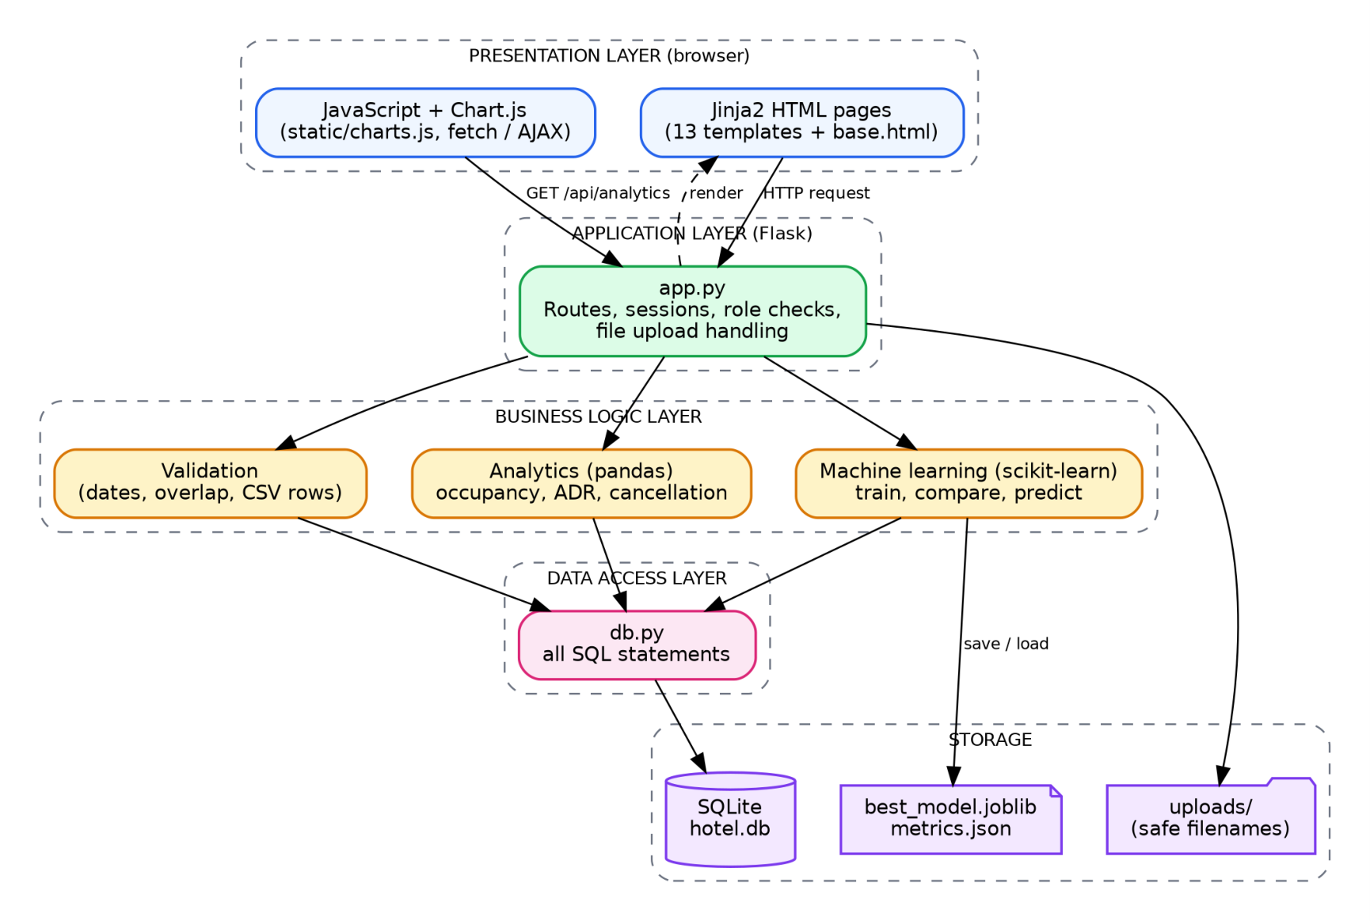
Hotel Booking Analytics & Cancellation Prediction System Design
9.1 Risks and mitigation
Table 9.2: Risk analysis

Risk | Mitigation in this project
No real data available | A documented, seeded generator creates a reproducible dataset; the upload module  accepts real data later.
Model over-fitting | Hold-out test set, stratified 5-fold cross-validation and a train-versus-test  comparison (Chapter 18).
Wrong or double bookings | Validation rules and tests for overlap, dates and maintenance rooms.
Unsafe uploads | Extension check, 2 MB limit, safe filename, row validation and parameterised  inserts.
Model not available when  predicting | Clear error message asking the user to train the model first (tested).
CHAPTER 10
System Design
10.1 Architectural overview
The system is a layered web application. The browser sends HTTP requests to Flask routes. The routes
never contain SQL or analytics code; they call the business-logic layer, which in turn calls the data-ac-
cess layer. Results come back as Jinja-rendered pages, or as JSON for the charts. Keeping the layers
separate means that, for example, the database can be replaced without touching the routes, and the
analytics can be tested without starting a web server (this is how most of the automated tests are writ-
ten).
Figure 10.1: Layered architecture of the Hotel Booking Analytics portal
10

Hotel Booking Analytics & Cancellation Prediction System Design
Table 10.1: Layers and files

Layer | File(s) | Responsibility
Presentation | templates/*.html, static/style.css,  static/charts.js | Pages, forms, navigation, interactive charts and date  filter (fetch / AJAX)
Application | app.py | Routes, sessions, login and admin checks, flash  messages, file upload handling
Business logic | services.py | Booking and CSV validation, pandas analytics,  scikit-learn training and prediction, risk levels
Data access | db.py | Connection handling, table creation, every SQL  statement (parameterised)
Data / storage | hotel.db, models/, uploads/ | SQLite database, saved model and metrics,  uploaded CSV files
Demo data | seed.py | Creates rooms, customers and bookings for the  demonstration
10.2 Typical request flow
The flow below shows what happens when a user opens the Analytics page and applies a date filter. It
is the same pattern used by the dashboard.
1. The browser requests / a n a l y t i c s . Flask checks the session (login_required) and returns the
page with empty chart canvases.
2. The page's JavaScript calls / a p i / a n a l y t i c s ? s t a r t = … & e n d = … with fetch().
3. The route passes the two dates to s e r v i c e s . g e t _ a n a l y t i c s ( ) .
4. The service reads the joined booking data through db.py into one pandas DataFrame, filters it,
and computes KPIs and chart series.
5. The route returns the result with jsonify(); the JavaScript redraws all charts and KPI cards with-
out reloading the page.
10.3 Project folder structure
h o t e l _ a p p /
a p p . p y F l a s k r o u t e s ( p r e s e n t a t i o n / a p p l i c a t i o n l a y e r )
s e r v i c e s . p y v a l i d a t i o n , a n a l y t i c s ( p a n d a s ) , m a c h i n e l e a r n i n g ( s c i k i t - l e a r n )
d b . p y d a t a b a s e a c c e s s l a y e r , S Q L s c h e m a
s e e d . p y d e m o d a t a g e n e r a t o r ( f i x e d r a n d o m s e e d )
r e q u i r e m e n t s . t x t P y t h o n d e p e n d e n c i e s
t e m p l a t e s / b a s e . h t m l + l o g i n , r e g i s t e r , d a s h b o a r d , r o o m s , c u s t o m e r s ,
b o o k i n g s , b o o k i n g _ f o r m , u p l o a d , a n a l y t i c s , p r e d i c t i o n ,
h i s t o r y , r e p o r t s
s t a t i c / s t y l e . c s s , c h a r t s . j s , s a m p l e _ u p l o a d . c s v
m o d e l s / b e s t _ m o d e l . j o b l i b , m e t r i c s . j s o n ( c r e a t e d b y t r a i n i n g )
u p l o a d s / u p l o a d e d C S V f i l e s ( s a f e , t i m e - s t a m p e d n a m e s )
t e s t s / t e s t _ a p p . p y ( 4 4 t e s t s ) , r u n _ t e s t s . p y , t e s t _ l o g . j s o n
11

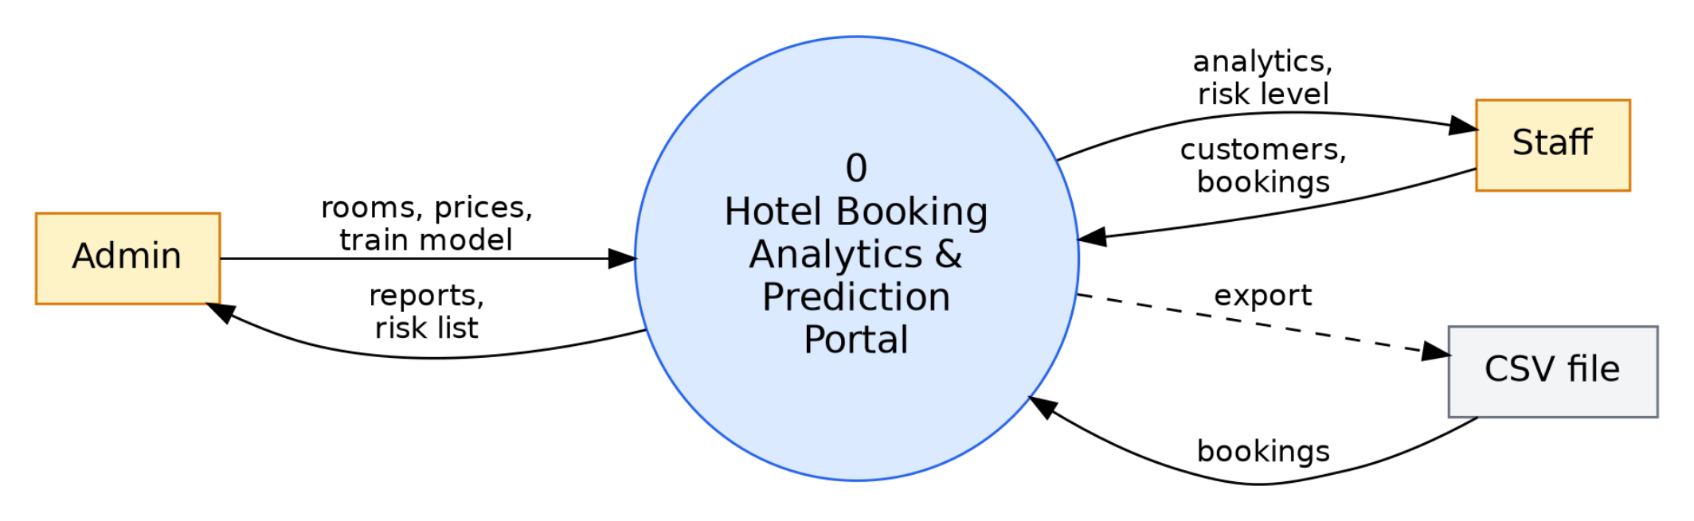
Hotel Booking Analytics & Cancellation Prediction Data Flow Diagrams
10.4 Security design
Table 10.2: Security measures

Threat | Design measure | Where
Password theft | Passwords hashed with Werkzeug (salted); plain text never  stored | app.py register / login
SQL injection | Every statement uses ? placeholders; no string concatenation of  user input | db.py
Unauthorised access | login_required on every page; admin_required on room  changes | app.py
Malicious upload | Only .csv, 2 MB limit, secure_filename, time-stamped storage  name, row validation | app.py, services.py
Invalid data | Server-side validation of dates, rooms, enums and numbers | services.py
Information leakage | Errors shown as short messages; no stack traces for expected  failures | app.py
CHAPTER 11
Data Flow Diagrams
Data flow diagrams (DFD) show how data move between the users, the processes and the data stores.
The notation used is: rectangles for external entities, circles / ellipses for processes, and open boxes
for data stores.
11.1 Level 0 (context diagram)
At level 0 the whole portal is a single process. Admin and staff supply credentials, master data, book-
ings and requests, and receive pages, charts, risk lists and reports. A CSV file is an additional input,
and a CSV export is an output.
Figure 11.1: Level 0 DFD (context diagram)
11.2 Level 1
12

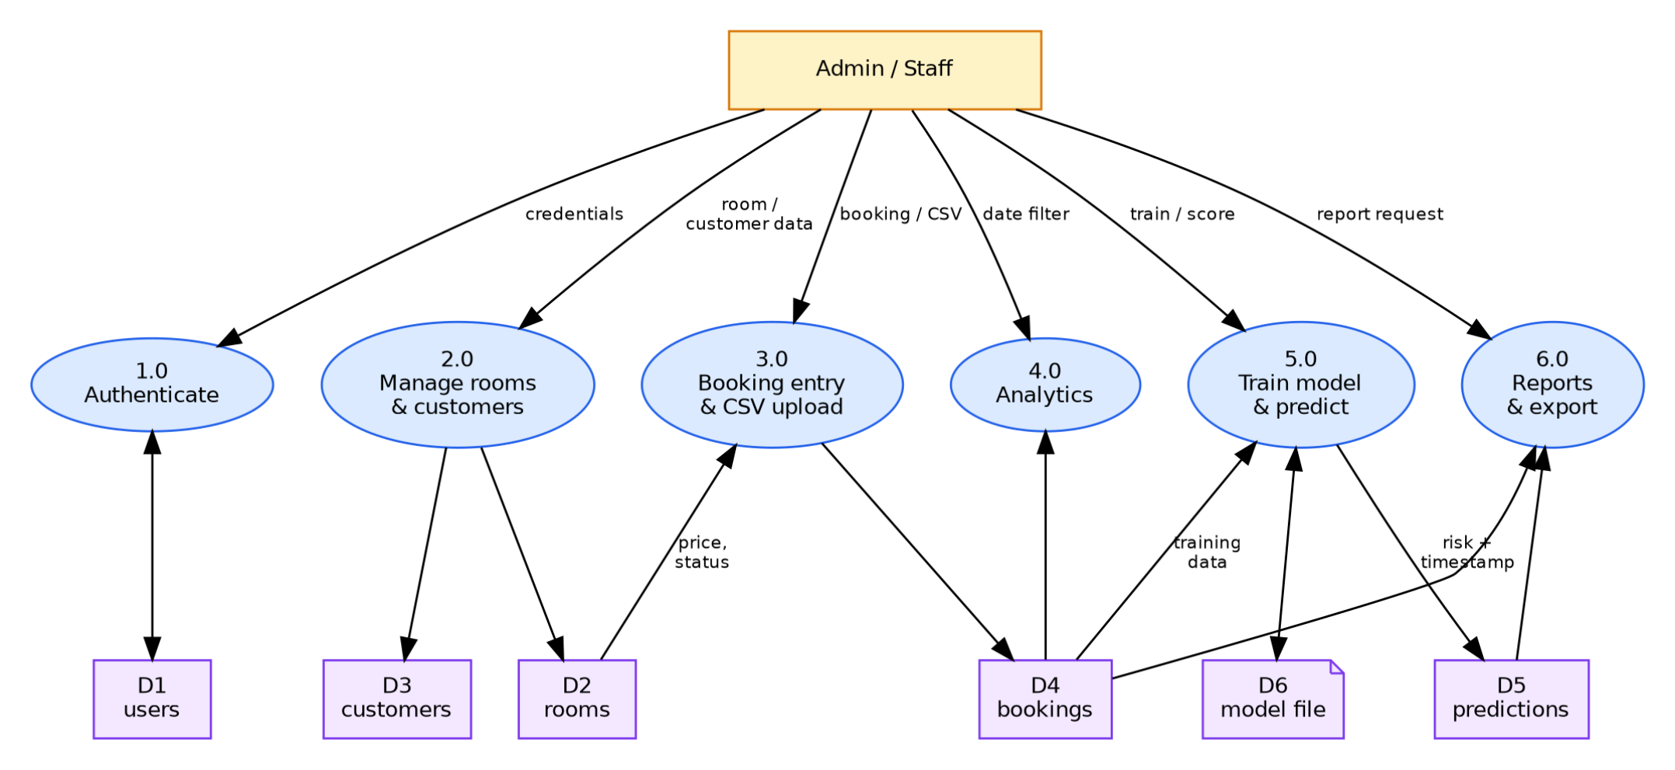
Hotel Booking Analytics & Cancellation Prediction Use Cases
Figure 11.2: Level 1 DFD of the portal
Table 11.1: Process descriptions for the level 1 DFD

Process | Input | Output | Data stores used
1.0 Authenticate | Username, password | Session with role, or error | D1 users
2.0 Manage rooms and  customers | Room and customer  details | Saved / updated records | D2 rooms, D3 customers
3.0 Booking entry and CSV  upload | Booking form or CSV  file | Saved booking, row errors | D2, D3, D4 bookings
4.0 Analytics | Optional date range | KPIs and chart series  (JSON) | D2, D4
5.0 Train model and predict | Train / score request | Metrics, probability, risk  level | D4, D5 predictions, D6  model file
6.0 Reports and export | Report request | Summary tables, bookings  CSV | D4, D5
CHAPTER 12
Use Case Diagram
There are two actors. Staff perform the daily work. Admin has every staff use case and, in addition,
manages rooms and prices and trains the prediction model.
13

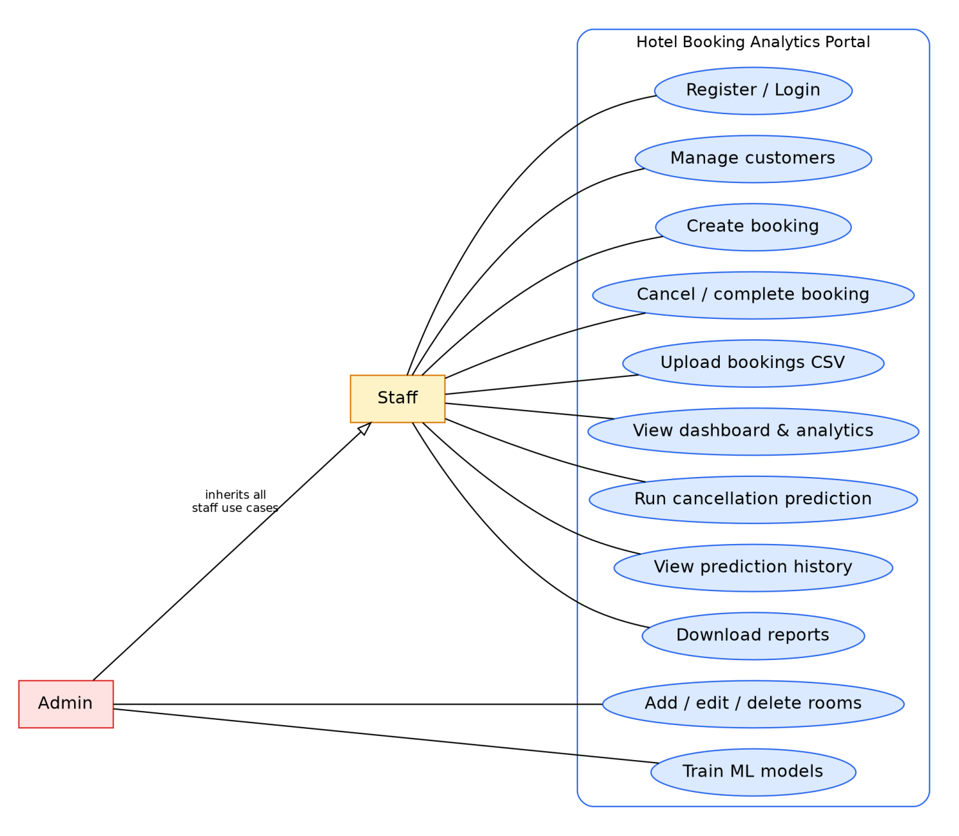
Hotel Booking Analytics & Cancellation Prediction Use Cases
Figure 12.1: Use case diagram
12.1 Use case descriptions
Table 12.1: Use case UC-03: Create booking

Use case | UC-03 Create booking
Actor | Staff or Admin
Precondition | User is logged in; customer and available room exist
Main flow | 1. Open New booking. 2. Choose customer and room. 3. Enter check-in, check-out and  booking date. 4. Submit. 5. System validates the data, calculates the total (nights × price)  and saves the booking with status Confirmed.
Alternative flow | Check-out not after check-in, booking date after check-in, room under maintenance or  room already booked for those dates: the system shows an error message and saves nothing.
Postcondition | A new Confirmed booking exists and appears in the booking list and the analytics.
Table 12.2: Use case UC-05: Upload bookings CSV

Use case | UC-05 Upload bookings CSV
Actor | Staff or Admin
Precondition | User is logged in; file has the required columns
Main flow | 1. Choose a .csv file. 2. System checks the extension and size, stores it under a safe,  time-stamped name. 3. Every row is validated (enums, room number, dates, overlap). 4.  Valid rows are inserted; customers are created if needed.
Alternative flow | Wrong extension, file over 2 MB, missing columns or invalid rows: the file or row is  rejected and the reason is displayed (first 20 errors).
Postcondition | Valid rows are in the database; the page shows the number imported and the rows skipped.
14

Hotel Booking Analytics & Cancellation Prediction ER Diagram
Table 12.3: Use case UC-07: Run cancellation prediction

Use case | UC-07 Run cancellation prediction
Actor | Staff or Admin
Precondition | A model has been trained (Admin: UC-11)
Main flow | 1. Open Prediction. 2. Click Score all upcoming bookings (or Predict on one booking). 3.  System loads the saved model, calculates the probability for each Confirmed booking,  assigns Low / Medium / High and inserts one row per booking in predictions with the  current time.
Alternative flow | No model exists: the system shows 'Train the model first'.
Postcondition | New prediction rows exist; the risky-bookings list and the history page show them.
Table 12.4: Use case UC-11: Train ML models

Use case | UC-11 Train ML models
Actor | Admin (any logged-in user can open the page; training is a single button)
Precondition | At least 100 bookings with known outcome, both classes present
Main flow | 1. Click Train models. 2. System builds the dataset, splits it 75/25, trains Logistic  Regression and Random Forest, computes the metrics, saves the best model and a metrics  file.
Alternative flow | Too little data or only one class: an error message explains the minimum data needed.
Postcondition | best_model.joblib and metrics.json are updated; the Prediction page shows the comparison.
CHAPTER 13
ER Diagram
The entity-relationship diagram below shows the five tables, their primary keys (underlined), foreign
keys and the relationships between them.
15

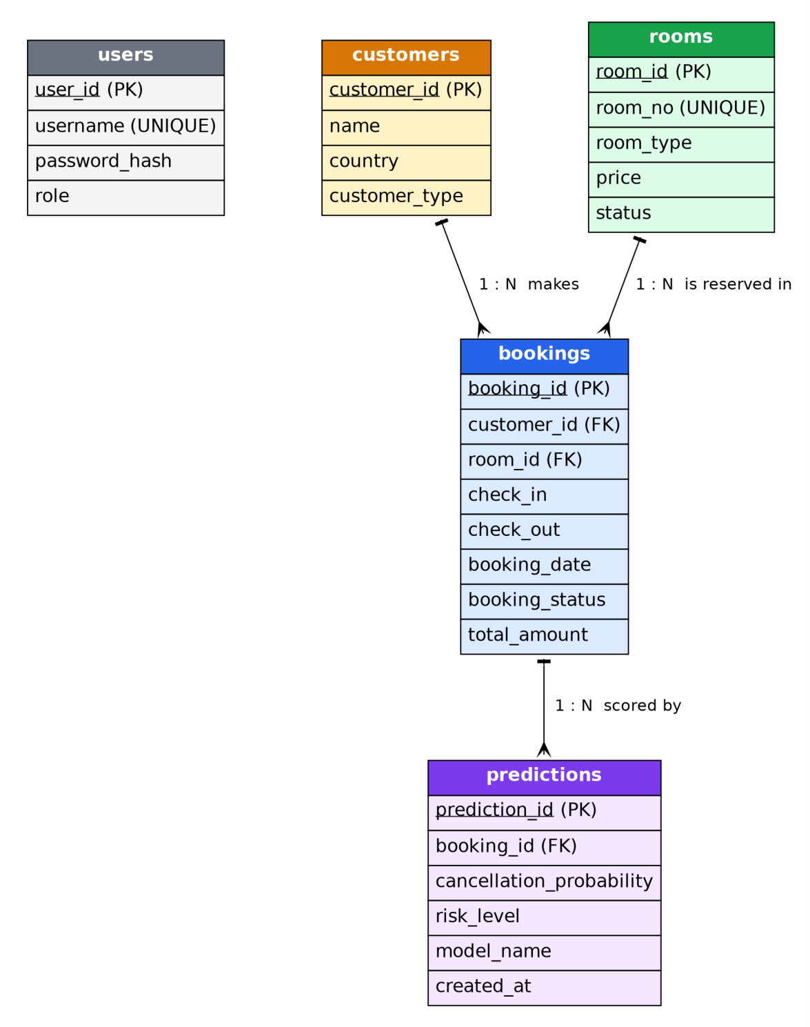
Hotel Booking Analytics & Cancellation Prediction ER Diagram
Figure 13.1: Entity-relationship diagram
Table 13.1: Relationships

Relationship | Cardinality | Meaning | Implemented by
customers – bookings | 1 : N | One customer can make many bookings;  a booking belongs to one customer | bookings.customer_id →  customers.customer_id
rooms – bookings | 1 : N | One room can be reserved many times  (on different dates); a booking is for one  room | bookings.room_id →  rooms.room_id
bookings – predictions | 1 : N | A booking can be scored many times  (history); each prediction belongs to one  booking | predictions.booking_id →  bookings.booking_id
users | — | Stand-alone table used only for login and  roles | —
13.1 Normalisation
First normal form: every column holds one atomic value and every table has a primary key. Second
normal form: all tables use a single-column key, so no attribute can depend on part of a key. Third
normal form: descriptive data about a customer (name, country, type) live in customers and about a
room (type, price, status) in rooms, not in bookings, so they are stored once and no non-key attribute
depends on another non-key attribute.
One deliberate exception is b o o k i n g s . t o t a l _ a m o u n t . It equals nights × room price at the time of
booking and is stored so that a later change of room price does not rewrite the revenue of past book-
ings. The data-quality check in Chapter 16 confirms that the stored amount equals nights × current
price for all 2,000 bookings in the demonstration dataset (mismatches: 0).
16

Hotel Booking Analytics & Cancellation Prediction Database Design
CHAPTER 14
Database Design
SQLite is used as the database. It stores everything in one file, needs no server, supports foreign keys
(enabled with PRAGMA foreign_keys = ON on every connection) and is sufficient for the data vol-
ume of a single hotel. The columns below are exactly those of the project brief, with two additions to
the predictions table (model_name and created_at) that are needed for the audit history.
14.1 Data dictionary
Table 14.1: Table users

Column | Type | Constraint | Description
user_id | INTEGER | PRIMARY KEY,  AUTOINCREMENT | Unique user number
username | TEXT | UNIQUE, NOT NULL | Login name
password_hash | TEXT | NOT NULL | Salted hash produced by Werkzeug
role | TEXT | NOT NULL, default 'staff' | admin or staff
Table 14.2: Table rooms

Column | Type | Constraint | Description
room_id | INTEGER | PRIMARY KEY,  AUTOINCREMENT | Unique room number (internal)
room_no | TEXT | UNIQUE, NOT NULL | Room number shown to users, e.g.  101
room_type | TEXT | NOT NULL | Single, Double, Deluxe or Suite
price | REAL | NOT NULL | Price per night
status | TEXT | NOT NULL, default 'Available' | Available or Maintenance
Table 14.3: Table customers

Column | Type | Constraint | Description
customer_id | INTEGER | PRIMARY KEY,  AUTOINCREMENT | Unique customer number
name | TEXT | NOT NULL | Customer name
country | TEXT | NOT NULL | Country of origin
customer_type | TEXT | NOT NULL | Online, Corporate, Walk-in or  Repeat
17

Hotel Booking Analytics & Cancellation Prediction Database Design
Table 14.4: Table bookings

Column | Type | Constraint | Description
booking_id | INTEGER | PRIMARY KEY,  AUTOINCREMENT | Unique booking number
customer_id | INTEGER | NOT NULL, FOREIGN KEY →  customers | Who booked
room_id | INTEGER | NOT NULL, FOREIGN KEY →  rooms | Which room
check_in / check_out | TEXT | NOT NULL | ISO dates (YYYY-MM-DD)
booking_date | TEXT | NOT NULL | Date the booking was made
booking_status | TEXT | NOT NULL, default 'Confirmed' | Confirmed, Cancelled or Completed
total_amount | REAL | NOT NULL | nights × room price
Table 14.5: Table predictions

Column | Type | Constraint | Description
prediction_id | INTEGER | PRIMARY KEY,  AUTOINCREMENT | Unique prediction number
booking_id | INTEGER | NOT NULL, FOREIGN KEY  → bookings | Booking that was scored
cancellation_probability | REAL | NOT NULL | Model output between 0 and 1
risk_level | TEXT | NOT NULL | Low, Medium or High
model_name | TEXT |  | Model that produced the value  (added for audit)
created_at | TEXT | NOT NULL, default  datetime('now') | Time stamp (added for audit)
18

Hotel Booking Analytics & Cancellation Prediction Database Design
14.2 Table creation script
Listing 14.1: SQL schema (extract of db.py)
C R E A T E T A B L E I F N O T E X I S T S u s e r s (
u s e r _ i d I N T E G E R P R I M A R Y K E Y A U T O I N C R E M E N T ,
u s e r n a m e T E X T U N I Q U E N O T N U L L ,
p a s s w o r d _ h a s h T E X T N O T N U L L ,
r o l e T E X T N O T N U L L D E F A U L T ' s t a f f '
) ;
C R E A T E T A B L E I F N O T E X I S T S r o o m s (
r o o m _ i d I N T E G E R P R I M A R Y K E Y A U T O I N C R E M E N T ,
r o o m _ n o T E X T U N I Q U E N O T N U L L ,
r o o m _ t y p e T E X T N O T N U L L ,
p r i c e R E A L N O T N U L L ,
s t a t u s T E X T N O T N U L L D E F A U L T ' A v a i l a b l e '
) ;
C R E A T E T A B L E I F N O T E X I S T S c u s t o m e r s (
c u s t o m e r _ i d I N T E G E R P R I M A R Y K E Y A U T O I N C R E M E N T ,
n a m e T E X T N O T N U L L ,
c o u n t r y T E X T N O T N U L L ,
c u s t o m e r _ t y p e T E X T N O T N U L L
) ;
C R E A T E T A B L E I F N O T E X I S T S b o o k i n g s (
b o o k i n g _ i d I N T E G E R P R I M A R Y K E Y A U T O I N C R E M E N T ,
c u s t o m e r _ i d I N T E G E R N O T N U L L R E F E R E N C E S c u s t o m e r s ( c u s t o m e r _ i d ) ,
r o o m _ i d I N T E G E R N O T N U L L R E F E R E N C E S r o o m s ( r o o m _ i d ) ,
c h e c k _ i n T E X T N O T N U L L ,
c h e c k _ o u t T E X T N O T N U L L ,
b o o k i n g _ d a t e T E X T N O T N U L L ,
b o o k i n g _ s t a t u s T E X T N O T N U L L D E F A U L T ' C o n f i r m e d ' ,
t o t a l _ a m o u n t R E A L N O T N U L L
) ;
C R E A T E T A B L E I F N O T E X I S T S p r e d i c t i o n s (
p r e d i c t i o n _ i d I N T E G E R P R I M A R Y K E Y A U T O I N C R E M E N T ,
b o o k i n g _ i d I N T E G E R N O T N U L L R E F E R E N C E S b o o k i n g s ( b o o k i n g _ i d ) ,
c a n c e l l a t i o n _ p r o b a b i l i t y R E A L N O T N U L L ,
r i s k _ l e v e l T E X T N O T N U L L ,
m o d e l _ n a m e T E X T ,
c r e a t e d _ a t T E X T N O T N U L L D E F A U L T ( d a t e t i m e ( ' n o w ' ) )
) ;
14.3 Contents of the database used in this report
The database file used for every result in this report is 180 KB. Row counts after the demonstration
data were generated, the model trained and the upcoming bookings scored are shown below; the first
rows of each table follow.
Table 14.6: Row counts

Table | users | rooms | customers | bookings | predictions
Rows | 2 | 30 | 400 | 2,000 | 164
Table 14.7: Sample rows from bookings (actual data)

booking_id | customer_id | room_id | check_in | check_out | booking_date | status | total
1 | 51 | 29 | 2026-01-21 | 2026-01-23 | 2025-12-08 | Completed | 600
2 | 217 | 16 | 2026-06-11 | 2026-06-15 | 2026-05-30 | Completed | 480
3 | 336 | 11 | 2026-08-11 | 2026-08-18 | 2026-08-02 | Completed | 840
4 | 129 | 18 | 2026-06-06 | 2026-06-12 | 2026-06-01 | Cancelled | 720
19

Hotel Booking Analytics & Cancellation Prediction Database Design
Table 14.8: Sample rows from rooms and customers (actual data)

room_id | room_no | room_type | price | status
1 | 101 | Single | 80 | Available
2 | 102 | Single | 80 | Available
3 | 103 | Single | 80 | Available
customer_id | name | country | customer_type
1 | Omar Brown | USA | Online
2 | Priya Smith | USA | Online
3 | Karan Khan | India | Online
Table 14.9: Sample rows from predictions (actual data)

prediction_i  d | booking_id | probability | risk_level | model_name | created_at
1 | 14 | 0.5012 | High | Logistic Regression | 2026-10-15 01:40:14
2 | 25 | 0.3246 | Medium | Logistic Regression | 2026-10-15 01:40:14
3 | 26 | 0.2072 | Low | Logistic Regression | 2026-10-15 01:40:14
14.4 Important SQL statements
Listing 14.2: Two key queries
- - O v e r l a p c h e c k u s e d b e f o r e s a v i n g a b o o k i n g ( d b . r o o m _ i s _ b o o k e d )
S E L E C T 1 F R O M b o o k i n g s
W H E R E r o o m _ i d = ? A N D b o o k i n g _ s t a t u s ! = ' C a n c e l l e d '
A N D c h e c k _ i n < : n e w _ c h e c k _ o u t A N D c h e c k _ o u t > : n e w _ c h e c k _ i n L I M I T 1 ;
- - L a t e s t p r e d i c t i o n o f e v e r y s t i l l - c o n f i r m e d b o o k i n g , h i g h e s t r i s k f i r s t ( d b . r i s k y _ b o o k i n g s )
S E L E C T p . * , b . c h e c k _ i n , b . t o t a l _ a m o u n t , c . n a m e A S c u s t o m e r _ n a m e , r . r o o m _ n o
F R O M p r e d i c t i o n s p
J O I N b o o k i n g s b O N b . b o o k i n g _ i d = p . b o o k i n g _ i d
J O I N c u s t o m e r s c O N c . c u s t o m e r _ i d = b . c u s t o m e r _ i d
J O I N r o o m s r O N r . r o o m _ i d = b . r o o m _ i d
W H E R E p . p r e d i c t i o n _ i d I N ( S E L E C T M A X ( p r e d i c t i o n _ i d ) F R O M p r e d i c t i o n s G R O U P B Y b o o k i n g _ i d )
A N D b . b o o k i n g _ s t a t u s = ' C o n f i r m e d '
O R D E R B Y p . c a n c e l l a t i o n _ p r o b a b i l i t y D E S C L I M I T ? ;
The overlap condition treats a stay as the half-open interval [check-in, check-out). A new stay may
therefore start on the same day another one ends (back-to-back stays are allowed), which is tested ex-
plicitly in Chapter 22. Cancelled bookings are ignored, so their dates become free again.
20

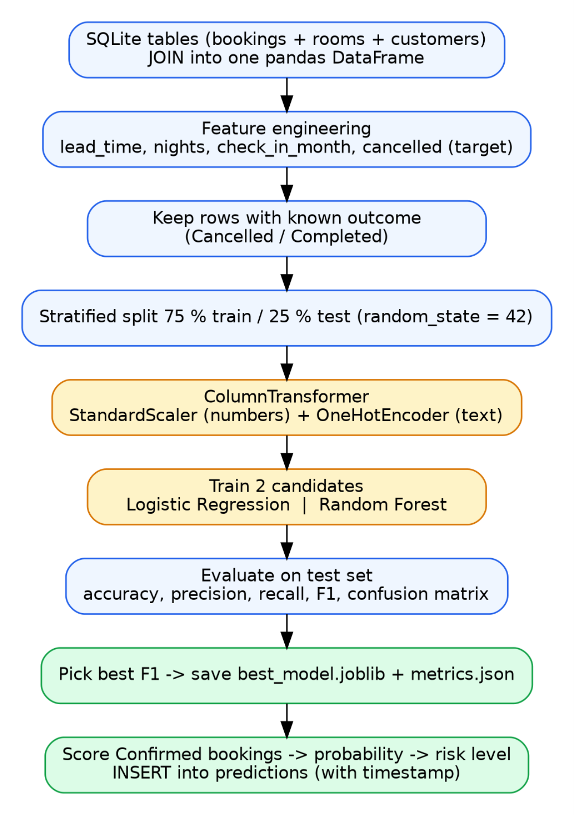
Hotel Booking Analytics & Cancellation Prediction Methodology
CHAPTER 15
Methodology
15.1 Development approach
The project was built iteratively: first the database and the booking workflow, then analytics, then ma-
chine learning, then the interface and finally tests. After each step the application was run and
checked, so that errors were found early. The analytics and prediction work follows the usual phases
of a data-mining project: understand the business question, collect the data, prepare it, model it, evalu-
ate the models and deploy the best one.
15.2 Analytics methodology
• Descriptive analytics answers what happened: totals, occupancy, ADR, revenue by room type,
customer origin and the monthly cancellation rate.
• Diagnostic analytics answers why: the cancellation rate is split by lead time, customer type,
room type and country, and the correlation of each numeric feature with cancellation is measured.
• Predictive analytics answers what may happen next: a classifier estimates the cancellation proba-
bility of every upcoming confirmed booking.
15.3 Machine-learning workflow
Figure 15.1: Machine-learning workflow implemented in services.py
21

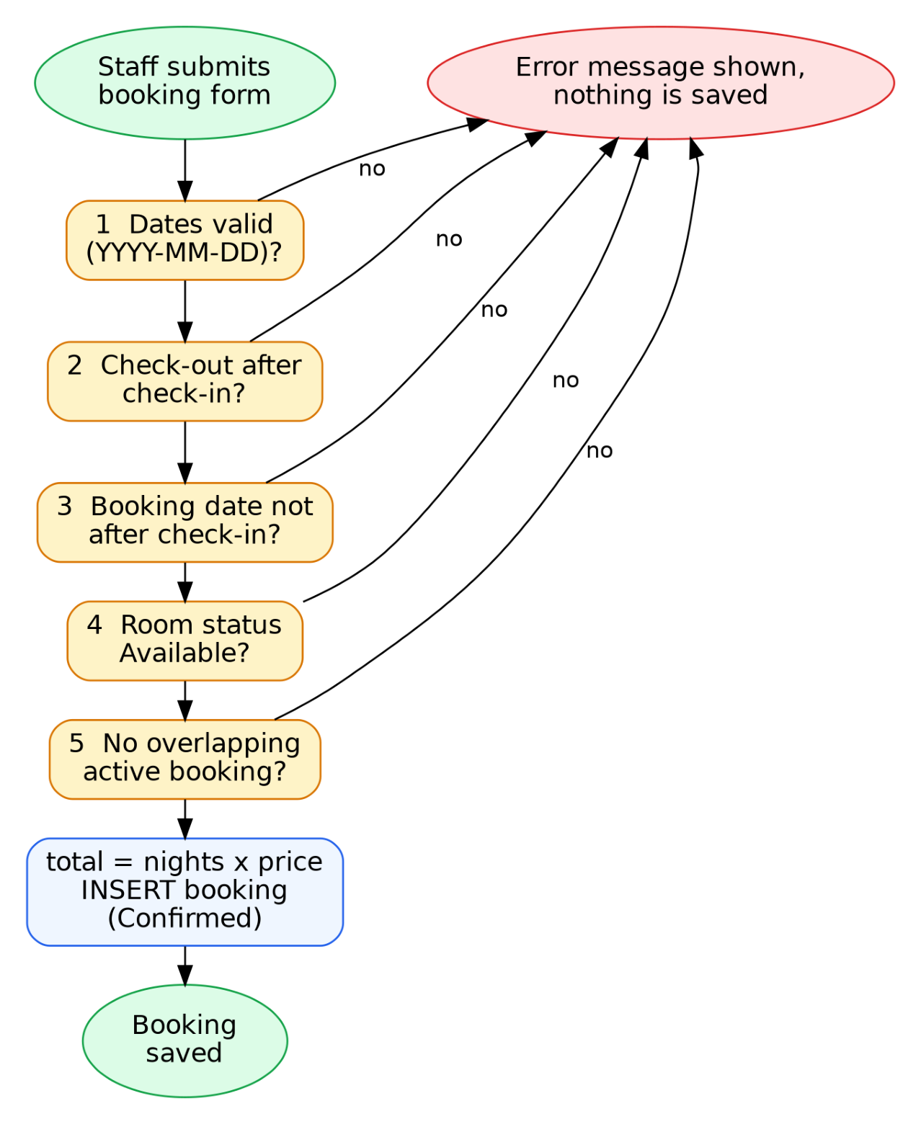
Hotel Booking Analytics & Cancellation Prediction Methodology
15.4 Evaluation protocol
Only bookings whose outcome is known (Cancelled or Completed) are used for training and testing.
Confirmed bookings are the ones to be predicted and are never used as training examples. The data
are split into 75 % training and 25 % test data with stratification so that both parts keep the same share
of cancellations, and a fixed random_state makes the split repeatable. All preprocessing is fitted on
the training part only (inside a scikit-learn Pipeline), so no information from the test set leaks into the
model. The two models are compared on the test set using accuracy, precision, recall, F1-score and the
confusion matrix; ROC-AUC and 5-fold cross-validation are added as extra checks. The model with
the higher F1-score is saved.
15.5 Booking validation logic
The same validation function is used by the booking form and by the CSV upload, so both paths en-
force identical rules. Figure 15.2 shows the sequence of checks.
Figure 15.2: Flow of booking validation
22

Hotel Booking Analytics & Cancellation Prediction Data Preprocessing
CHAPTER 16
Data Preprocessing
16.1 Dataset description
No real hotel records were available, so the dataset was produced by the project's own generator,
s e e d . p y , which uses Python's random module with a fixed seed. It creates 30 rooms, 400 customers
and 2,000 bookings. The generator was run on 15 October 2026; booking dates are created relative to
that day (from 330 days before to 45 days after it), so the check-in dates run from 2025-11-19 to
2026-11-29. Regenerating the data on another day shifts the dates and changes the figures slightly.
The rules used by the generator are listed below. They are the reason certain patterns (for example a
higher cancellation rate for long lead times) appear in the results, which is why the results must be
read as a demonstration of the method and not as findings about a real hotel.
Table 16.1: Rules used to generate the dataset

Element | Rule in the generator
Rooms | 10 Single at 80, 10 Double at 120, 6 Deluxe at 180, 4 Suite at 300 (price per night)
Customers | Types Online / Corporate / Walk-in / Repeat with weights 45 / 20 / 15 / 20; ten countries  (India 30 %, USA 15 %, UK 10 %, others 5–8 %)
Stay length | 1 to 7 nights with weights 10, 25, 25, 15, 10, 8, 7
Lead time | Exponential distribution with mean 45 days, capped at 300 days
Seasonality | Check-in months June, July, August and December are accepted with probability 1;  other months between 0.6 and 0.8
Room clash | A stay is accepted only if the room has no overlapping non-cancelled stay
Cancellation probability | 0.10 + min(lead, 200) ÷ 400 + type effect (Online +0.15, Corporate −0.05, Walk-in  −0.08, Repeat −0.08) + 0.05 for price ≥ 180, limited to 0.03–0.85; halved for future  check-ins
Status | Past stays: Cancelled or Completed by a random draw against that probability; future  stays: Confirmed or Cancelled
16.2 Data collection and joining
The bookings, rooms and customers tables are joined into one pandas DataFrame with one row per
booking (function b o o k i n g s _ d f ). Date columns are converted to datetime. The same DataFrame
feeds both the analytics and the machine-learning code, so both always see identical data.
16.3 Data quality checks
The checks below were run on the full dataset. They were computed by the analysis script, not as-
sumed.
23

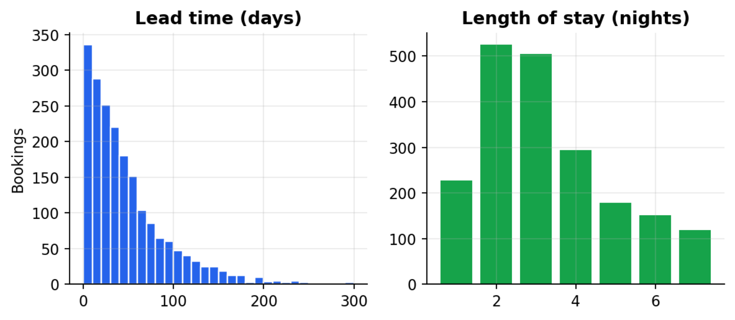
Hotel Booking Analytics & Cancellation Prediction Data Preprocessing
Table 16.2: Data quality checks

Check | Result
Missing values in any of the 12 joined columns | 0 (all columns complete)
Duplicate booking_id | 0
Duplicate rows apart from booking_id | 0
Bookings with negative lead time | 0
Bookings with zero or negative nights | 0
total_amount differs from nights × price | 0
Distinct values of room_type / customer_type / country | 4 / 4 / 10
Handling of missing values. No missing values were found, because the database has NOT NULL
constraints on every column and validation rejects incomplete rows at entry and upload. If a future
dataset did contain gaps, the loading step is the place to add imputation; no imputation was needed for
this dataset and none was applied.
16.4 Summary statistics
Table 16.3: Summary statistics of the numeric variables (2,000 bookings)

Variable | Mean | Std | Min | 25 % | Median | 75 % | Max
Lead time (days) | 48.42 | 46.79 | 0 | 14 | 35 | 65 | 300
Nights | 3.3 | 1.66 | 1 | 2 | 3 | 4 | 7
Room price | 145.14 | 72.67 | 80 | 80 | 120 | 180 | 300
Total amount | 478.63 | 357.88 | 80 | 240 | 360 | 600 | 2100
Check-in month | 6.85 | 3.37 | 1 | 4 | 7 | 10 | 12
Figure 16.1: Distribution of lead time and length of stay
24

Hotel Booking Analytics & Cancellation Prediction Data Preprocessing
16.5 Outlier analysis
Outliers were examined with the 1.5 × IQR rule. Lead time has Q1 = 14 and Q3 = 65 days, so the up-
per fence is 141.5 days; 107 bookings (5.3 %) lie above it. Total amount has an upper fence of 1140
and 142 bookings (7.1 %) lie above it; these are genuine long stays in the Suite and Deluxe rooms.
Length of stay has 0 outliers. These values are legitimate (a long advance booking, an expensive suite)
and are cancelled more often, which is exactly the information the model should learn, so no rows
were removed or capped. The scaling step described below reduces their influence on the logistic re-
gression, and the random forest is insensitive to them.
16.6 Feature engineering
Table 16.4: Features used by the model

Feature | Type | Derived from | Reason
lead_time | Numeric | check_in − booking_date (days) | Strongest expected driver of  cancellation
nights | Numeric | check_out − check_in (days) | Length of stay
price | Numeric | rooms.price | Price level of the room
total_amount | Numeric | bookings.total_amount | Money at stake
check_in_month | Numeric | month of check_in | Seasonality
room_type | Categorical | rooms.room_type | Room category
country | Categorical | customers.country | Customer origin
customer_type | Categorical | customers.customer_type | Booking channel / guest type
cancelled | Target (0 / 1) | booking_status = 'Cancelled' | What the model predicts
All features are available at the moment a booking is made or shortly after, so no information from the
future (such as the final status) is used as a feature. The status column is used only to create the target.
16.7 Encoding categorical variables
Text columns cannot be used directly by the models. OneHotEncoder converts each category into a
0/1 column: room_type gives 4 columns, country 10 and customer_type 4. Together with the 5 numer-
ic columns this gives 23 input features for the models. The encoder is set to ignore categories it has
not seen, so a new country entered after training will not crash the prediction.
16.8 Scaling numeric variables
The numeric features have very different ranges (nights 1–7, total amount up to 2,100). Logistic re-
gression is sensitive to such differences, so StandardScaler subtracts the training mean and divides by
the training standard deviation. The values below were measured on the training part; after scaling,
each column has mean 0 and standard deviation 1 (the check is shown in the last two columns).
25

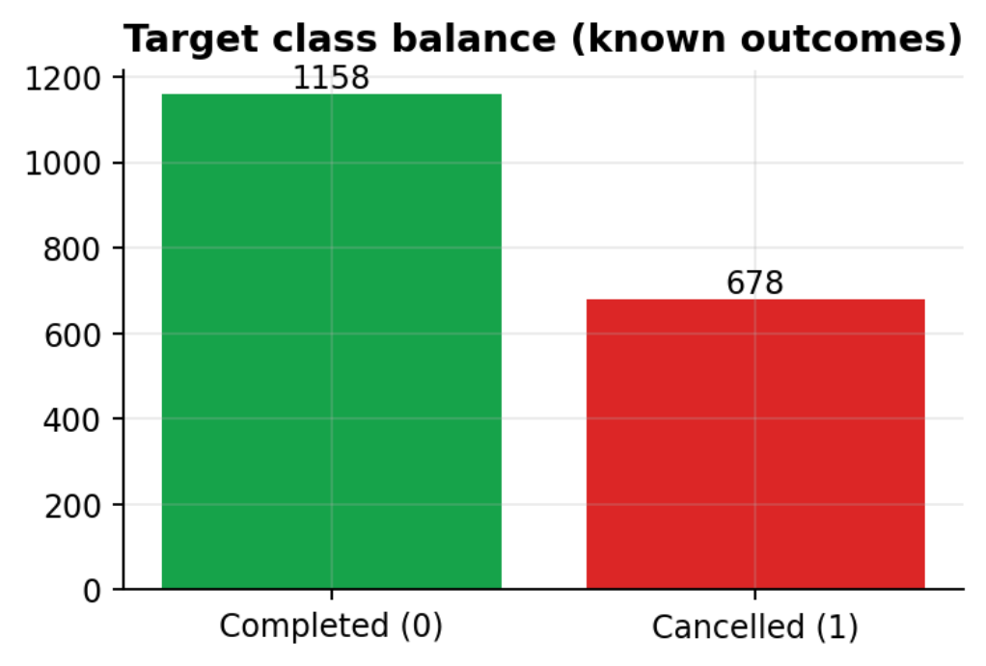
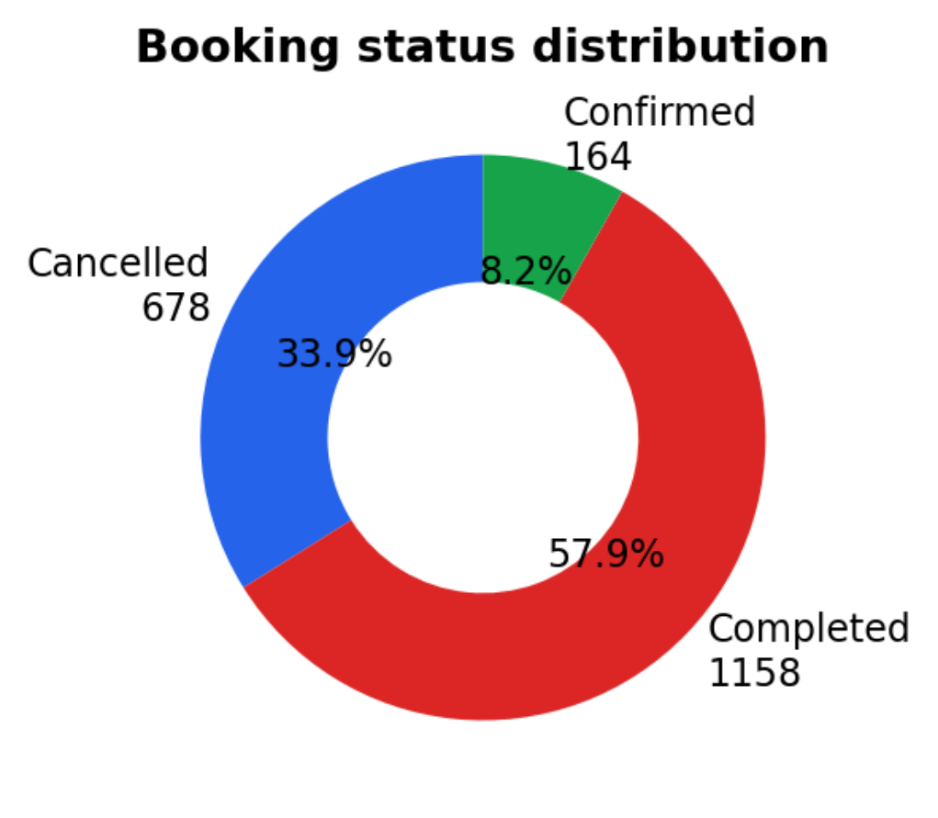
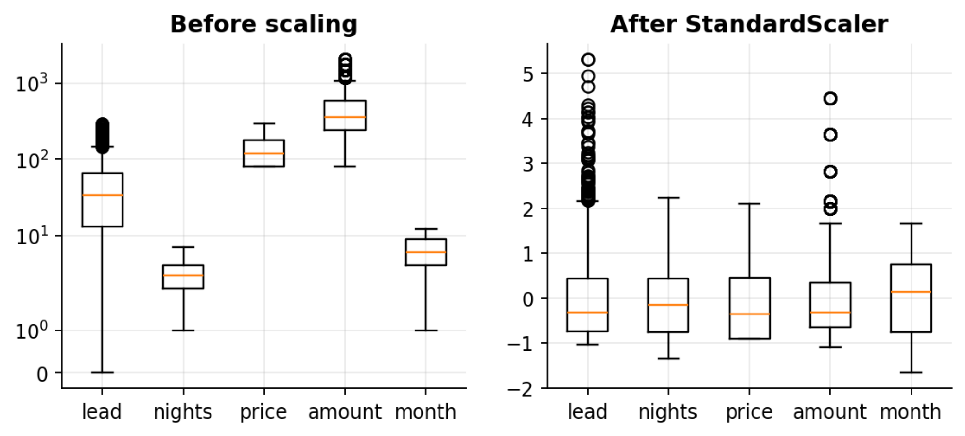
Hotel Booking Analytics & Cancellation Prediction Data Preprocessing
Table 16.5: Standardisation of numeric features (training data)

Feature | Mean (train) | Std (train) | Mean after | Std after
lead_time | 48.84 | 47.2 | 0.000 | 1.0
nights | 3.26 | 1.67 | 0.000 | 1.0
price | 146.29 | 73.07 | 0.000 | 1.0
total_amount | 478.0 | 363.61 | 0.000 | 1.0
check_in_month | 6.51 | 3.31 | 0.000 | 1.0
Figure 16.2: Numeric features before and after StandardScaler
16.9 Train / test split and class balance
Of the 2,000 bookings, 164 are still Confirmed and are kept out of training. The remaining 1,836 have
a known outcome: 678 cancelled (36.9 %) and 1158 completed. They were split with stratification into
1377 training rows (509 cancelled, 37.0 %) and 459 test rows (169 cancelled, 36.8 %). The classes are
moderately unbalanced; a model that always answers 'not cancelled' would reach an accuracy of 0.631,
which is the baseline the real models must beat. For this reason recall and F1-score are examined to-
gether with accuracy.
Figure 16.3: Target class balance and booking status distribution
26

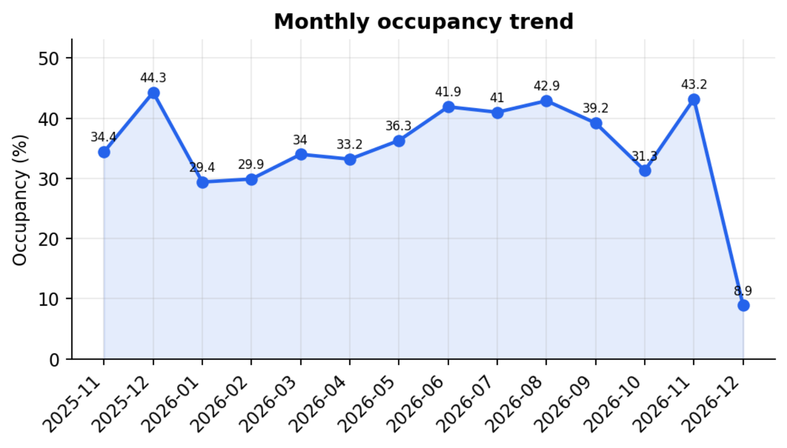
Hotel Booking Analytics & Cancellation Prediction Analytics
CHAPTER 17
Analytics
This chapter reports the descriptive and diagnostic analytics computed by the portal on the demonstra-
tion dataset. All values come from the analytics module (the same numbers the dashboard shows) and
were cross-checked against direct SQL queries in the automated tests.
17.1 Descriptive analytics: what happened?
Key performance indicators
Table 17.1: Key performance indicators of the demonstration dataset

Indicator | Value | Note
Total bookings | 2,000 | All statuses
Cancellation rate | 33.9 % | 678 of 2,000 bookings
Occupancy | 36.9 % | Room-nights sold ÷ (rooms × days in the data span); cancelled  stays excluded
ADR | 143.43 | Revenue ÷ room-nights sold
RevPAR (derived) | 52.9 | ADR × occupancy, calculated from the two values above
Revenue | 604,000 | Non-cancelled bookings (completed and confirmed)
Average lead time | 48.4 days | Mean of check-in minus booking date
Occupancy trend
Monthly occupancy ranges from 29.4 % (2026-01) to 44.3 % (2025-12) among complete months.
Summer months (June to August 2026) stay between 41.0 % and 42.9 %, which reflects the seasonali-
ty built into the generator. The final month (2026-12) shows only 8.9 % because the data end shortly
after the generation date: only the bookings already made for those few future days exist. It is a prop-
erty of the data span and not a real drop in demand.
Figure 17.1: Monthly occupancy trend
27

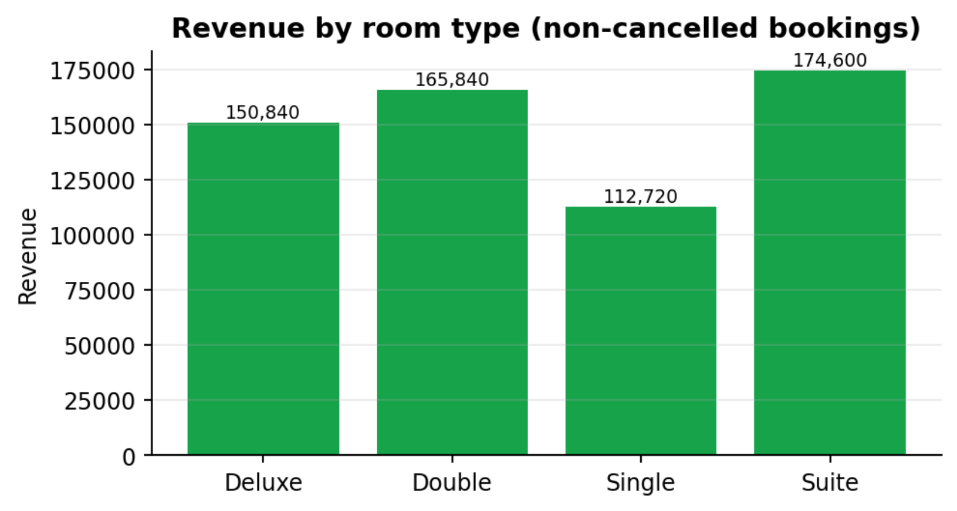
Hotel Booking Analytics & Cancellation Prediction Analytics
Revenue by room type and ADR
Table 17.2: Revenue summary by room type (from the Reports page)

Room type | Bookings | Cancelled | Cancel rate | Revenue | ADR
Deluxe | 411 | 150 | 36.5 % | 150,840 | 180.0
Double | 651 | 217 | 33.3 % | 165,840 | 120.0
Single | 651 | 211 | 32.4 % | 112,720 | 80.0
Suite | 287 | 100 | 34.8 % | 174,600 | 300.0
The Suite rooms bring the highest revenue (174,600) although there are only 4 of them and they re-
ceived only 287 bookings, whereas the Single rooms, which are the most frequently booked together
with the Double rooms (651 bookings), bring the lowest (112,720). The ADR of each room type
equals its listed price because the system uses one fixed price per room; the overall ADR (143.43) is
the weighted mix of the four prices. This changes only if the price is edited or dynamic prices are in-
troduced.
Figure 17.2: Revenue by room type
Customer origin
Table 17.3: Customer origin and cancellation by country

Country | Bookings | Share | Cancelled | Cancel rate
India | 637 | 31.9 % | 230 | 36.1 %
USA | 286 | 14.3 % | 94 | 32.9 %
UK | 193 | 9.7 % | 65 | 33.7 %
Germany | 150 | 7.5 % | 40 | 26.7 %
UAE | 145 | 7.2 % | 54 | 37.2 %
Singapore | 145 | 7.2 % | 44 | 30.3 %
Canada | 144 | 7.2 % | 54 | 37.5 %
Australia | 107 | 5.3 % | 37 | 34.6 %
Japan | 107 | 5.3 % | 35 | 32.7 %
France | 86 | 4.3 % | 25 | 29.1 %
28

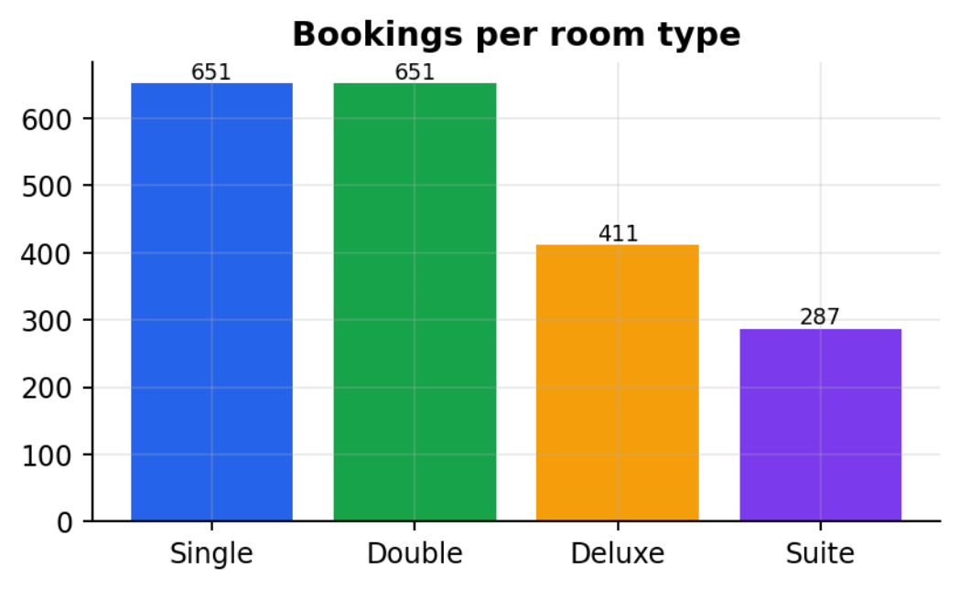
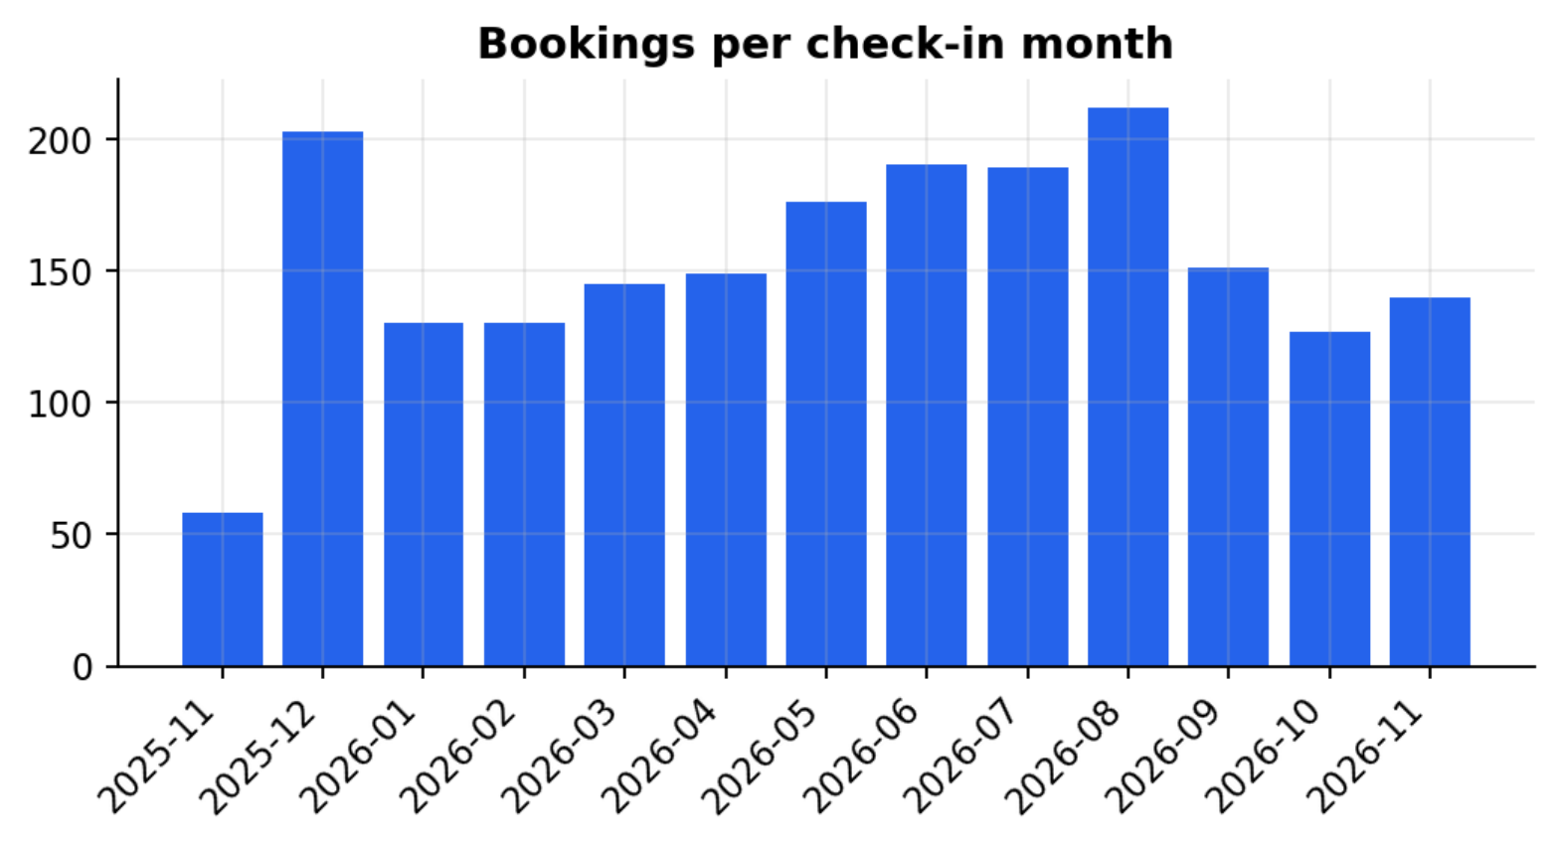
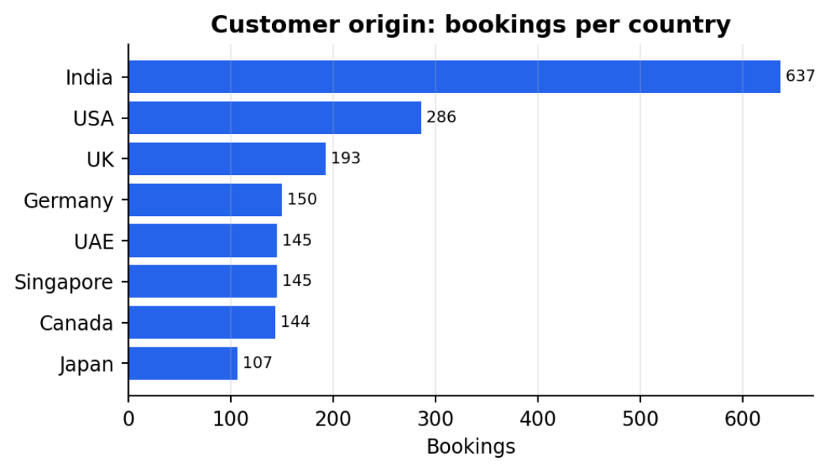
Hotel Booking Analytics & Cancellation Prediction Analytics
India is the largest source market with 637 bookings (31.9 %), followed by USA (286) and UK (193).
In the dashboard the chart shows the top eight countries.
Figure 17.3: Bookings by country (top 8) and by room type
Figure 17.4: Number of bookings per check-in month
17.2 Diagnostic analytics: why do guests cancel?
Diagnostic analytics compares the cancellation rate across groups of bookings. A factor is relevant if
the rate changes clearly between its groups.
Lead time
The cancellation rate rises steadily with lead time: 19.9 % for bookings made 0–7 days ahead, 26.8 %
for 8–30 days, 34.3 % for 31–90 days, 58.9 % for 91–180 days and 64.3 % for more than 180 days.
The mean lead time of cancelled bookings is 65.8 days against 39.5 days for the others (medians 50
and 29). Guests who book far ahead have more time for their plans to change.
29

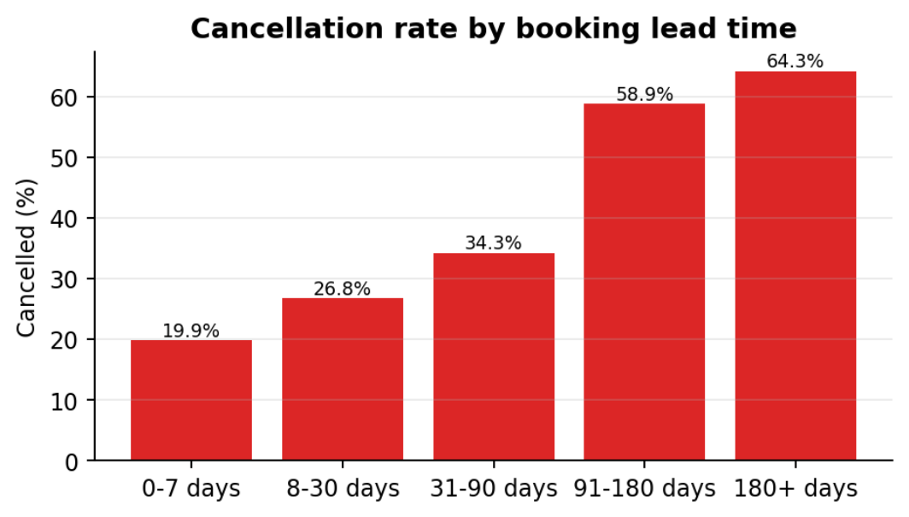
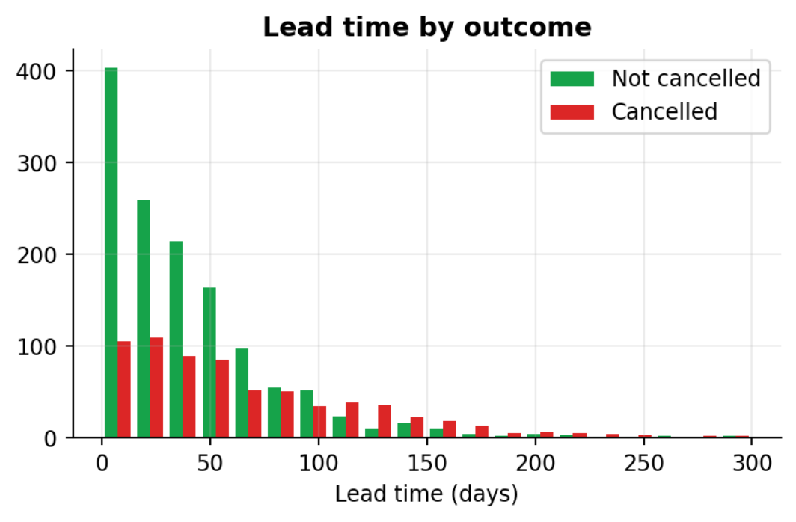
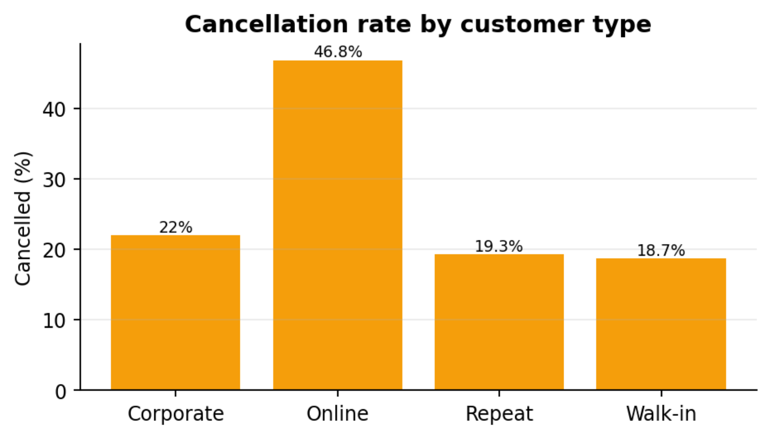
Hotel Booking Analytics & Cancellation Prediction Analytics
Figure 17.5: Cancellation rate by lead-time bucket and lead-time histogram by outcome
Customer type
Online bookings are cancelled in 46.8 % of cases, more than twice the rate of Corporate (22.0 %), Re-
peat (19.3 %) and Walk-in (18.7 %) guests. Guests who book on the web without direct contact can
cancel without effort, while repeat and corporate guests have a relationship with the hotel.
Figure 17.6: Cancellation rate by customer type
Room type, country and the other numeric features
The cancellation rate is almost the same across room types (32.4 % to 36.5 %), so the room category
on its own is not a useful signal. The rates by country vary between 26.7 % and 37.5 %, but with only
86 to 637 bookings per country, differences of this size can arise by chance; they should not be over-
interpreted. The correlation of each numeric feature with the cancelled flag (Pearson, 0/1 target) con-
firms the ranking:
Table 17.4: Correlation of numeric features with cancellation

Feature | Correlation with cancelled
lead_time | +0.27
nights | +0.10
price | +0.02
total_amount | +0.08
check_in_month | -0.03
30

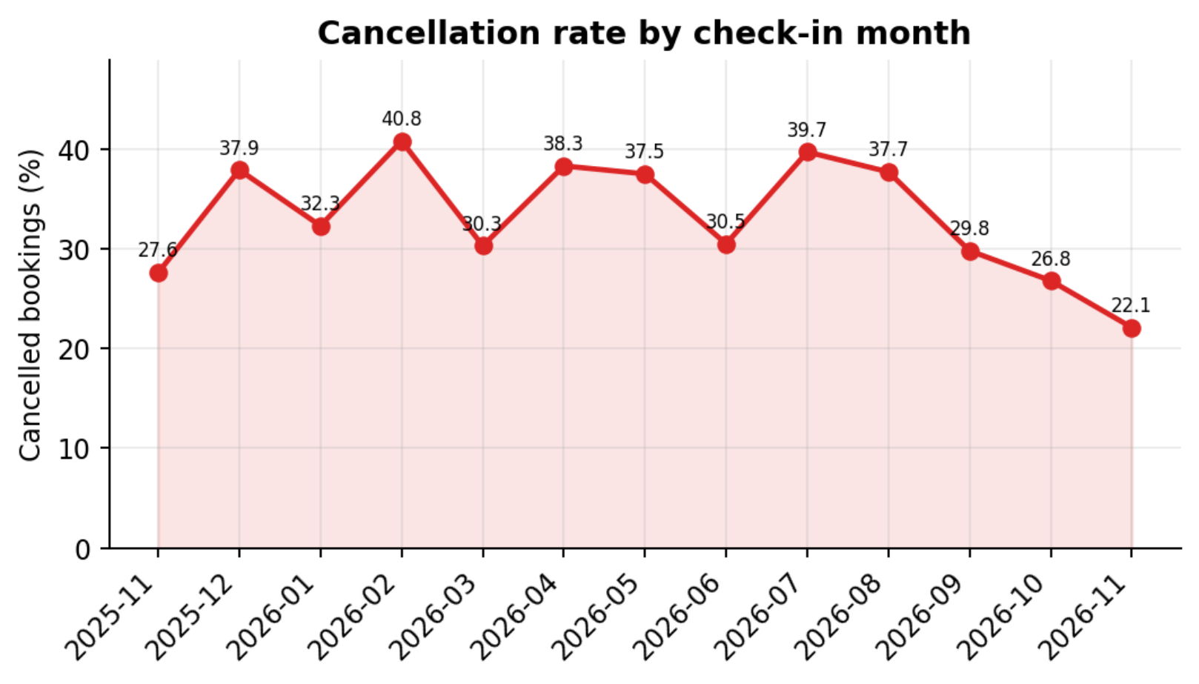

Hotel Booking Analytics & Cancellation Prediction ML Model
Lead time is the only numeric feature with a clear relationship (+0.27). Length of stay and total
amount show weak positive values and price and month are close to zero. Together with the customer-
type effect, this tells the hotel that long-lead online bookings are the group to watch.
Figure 17.7: Cancellation rate by check-in month
Reading the diagnostics honestly
Part of what the diagnostic charts show was put there by the data generator (lead time, customer type
and the small price effect, see Chapter 16). The room-type and country differences were not built in,
and the analysis correctly shows them to be small. With real hotel data the same charts would reveal
the real drivers.
17.3 Predictive analytics
Descriptive and diagnostic analytics describe the past. The next chapter builds the predictive layer that
scores bookings that have not yet been decided.
CHAPTER 18
Machine Learning Model
18.1 Problem formulation
Cancellation prediction is a binary classification problem. The positive class is cancelled (1) and the
negative class is not cancelled (0). 1,836 bookings with known outcomes are available; the features are
listed in Chapter 16 and the target is the cancelled flag.
31

Hotel Booking Analytics & Cancellation Prediction ML Model
18.2 Candidate models
Table 18.1: Candidate models

Model | Settings | Why it was chosen
Logistic Regression | scikit-learn defaults (L2 penalty, C = 1.0,  lbfgs solver), max_iter = 1000 | Simple, fast, gives interpretable  coefficients and well-calibrated  probabilities
Random Forest | 150 trees, min_samples_leaf = 5,  random_state = 42 | Captures non-linear effects and  interactions; robust to outliers
Both models are wrapped in the same scikit-learn Pipeline: a ColumnTransformer (StandardScaler on
the five numeric columns, OneHotEncoder on the three categorical columns) followed by the classifi-
er. Hyper-parameters were not tuned; the aim was a fair, repeatable comparison of two standard mod-
els.
18.3 Evaluation metrics
With TP, TN, FP, FN taken from the confusion matrix (cancelled is the positive class):
Table 18.2: Evaluation metrics

Metric | Formula | Question it answers
Accuracy | (TP + TN) ÷ all | How often is the prediction right?
Precision | TP ÷ (TP + FP) | Of the bookings flagged as cancellations, how many  really cancelled?
Recall | TP ÷ (TP + FN) | Of all real cancellations, how many did we catch?
F1-score | 2 × precision × recall ÷ (precision +  recall) | Balance of precision and recall (used to pick the  best model)
ROC-AUC | Area under the ROC curve | Ability to rank cancelled bookings above others, at  any threshold
18.4 Results on the test set (459 bookings)
Table 18.3: Test-set metrics (these values are stored in models/metrics.json)

Model | Accuracy | Precision | Recall | F1-score | ROC-AUC
Logistic Regression (saved) | 0.699 | 0.637 | 0.426 | 0.511 | 0.738
Random Forest | 0.673 | 0.577 | 0.42 | 0.486 | 0.727
Majority-class baseline | 0.631 | — | 0 | — | 0.5
Logistic Regression obtained the higher F1-score (0.511 against 0.486) and accuracy (0.699 against
0.673) and was therefore saved as the best model. Both models exceed the majority-class accuracy
(0.631) by 6.8 and 4.2 percentage points and have a ROC-AUC well above 0.5 (a model without infor-
mation), but the margin is modest, a reminder that accuracy alone is a weak measure on unbalanced
data. Recall is low for both models (0.426 and 0.42) at the default threshold of 0.5, which means they
miss more than half of the real cancellations; this is analysed further under threshold selection.
32

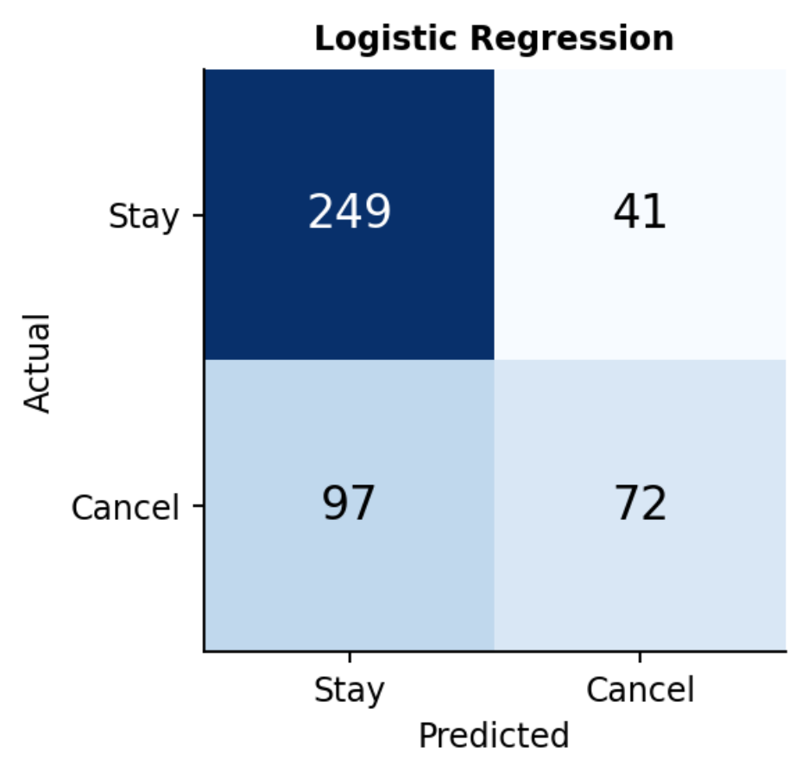
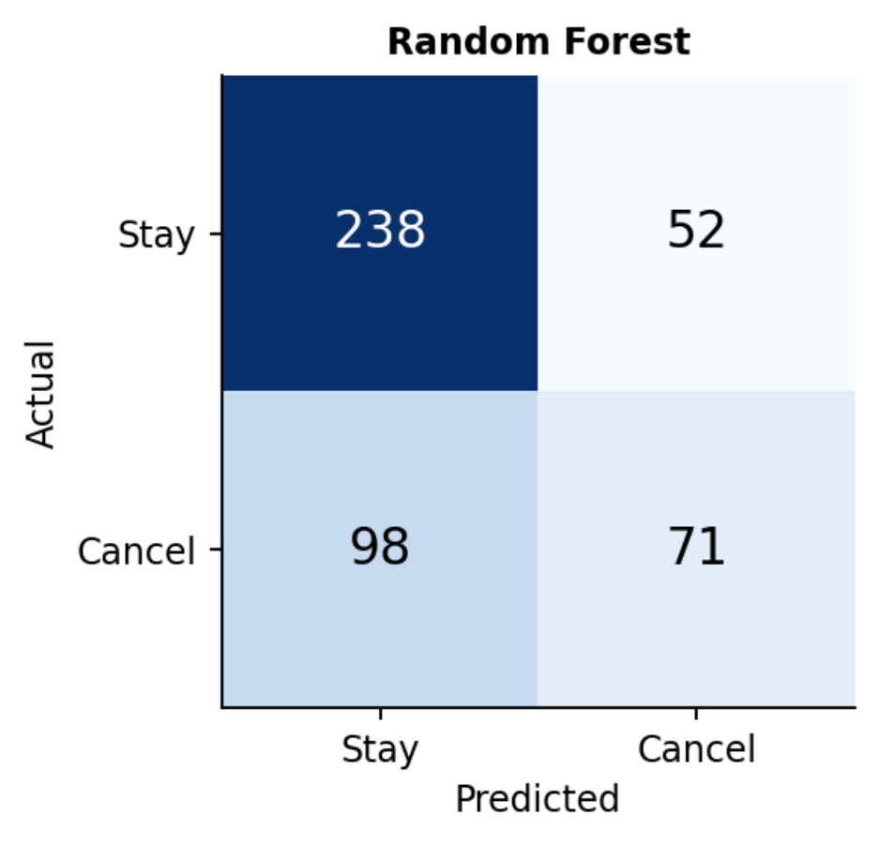
Hotel Booking Analytics & Cancellation Prediction ML Model
Confusion matrices
Figure 18.1: Confusion matrices on the test set (left: saved model)
Table 18.4: Confusion-matrix counts

Model | TN | FP | FN | TP | Total
Logistic Regression | 249 | 41 | 97 | 72 | 459
Random Forest | 238 | 52 | 98 | 71 | 459
For Logistic Regression, 249 of 290 non-cancelled bookings were recognised correctly, but only 72 of
169 real cancellations were caught. The confusion matrices were recomputed independently by the
analysis script and matched the stored values exactly.
Cross-validation and over-fitting check
Table 18.5: Training versus test accuracy and stratified 5-fold cross-validation (mean ± std)

Model | Train  accuracy | Test  accuracy | CV accuracy  (5-fold) | CV F1 (5-fold) | CV  ROC-AUC
Logistic Regression | 0.702 | 0.699 | 0.689 ± 0.014 | 0.492 ± 0.017 | 0.744 ± 0.015
Random Forest | 0.801 | 0.673 | 0.678 ± 0.024 | 0.494 ± 0.033 | 0.724 ± 0.02
The logistic regression shows no sign of over-fitting (train 0.702, test 0.699). The random forest
reaches 0.801 on the training data but only 0.673 on the test data, a typical sign of over-fitting. In
cross-validation the two models are practically equal (F1 0.492 and 0.494, with a fold-to-fold spread
of 0.017 and 0.033), so the difference seen on one test split should not be treated as decisive. The sim-
pler and more interpretable logistic regression is a sensible choice.
33

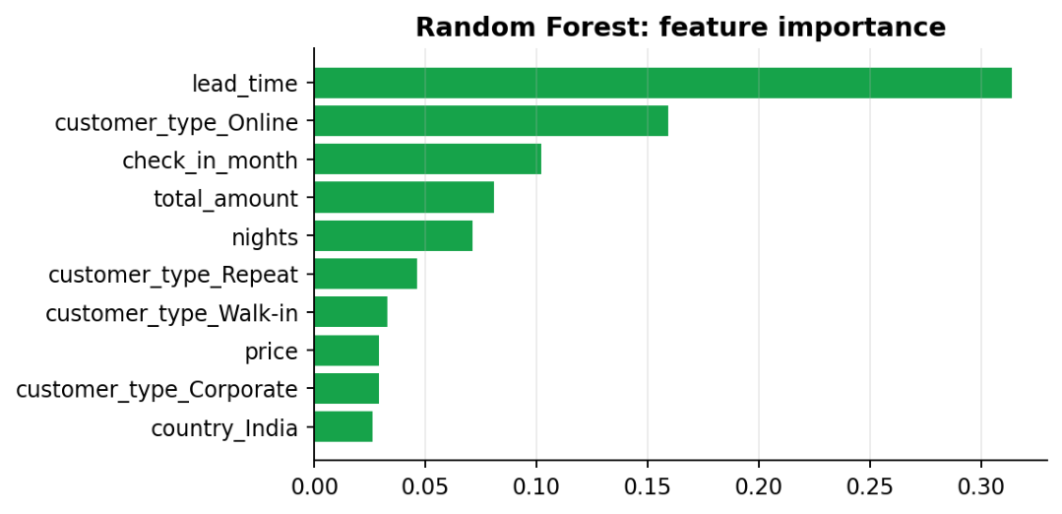
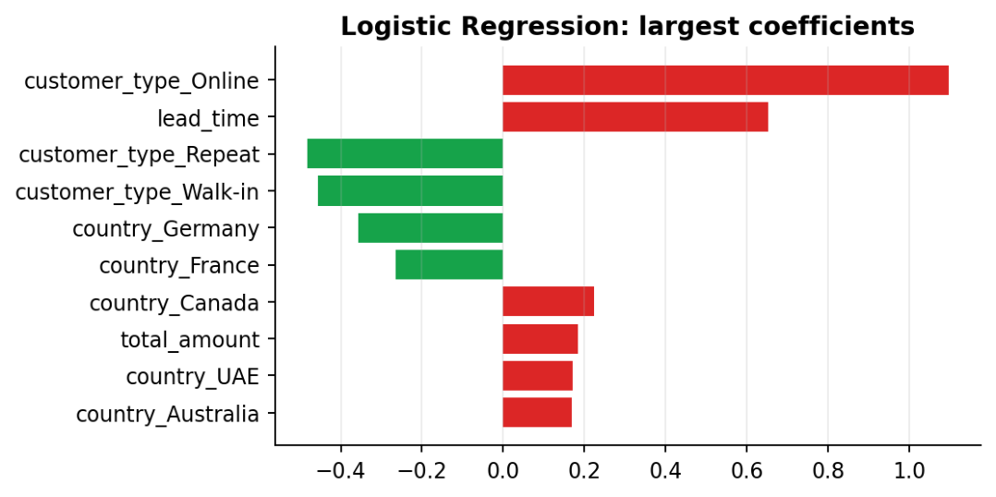
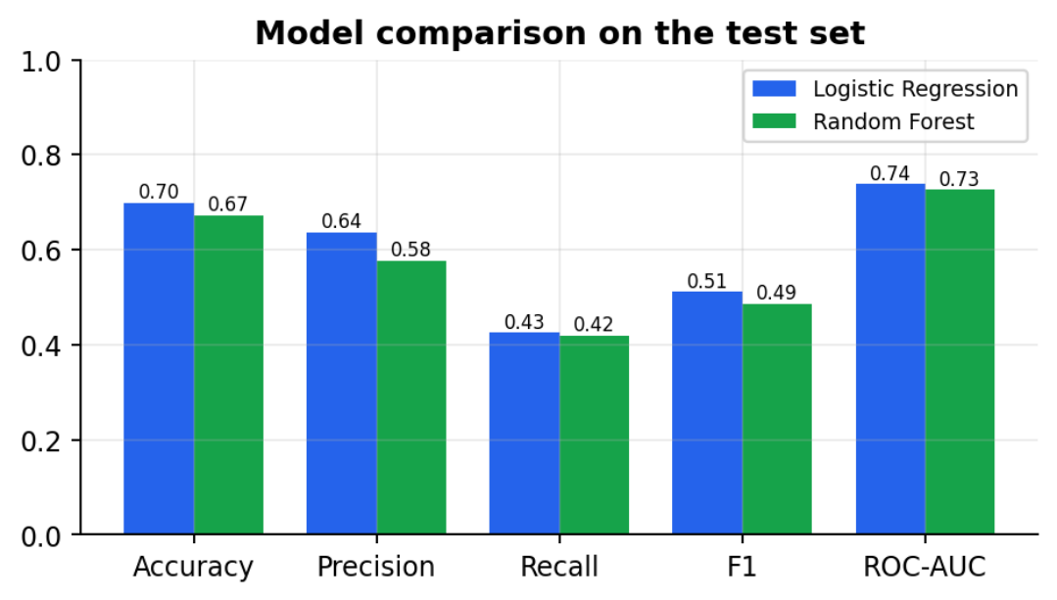
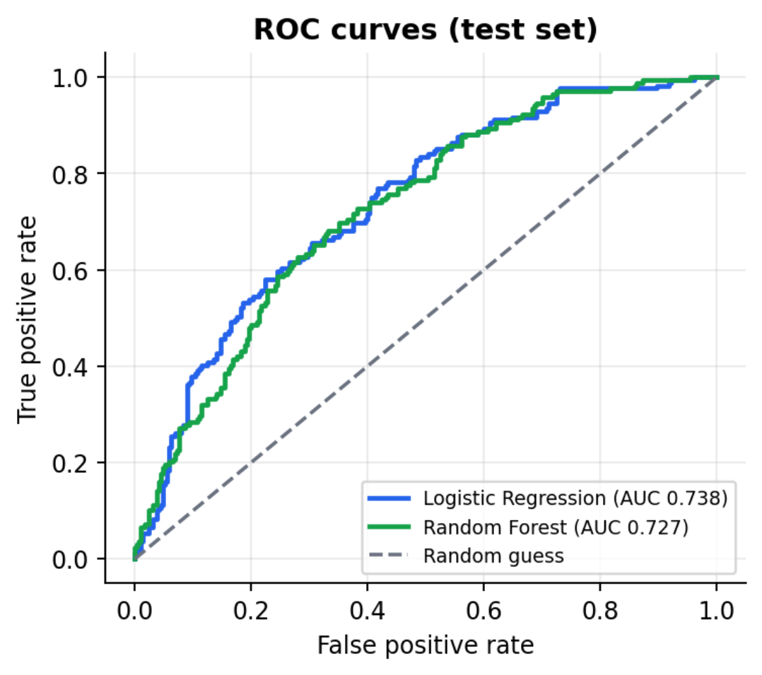
Hotel Booking Analytics & Cancellation Prediction ML Model
Figure 18.2: ROC curves and metric comparison of the two models
18.5 What the models learned
The largest logistic-regression coefficients are customer_type_Online (+1.098), lead_time (+0.652),
customer_type_Repeat (-0.483) and customer_type_Walk-in (-0.457). A positive coefficient raises
and a negative one lowers the cancellation probability (numeric features are standardised, so their co-
efficients are per standard deviation). The random forest ranks lead_time (0.314) first, followed by
customer_type_Online (0.159) and check_in_month (0.102). Both models therefore point to the same
two factors found in the diagnostic analytics, the booking lead time and the online channel.
Figure 18.3: Largest logistic-regression coefficients and random-forest feature importances
18.6 Decision threshold and risk levels
The metrics above use the default threshold of 0.5: a booking is classed as 'cancelled' when its proba-
bility is at least 0.5. For a hotel, missing a cancellation is usually worse than checking one booking too
many, so a lower threshold may be preferable. The table shows how the saved model behaves on the
test set at other thresholds.
34

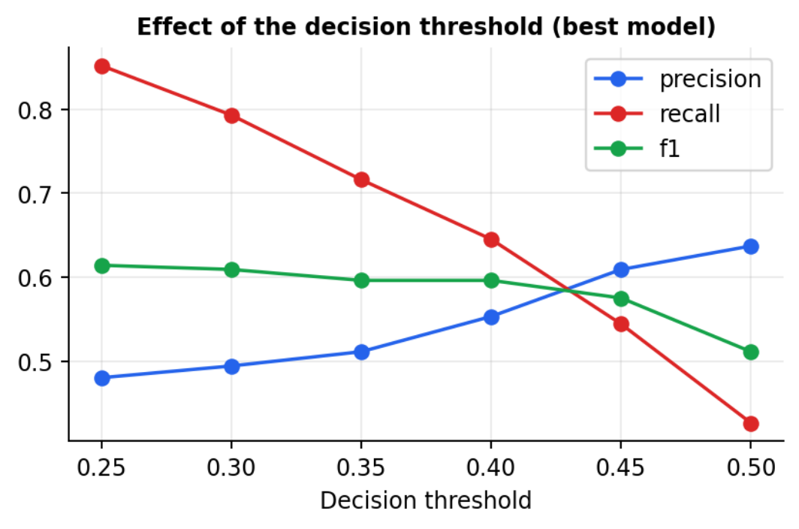
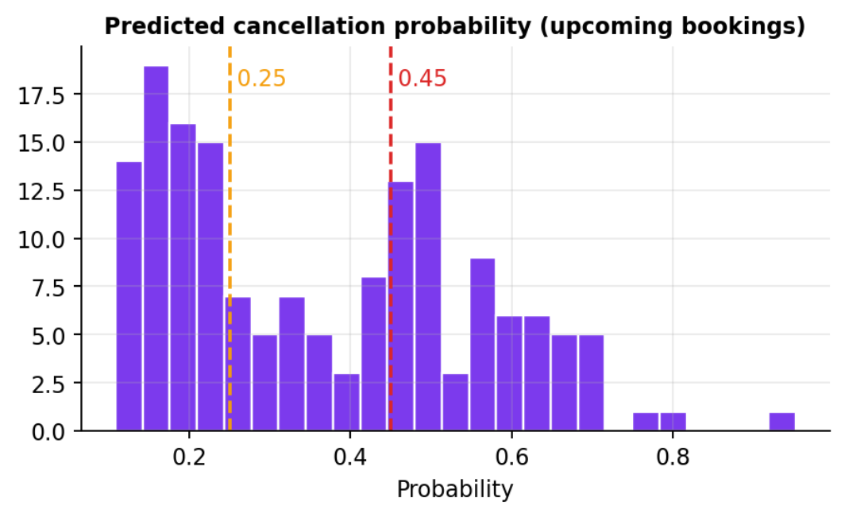
Hotel Booking Analytics & Cancellation Prediction ML Model
Table 18.6: Effect of the threshold on the test set (Logistic Regression)

Threshold | Bookings flagged | Precision | Recall | F1-score
0.25 | 300 | 0.48 | 0.852 | 0.614
0.3 | 271 | 0.494 | 0.793 | 0.609
0.35 | 237 | 0.511 | 0.716 | 0.596
0.4 | 197 | 0.553 | 0.645 | 0.596
0.45 | 151 | 0.609 | 0.544 | 0.575
0.5 | 113 | 0.637 | 0.426 | 0.511
Lowering the threshold from 0.5 to 0.25 raises recall from 0.426 to 0.852 and the F1-score from
0.511 to 0.614, at the cost of lower precision (0.48) and more bookings to review (300 of 459). The
portal therefore does not show a yes/no answer; it converts the probability into three risk levels: Low
(below 0.25), Medium (0.25 to 0.45) and High (0.45 or above). These cut-offs are set in one function
(r i s k _ l e v e l ) and can be changed by the hotel.
To check that the bands are meaningful, they were applied to the test-set predictions and compared
with what actually happened:
Table 18.7: Actual cancellation rate inside each risk band (test set)

Risk level | Test bookings | Actually cancelled
Low | 159 | 15.7 %
Medium | 149 | 34.9 %
High | 151 | 60.9 %
The actual cancellation rate increases from 15.7 % in the Low band to 34.9 % in the Medium band and
60.9 % in the High band, so the ranking is useful in practice even though the yes/no accuracy is mod-
est.
Figure 18.4: Effect of the threshold, and probabilities of the upcoming bookings
18.7 Scoring the upcoming bookings
After training, the 164 bookings that are still Confirmed were scored. The predicted probabilities
range from 0.108 to 0.952 with a mean of 0.367. 64 bookings were rated High, 34 Medium and 66
Low. Each result was stored in the predictions table with the model name and the time stamp. The
saved model file (best_model.joblib) is 4.1 KB; training both models takes a fraction of a second, so
retraining after new data is cheap.
35

Hotel Booking Analytics & Cancellation Prediction Modules
CHAPTER 19
Modules
The portal consists of the seven modules required by the project brief. Each module has its own
routes, template(s) and, where needed, a service function.
Table 19.1: Modules of the portal

Module | What it does | Main files / functions
1. Hotel / Room  management | List rooms; admin adds rooms, changes price  and status (Available / Maintenance), deletes  unused rooms; rooms with bookings cannot be  deleted | rooms.html; app.rooms,  room_update, room_delete;  db.list_rooms, add_room …
2. Customer  management | Add and list customers with name, country and  type | customers.html; app.customers;  db.add_customer
3. Booking entry | New booking with validation; list with status  filter; cancel / complete; CSV upload | booking_form.html, bookings.html,  upload.html;  services.validate_booking,  import_bookings_csv
4. Revenue analytics | KPIs, revenue by room type, ADR, customer  origin, diagnostic charts, date filter | analytics.html, charts.js;  services.get_analytics,  room_type_report
5. Cancellation  prediction | Train and compare models, save best, score  bookings, risk list, history | prediction.html, history.html;  services.train_models,  predict_bookings
6. Occupancy dashboard | KPI cards, occupancy and cancellation trends,  top risky bookings | dashboard.html;  services._occupancy_monthly
7. Reports | Revenue summary by room type, origin table,  CSV export of bookings | reports.html; app.export_csv
Support: Login /  Register | Authentication, hashed passwords, roles, logout | login.html, register.html; app.login,  register
19.1 Routes
Table 19.2: Routes defined in app.py (extracted from the source file)

URL | Methods | Access | View function
/login | GET,POST | Public | login
/register | GET,POST | Public | register
/logout | GET | Public | logout
/ | GET | Login | dashboard
/rooms | GET,POST | Login | rooms
/rooms//update | POST | Admin | room_update
/rooms//delete | POST | Admin | room_delete
/customers | GET,POST | Login | customers
/bookings | GET | Login | bookings
/bookings/new | GET,POST | Login | booking_new
36

Hotel Booking Analytics & Cancellation Prediction Implementation

URL | Methods | Access | View function
/bookings//status | POST | Login | booking_status
/upload | GET,POST | Login | upload
/analytics | GET | Login | analytics
/api/analytics | GET | Login | api_analytics
/prediction | GET | Login | prediction
/prediction/train | POST | Login | prediction_train
/prediction/run | POST | Login | prediction_run
/prediction/ | POST | Login | prediction_one
/history | GET | Login | history
/reports | GET | Login | reports
/reports/export.csv | GET | Login | export_csv
CHAPTER 20
Implementation
This chapter explains the most important parts of the code. The code shown in the listings is taken di-
rectly from the project files; the complete business-logic file is given in Appendix C.
20.1 Authentication and access control
Passwords are never stored as text: registration stores the Werkzeug hash and login compares with
check_password_hash. The two decorators below protect routes. login_required redirects anonymous
visitors to the login page, admin_required blocks staff users from changing rooms.
Listing 20.1: Access-control decorators (app.py)
d e f l o g i n _ r e q u i r e d ( v i e w ) :
@ w r a p s ( v i e w )
d e f w r a p p e r ( * a r g s , * * k w a r g s ) :
i f " u s e r _ i d " n o t i n s e s s i o n :
r e t u r n r e d i r e c t ( u r l _ f o r ( " l o g i n " ) )
r e t u r n v i e w ( * a r g s , * * k w a r g s )
r e t u r n w r a p p e r
d e f a d m i n _ r e q u i r e d ( v i e w ) :
@ w r a p s ( v i e w )
d e f w r a p p e r ( * a r g s , * * k w a r g s ) :
i f s e s s i o n . g e t ( " r o l e " ) ! = " a d m i n " :
f l a s h ( " O n l y a d m i n s c a n d o t h a t . " , " e r r o r " )
r e t u r n r e d i r e c t ( u r l _ f o r ( " d a s h b o a r d " ) )
r e t u r n v i e w ( * a r g s , * * k w a r g s )
r e t u r n w r a p p e r
20.2 Booking validation
validate_booking returns an error message or the total amount. The same function serves the booking
form and every row of the CSV upload. The overlap query is the one shown in Chapter 14.
37

Hotel Booking Analytics & Cancellation Prediction Implementation
Listing 20.2: Booking validation (services.py)
d e f v a l i d a t e _ b o o k i n g ( r o o m , c h e c k _ i n , c h e c k _ o u t , b o o k i n g _ d a t e , s t a t u s = " C o n f i r m e d " ) :
" " " R e t u r n s ( e r r o r _ m e s s a g e , t o t a l _ a m o u n t ) . e r r o r _ m e s s a g e i s N o n e w h e n e v e r y t h i n g i s f i n e . " " "
c i , c o , b d = p a r s e _ d a t e ( c h e c k _ i n ) , p a r s e _ d a t e ( c h e c k _ o u t ) , p a r s e _ d a t e ( b o o k i n g _ d a t e )
i f n o t ( c i a n d c o a n d b d ) :
r e t u r n " D a t e s m u s t l o o k l i k e Y Y Y Y - M M - D D . " , 0
i f c o < = c i :
r e t u r n " C h e c k - o u t m u s t b e a f t e r c h e c k - i n . " , 0
i f b d > c i :
r e t u r n " B o o k i n g d a t e c a n n o t b e a f t e r c h e c k - i n . " , 0
i f r o o m i s N o n e :
r e t u r n " R o o m n o t f o u n d . " , 0
i f r o o m [ " s t a t u s " ] ! = " A v a i l a b l e " :
r e t u r n f " R o o m { r o o m [ ' r o o m _ n o ' ] } i s u n d e r m a i n t e n a n c e . " , 0
i f s t a t u s ! = " C a n c e l l e d " a n d d b . r o o m _ i s _ b o o k e d ( r o o m [ " r o o m _ i d " ] , c i . i s o f o r m a t ( ) , c o . i s o f o r m a t ( ) ) :
r e t u r n f " R o o m { r o o m [ ' r o o m _ n o ' ] } i s a l r e a d y b o o k e d f o r t h o s e d a t e s . " , 0
r e t u r n N o n e , ( c o - c i ) . d a y s * r o o m [ " p r i c e " ]
20.3 Occupancy calculation
Each non-cancelled booking is expanded into the list of nights it occupies; the nights are counted per
day, the whole date span is filled with zeros for empty days, and the monthly occupancy is nights ÷
(rooms × days in the month). The function is tested on hand-made data (test TC-34).
Listing 20.3: Monthly occupancy (services.py)
d e f _ o c c u p a n c y _ m o n t h l y ( a c t i v e , t o t a l _ r o o m s ) :
" " " O c c u p a n c y % p e r m o n t h = r o o m - n i g h t s s o l d / ( r o o m s x d a y s ) . " " "
i f a c t i v e . e m p t y o r t o t a l _ r o o m s = = 0 :
r e t u r n p d . S e r i e s ( d t y p e = f l o a t ) , 0 . 0
s t a y s = [ p d . d a t e _ r a n g e ( c i , p e r i o d s = n ) f o r c i , n i n z i p ( a c t i v e [ " c h e c k _ i n " ] , a c t i v e [ " n i g h t s " ] ) ]
d a y s = p d . S e r i e s ( n p . c o n c a t e n a t e ( [ s . v a l u e s f o r s i n s t a y s ] ) )
d a i l y = d a y s . v a l u e _ c o u n t s ( ) . s o r t _ i n d e x ( )
d a i l y = d a i l y . r e i n d e x ( p d . d a t e _ r a n g e ( d a i l y . i n d e x . m i n ( ) , d a i l y . i n d e x . m a x ( ) ) , f i l l _ v a l u e = 0 )
m o n t h = d a i l y . i n d e x . t o _ p e r i o d ( " M " )
n i g h t s = d a i l y . g r o u p b y ( m o n t h ) . s u m ( )
n _ d a y s = d a i l y . g r o u p b y ( m o n t h ) . s i z e ( )
o c c = ( n i g h t s / ( n _ d a y s * t o t a l _ r o o m s ) * 1 0 0 ) . c l i p ( u p p e r = 1 0 0 ) . r o u n d ( 1 )
o v e r a l l = r o u n d ( 1 0 0 * d a i l y . s u m ( ) / ( l e n ( d a i l y ) * t o t a l _ r o o m s ) , 1 )
r e t u r n o c c , o v e r a l l
20.4 Training and selecting the model
train_models builds the dataset, splits it, trains both candidates through the same preprocessing pipe-
line, measures the metrics on the test set, keeps the model with the best F1-score and stores the model
and a JSON file with all metrics. The metrics file is what the Prediction page displays.
38

Hotel Booking Analytics & Cancellation Prediction Implementation
Listing 20.4: Model training and comparison (services.py)
d e f t r a i n _ m o d e l s ( ) :
" " " T r a i n 2 m o d e l s o n b o o k i n g s w i t h a k n o w n o u t c o m e , c o m p a r e t h e m , s a v e t h e b e s t o n e . " " "
d f = b o o k i n g s _ d f ( )
d f = d f [ d f [ " b o o k i n g _ s t a t u s " ] . i s i n ( [ " C a n c e l l e d " , " C o m p l e t e d " ] ) ]
i f l e n ( d f ) < 1 0 0 o r d f [ " c a n c e l l e d " ] . n u n i q u e ( ) < 2 :
r a i s e V a l u e E r r o r ( " N e e d a t l e a s t 1 0 0 f i n i s h e d b o o k i n g s ( c a n c e l l e d + c o m p l e t e d ) t o t r a i n . " )
X _ t r a i n , X _ t e s t , y _ t r a i n , y _ t e s t = t r a i n _ t e s t _ s p l i t (
d f [ F E A T U R E S ] , d f [ " c a n c e l l e d " ] , t e s t _ s i z e = 0 . 2 5 , r a n d o m _ s t a t e = 4 2 , s t r a t i f y = d f [ " c a n c e l l e d " ] )
# s c a l e n u m b e r s , o n e - h o t e n c o d e t e x t c o l u m n s
d e f m a k e _ p i p e l i n e ( m o d e l ) :
p r e p = C o l u m n T r a n s f o r m e r ( [ ( " n u m " , S t a n d a r d S c a l e r ( ) , N U M _ F E A T U R E S ) ,
( " c a t " , O n e H o t E n c o d e r ( h a n d l e _ u n k n o w n = " i g n o r e " ) , C A T _ F E A T U R E S ) ] )
r e t u r n P i p e l i n e ( [ ( " p r e p " , p r e p ) , ( " m o d e l " , m o d e l ) ] )
c a n d i d a t e s = {
" L o g i s t i c R e g r e s s i o n " : L o g i s t i c R e g r e s s i o n ( m a x _ i t e r = 1 0 0 0 ) ,
" R a n d o m F o r e s t " : R a n d o m F o r e s t C l a s s i f i e r ( n _ e s t i m a t o r s = 1 5 0 , m i n _ s a m p l e s _ l e a f = 5 , r a n d o m _ s t a t e = 4 2 ) ,
}
r e s u l t s , f i t t e d = [ ] , { }
f o r n a m e , m o d e l i n c a n d i d a t e s . i t e m s ( ) :
p i p e = m a k e _ p i p e l i n e ( m o d e l ) . f i t ( X _ t r a i n , y _ t r a i n )
p r e d = p i p e . p r e d i c t ( X _ t e s t )
r e s u l t s . a p p e n d ( {
" n a m e " : n a m e ,
" a c c u r a c y " : r o u n d ( a c c u r a c y _ s c o r e ( y _ t e s t , p r e d ) , 3 ) ,
" p r e c i s i o n " : r o u n d ( p r e c i s i o n _ s c o r e ( y _ t e s t , p r e d , z e r o _ d i v i s i o n = 0 ) , 3 ) ,
" r e c a l l " : r o u n d ( r e c a l l _ s c o r e ( y _ t e s t , p r e d , z e r o _ d i v i s i o n = 0 ) , 3 ) ,
" f 1 " : r o u n d ( f 1 _ s c o r e ( y _ t e s t , p r e d , z e r o _ d i v i s i o n = 0 ) , 3 ) ,
" c o n f u s i o n _ m a t r i x " : c o n f u s i o n _ m a t r i x ( y _ t e s t , p r e d ) . t o l i s t ( ) , # [ [ T N , F P ] , [ F N , T P ] ]
} )
f i t t e d [ n a m e ] = p i p e
b e s t = m a x ( r e s u l t s , k e y = l a m b d a r : r [ " f 1 " ] )
o s . m a k e d i r s ( M O D E L _ D I R , e x i s t _ o k = T r u e )
j o b l i b . d u m p ( f i t t e d [ b e s t [ " n a m e " ] ] , M O D E L _ P A T H )
i n f o = { " b e s t " : b e s t [ " n a m e " ] , " r e s u l t s " : r e s u l t s , " t r a i n _ r o w s " : l e n ( X _ t r a i n ) ,
" t e s t _ r o w s " : l e n ( X _ t e s t ) , " t r a i n e d _ a t " : d a t e t i m e . n o w ( ) . s t r f t i m e ( " % Y - % m - % d % H : % M " ) }
w i t h o p e n ( M E T R I C S _ P A T H , " w " ) a s f :
j s o n . d u m p ( i n f o , f , i n d e n t = 2 )
r e t u r n i n f o
20.5 Predicting and storing the history
predict_bookings loads the saved pipeline, computes the probability of each requested booking and in-
serts one row per booking into the predictions table together with the model name; the time stamp is
added by the database at insertion. Old predictions are never overwritten, so the table is a complete
history.
Listing 20.5: Prediction and risk level (services.py, db.py)
d e f p r e d i c t _ b o o k i n g s ( b o o k i n g _ i d s ) :
" " " S c o r e b o o k i n g s a n d s t o r e e v e r y r e s u l t ( w i t h t i m e s t a m p ) i n t h e p r e d i c t i o n s t a b l e . " " "
i n f o = l o a d _ m e t r i c s ( )
i f n o t i n f o o r n o t o s . p a t h . e x i s t s ( M O D E L _ P A T H ) :
r a i s e V a l u e E r r o r ( " N o t r a i n e d m o d e l y e t . T r a i n t h e m o d e l f i r s t . " )
p i p e = j o b l i b . l o a d ( M O D E L _ P A T H )
d f = b o o k i n g s _ d f ( )
d f = d f [ d f [ " b o o k i n g _ i d " ] . i s i n ( b o o k i n g _ i d s ) ]
i f d f . e m p t y :
r e t u r n 0
p r o b s = p i p e . p r e d i c t _ p r o b a ( d f [ F E A T U R E S ] ) [ : , 1 ]
f o r b i d , p i n z i p ( d f [ " b o o k i n g _ i d " ] , p r o b s ) :
d b . s a v e _ p r e d i c t i o n ( i n t ( b i d ) , r o u n d ( f l o a t ( p ) , 4 ) , r i s k _ l e v e l ( p ) , i n f o [ " b e s t " ] )
r e t u r n l e n ( d f )
d e f r i s k _ l e v e l ( p ) :
r e t u r n " L o w " i f p < 0 . 2 5 e l s e " M e d i u m " i f p < 0 . 4 5 e l s e " H i g h "
d e f s a v e _ p r e d i c t i o n ( b o o k i n g _ i d , p r o b a b i l i t y , r i s k , m o d e l _ n a m e ) :
e x e c u t e ( " " " I N S E R T I N T O p r e d i c t i o n s ( b o o k i n g _ i d , c a n c e l l a t i o n _ p r o b a b i l i t y , r i s k _ l e v e l , m o d e l _ n a m e ,
c r e a t e d _ a t )
V A L U E S ( ? , ? , ? , ? , d a t e t i m e ( ' n o w ' ) ) " " " , ( b o o k i n g _ i d , p r o b a b i l i t y , r i s k , m o d e l _ n a m e ) )
39

Hotel Booking Analytics & Cancellation Prediction Implementation
20.6 Safe file upload
The upload route accepts only .csv files, the 2 MB limit is enforced by Flask's
MAX_CONTENT_LENGTH setting, and the stored name is a time stamp plus the sanitised original
name (secure_filename), so a name such as ../../evil.csv cannot escape the uploads folder (test TC-29).
After saving, the file content is validated row by row.
Listing 20.6: Upload route (app.py)
@ a p p . r o u t e ( " / u p l o a d " , m e t h o d s = [ " G E T " , " P O S T " ] )
@ l o g i n _ r e q u i r e d
d e f u p l o a d ( ) :
r e s u l t = N o n e
i f r e q u e s t . m e t h o d = = " P O S T " :
f i l e = r e q u e s t . f i l e s . g e t ( " f i l e " )
i f n o t f i l e o r f i l e . f i l e n a m e = = " " :
f l a s h ( " P l e a s e c h o o s e a f i l e . " , " e r r o r " )
e l i f n o t f i l e . f i l e n a m e . l o w e r ( ) . e n d s w i t h ( " . c s v " ) :
f l a s h ( " O n l y . c s v f i l e s a r e a l l o w e d . " , " e r r o r " )
e l s e :
s a f e = d a t e t i m e . n o w ( ) . s t r f t i m e ( " % Y % m % d % H % M % S _ " ) + s e c u r e _ f i l e n a m e ( f i l e . f i l e n a m e )
p a t h = o s . p a t h . j o i n ( U P L O A D _ D I R , s a f e )
f i l e . s a v e ( p a t h )
r e s u l t = s e r v i c e s . i m p o r t _ b o o k i n g s _ c s v ( p a t h )
f l a s h ( f " { r e s u l t [ 0 ] } b o o k i n g s i m p o r t e d . " , " s u c c e s s " i f r e s u l t [ 0 ] e l s e " e r r o r " )
r e t u r n r e n d e r _ t e m p l a t e ( " u p l o a d . h t m l " , r e s u l t = r e s u l t )
20.7 Interactive charts
One JavaScript function requests the JSON from /api/analytics, optionally with a start and end date,
and redraws all charts and KPI cards. Because the page is not reloaded, filtering feels immediate. The
same function is used by the dashboard and the analytics page.
Listing 20.7: Chart rendering (static/charts.js, abridged)
c o n s t C O L O R S = [ ' # 2 5 6 3 e b ' , ' # 1 6 a 3 4 a ' , ' # f 5 9 e 0 b ' , ' # d c 2 6 2 6 ' , ' # 7 c 3 a e d ' , ' # 0 8 9 1 b 2 ' , ' # d b 2 7 7 7 ' , ' # 6 5 a 3 0 d ' ] ;
c o n s t c h a r t s = { } ;
. . .
f u n c t i o n r e n d e r A l l ( d ) {
c o n s t k = d . k p i s ;
s e t K p i ( ' t o t a l _ b o o k i n g s ' , k . t o t a l _ b o o k i n g s . t o L o c a l e S t r i n g ( ) ) ;
s e t K p i ( ' c a n c e l _ r a t e ' , k . c a n c e l _ r a t e + ' % ' ) ;
s e t K p i ( ' r e v e n u e ' , ' $ ' + k . r e v e n u e . t o L o c a l e S t r i n g ( ) ) ;
s e t K p i ( ' a d r ' , ' $ ' + k . a d r ) ;
s e t K p i ( ' o c c u p a n c y ' , k . o c c u p a n c y + ' % ' ) ;
s e t K p i ( ' a v g _ l e a d _ t i m e ' , k . a v g _ l e a d _ t i m e + ' d a y s ' ) ;
d r a w C h a r t ( ' c h a r t - o c c u p a n c y ' , ' l i n e ' , d . o c c u p a n c y , ' O c c u p a n c y % ' ) ;
d r a w C h a r t ( ' c h a r t - c a n c e l - t r e n d ' , ' l i n e ' , d . c a n c e l _ t r e n d , ' C a n c e l l a t i o n % ' ) ;
d r a w C h a r t ( ' c h a r t - r e v e n u e ' , ' b a r ' , d . r e v e n u e _ r o o m , ' R e v e n u e ' ) ;
d r a w C h a r t ( ' c h a r t - o r i g i n ' , ' d o u g h n u t ' , d . o r i g i n , ' B o o k i n g s ' ) ;
d r a w C h a r t ( ' c h a r t - c a n c e l - l e a d ' , ' b a r ' , d . c a n c e l _ l e a d , ' C a n c e l l a t i o n % ' ) ;
d r a w C h a r t ( ' c h a r t - c a n c e l - t y p e ' , ' b a r ' , d . c a n c e l _ t y p e , ' C a n c e l l a t i o n % ' ) ;
}
a s y n c f u n c t i o n l o a d A n a l y t i c s ( s t a r t , e n d ) {
c o n s t p a r a m s = n e w U R L S e a r c h P a r a m s ( ) ;
i f ( s t a r t ) p a r a m s . a p p e n d ( ' s t a r t ' , s t a r t ) ;
i f ( e n d ) p a r a m s . a p p e n d ( ' e n d ' , e n d ) ;
c o n s t r e s p o n s e = a w a i t f e t c h ( ' / a p i / a n a l y t i c s ? ' + p a r a m s . t o S t r i n g ( ) ) ;
r e n d e r A l l ( a w a i t r e s p o n s e . j s o n ( ) ) ;
}
40

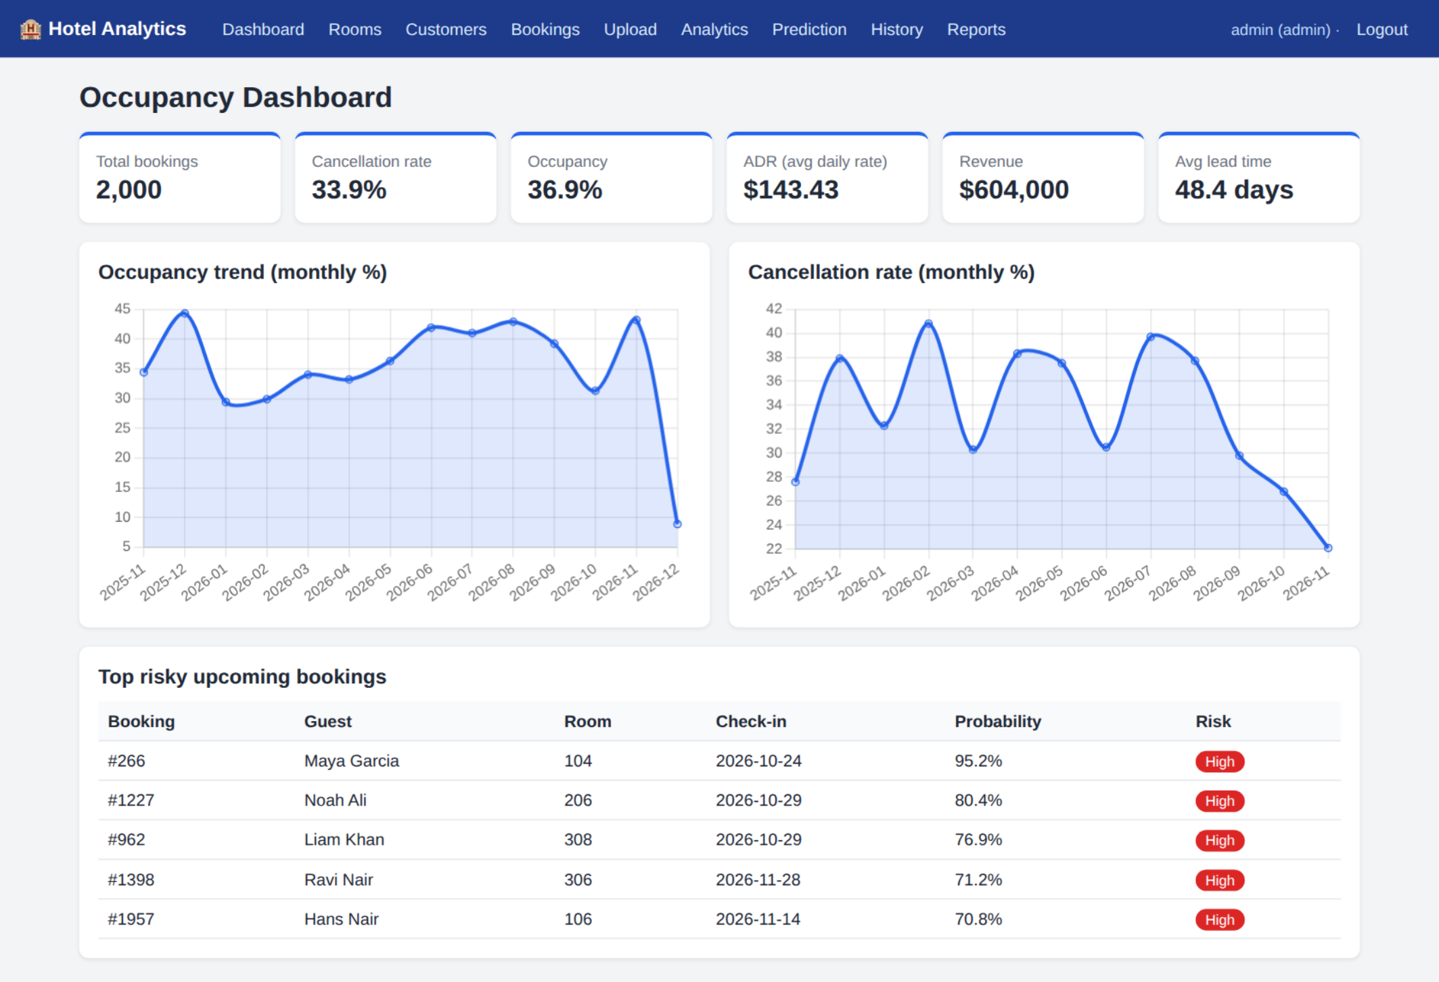
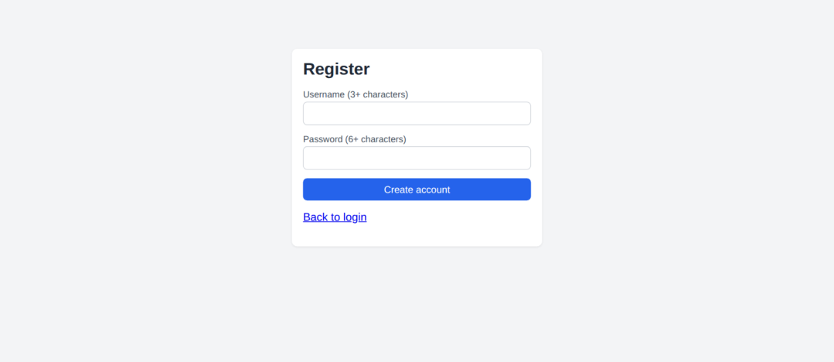
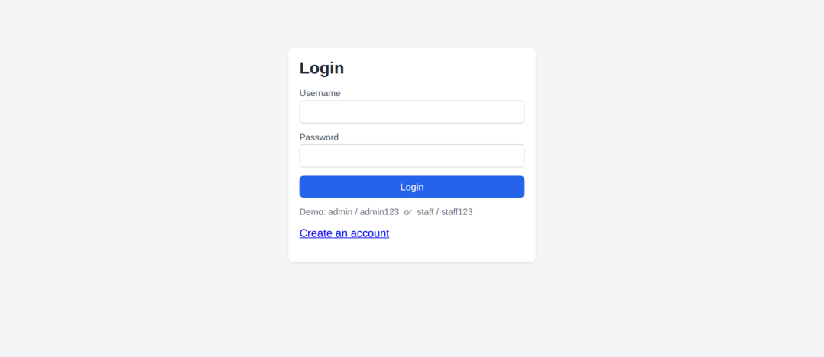
Hotel Booking Analytics & Cancellation Prediction Screenshots
CHAPTER 21
Screenshots
All screenshots were taken from the running application (Chromium browser, 1200 px wide window)
on the demonstration database. The user logged in as admin. They show real values of the dataset de-
scribed in Chapter 16.
Figure 21.1: Login page (left) and registration page (right)
The login page validates the credentials and shows an error for a wrong password. The registration
page creates a staff account when the username is free and the password has at least six characters.
Figure 21.2: Occupancy dashboard with KPI cards, trend charts and the top risky bookings
The dashboard loads its KPIs and charts through one fetch call. The table below the charts shows the
five highest-risk upcoming bookings from the latest predictions.
41

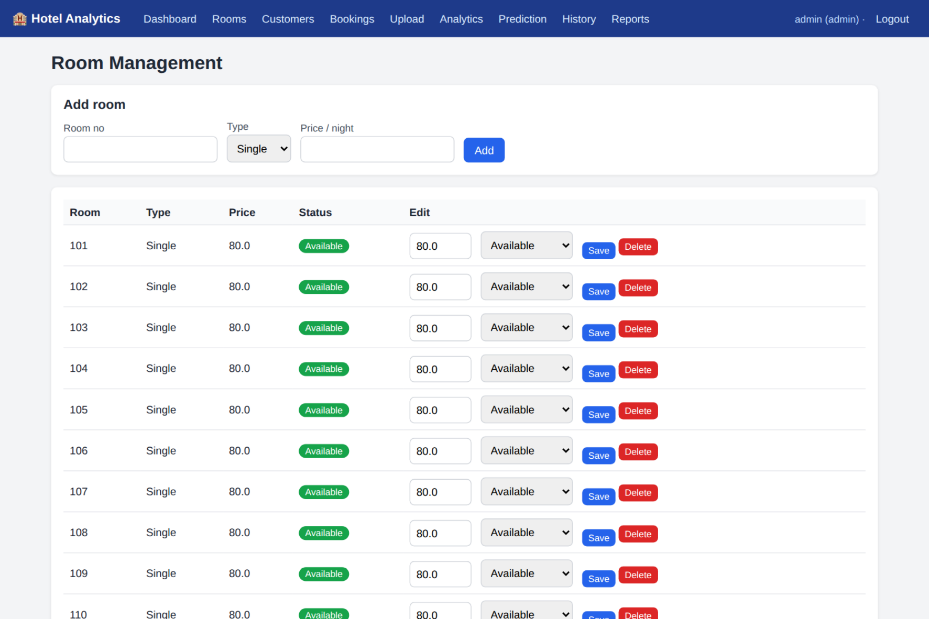
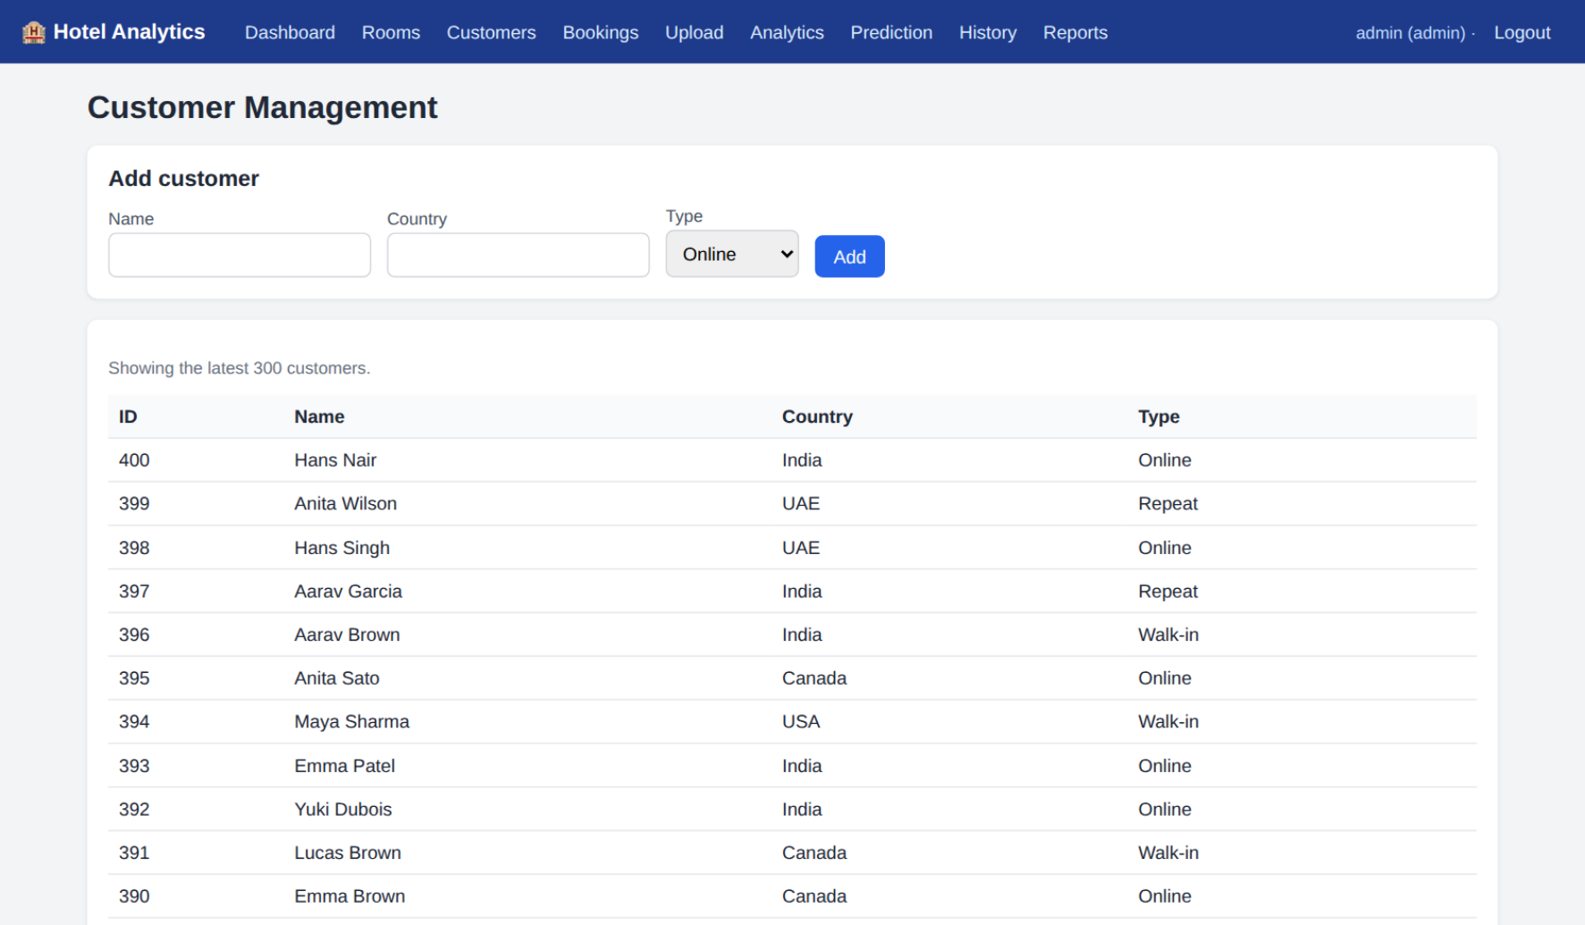
Hotel Booking Analytics & Cancellation Prediction Screenshots
Figure 21.3: Room management (admin view with add form and edit controls)
Figure 21.4: Customer management
42

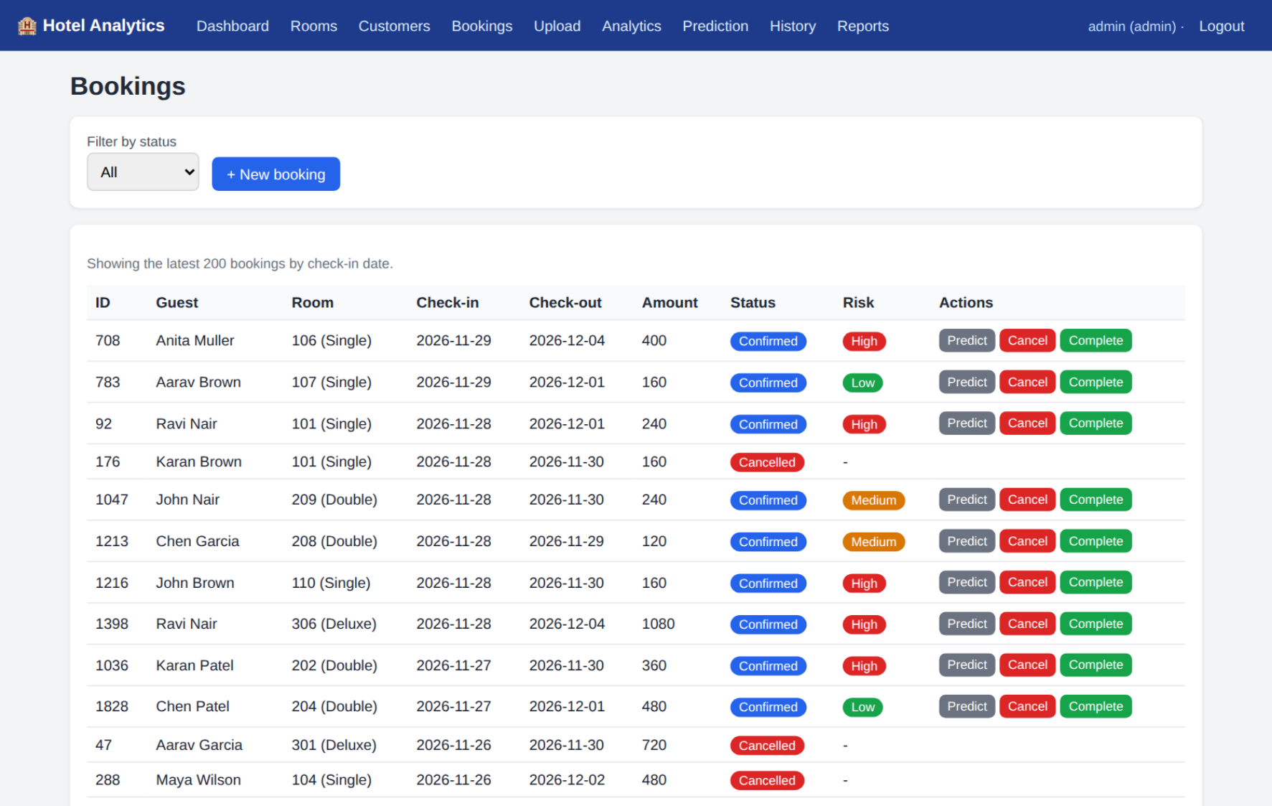
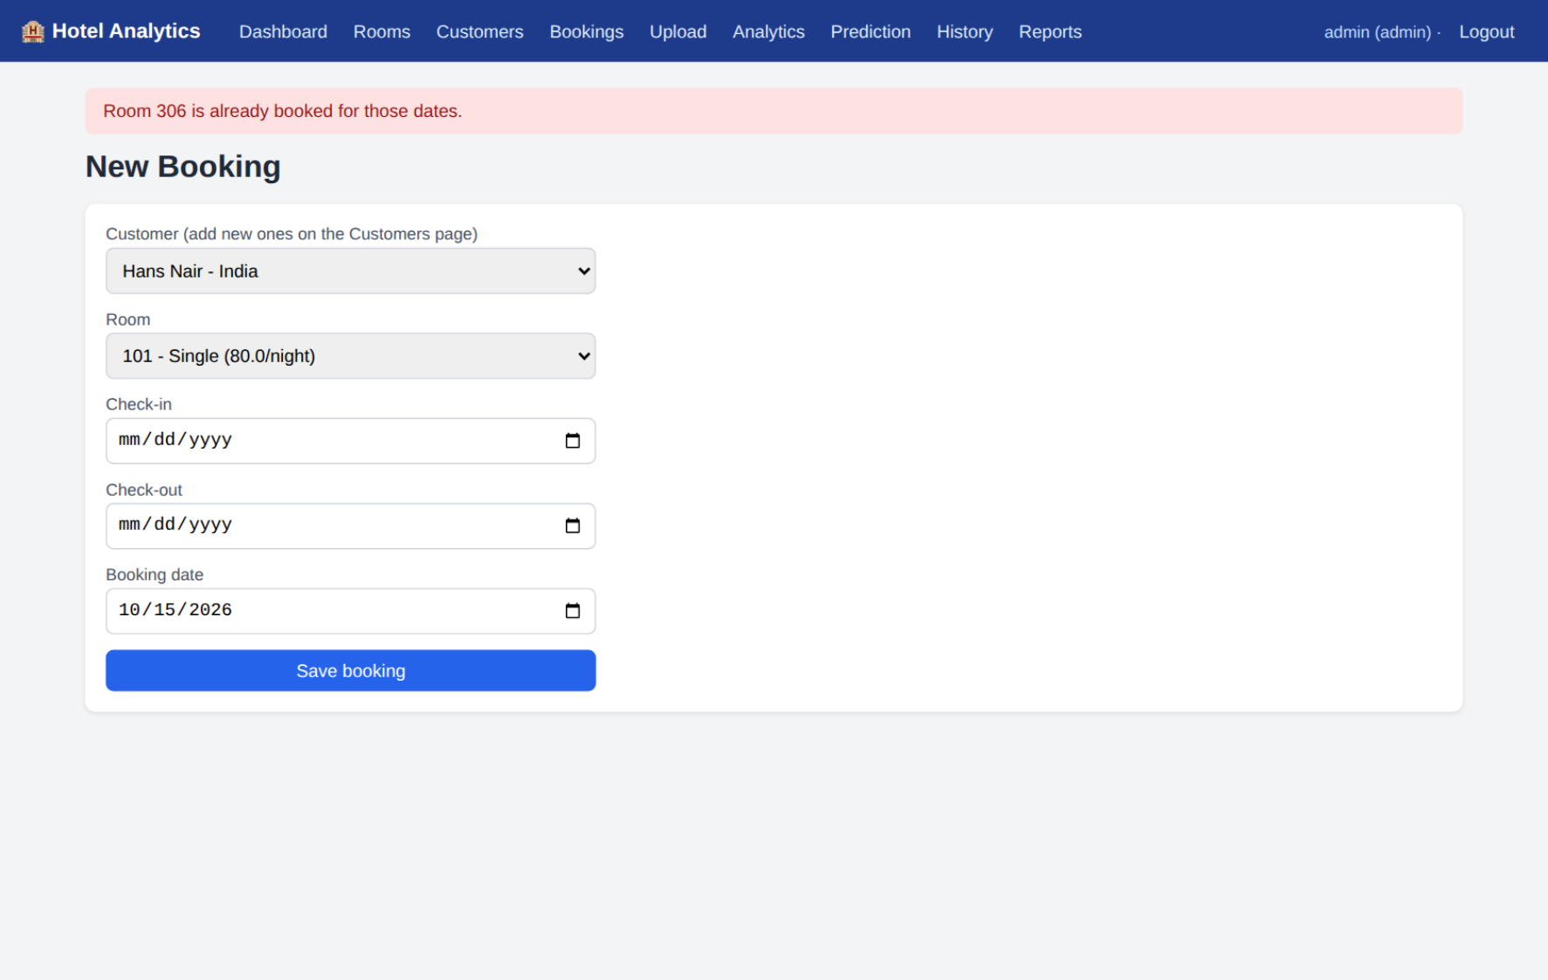
Hotel Booking Analytics & Cancellation Prediction Screenshots
Figure 21.5: Booking list with status filter, risk badges and action buttons
Confirmed bookings have Predict, Cancel and Complete buttons. The Risk column shows the latest
stored prediction.
Figure 21.6: Booking form rejecting an overlapping booking
A booking was submitted for a room and dates that already have a confirmed booking. The system re-
fused it with the message 'already booked' and saved nothing.
43

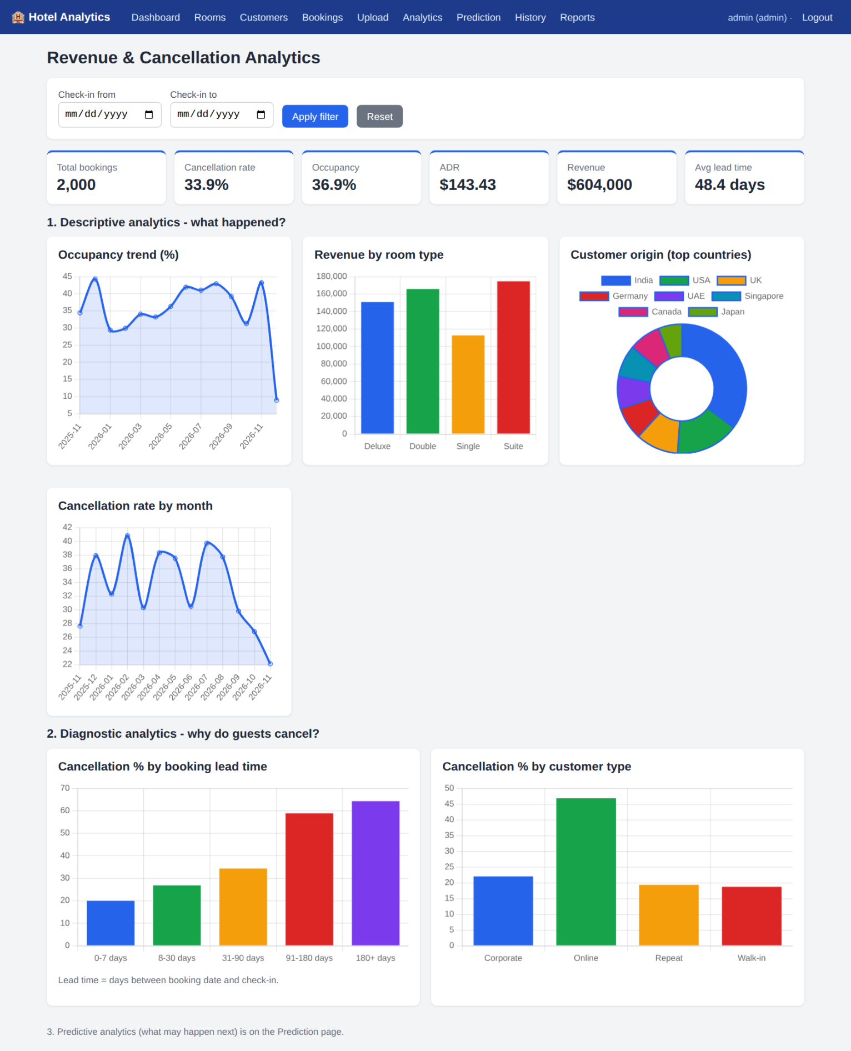
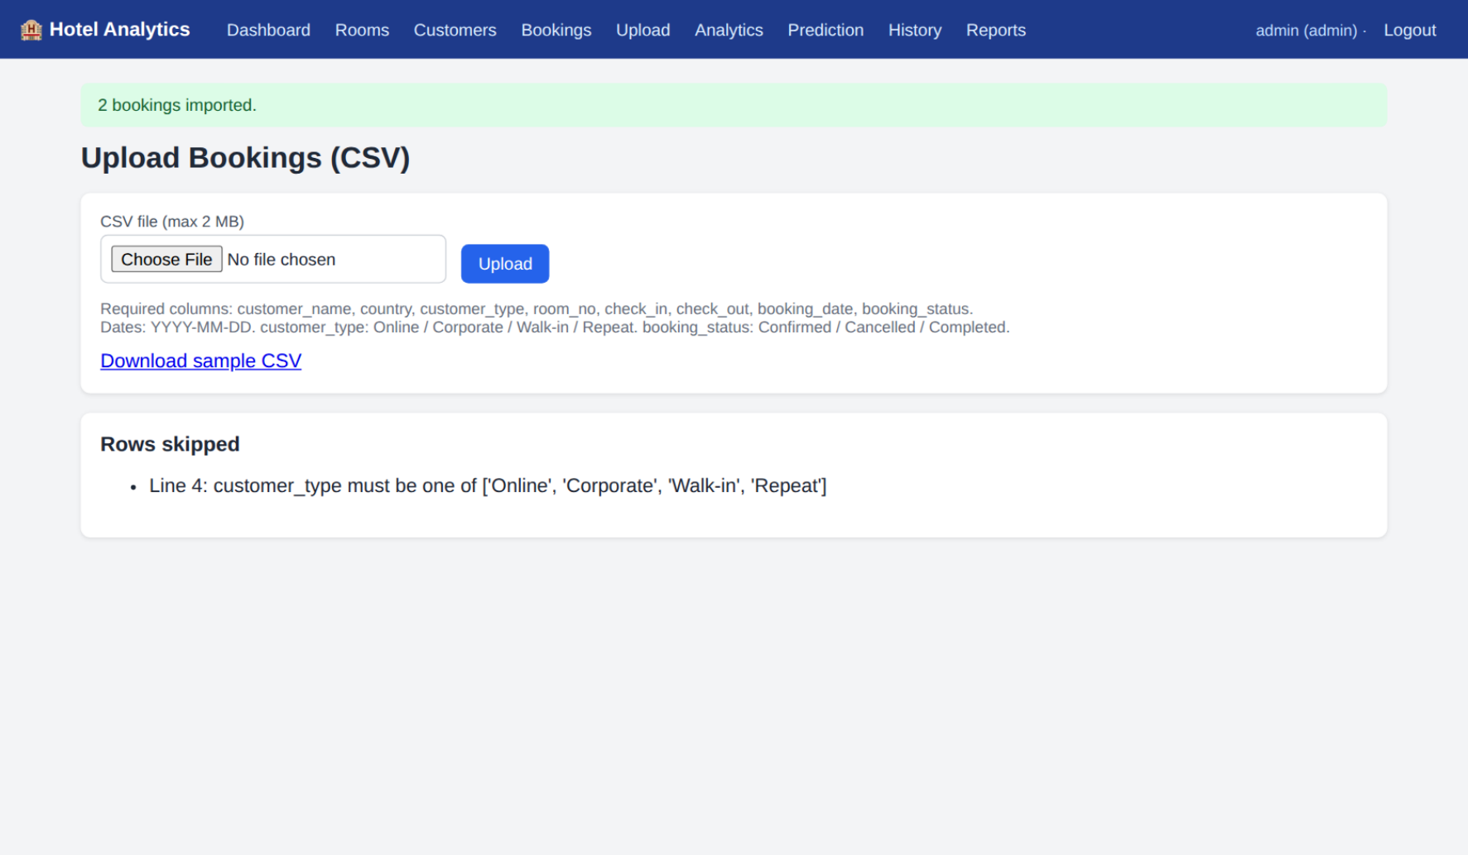
Hotel Booking Analytics & Cancellation Prediction Screenshots
Figure 21.7: CSV upload: rows imported and the rejected row reported
The uploaded sample file contains three rows: two valid rows were imported and the row with the in-
valid customer type 'Vacation' was skipped and listed.
Figure 21.8: Analytics page: descriptive and diagnostic charts (no filter)
44

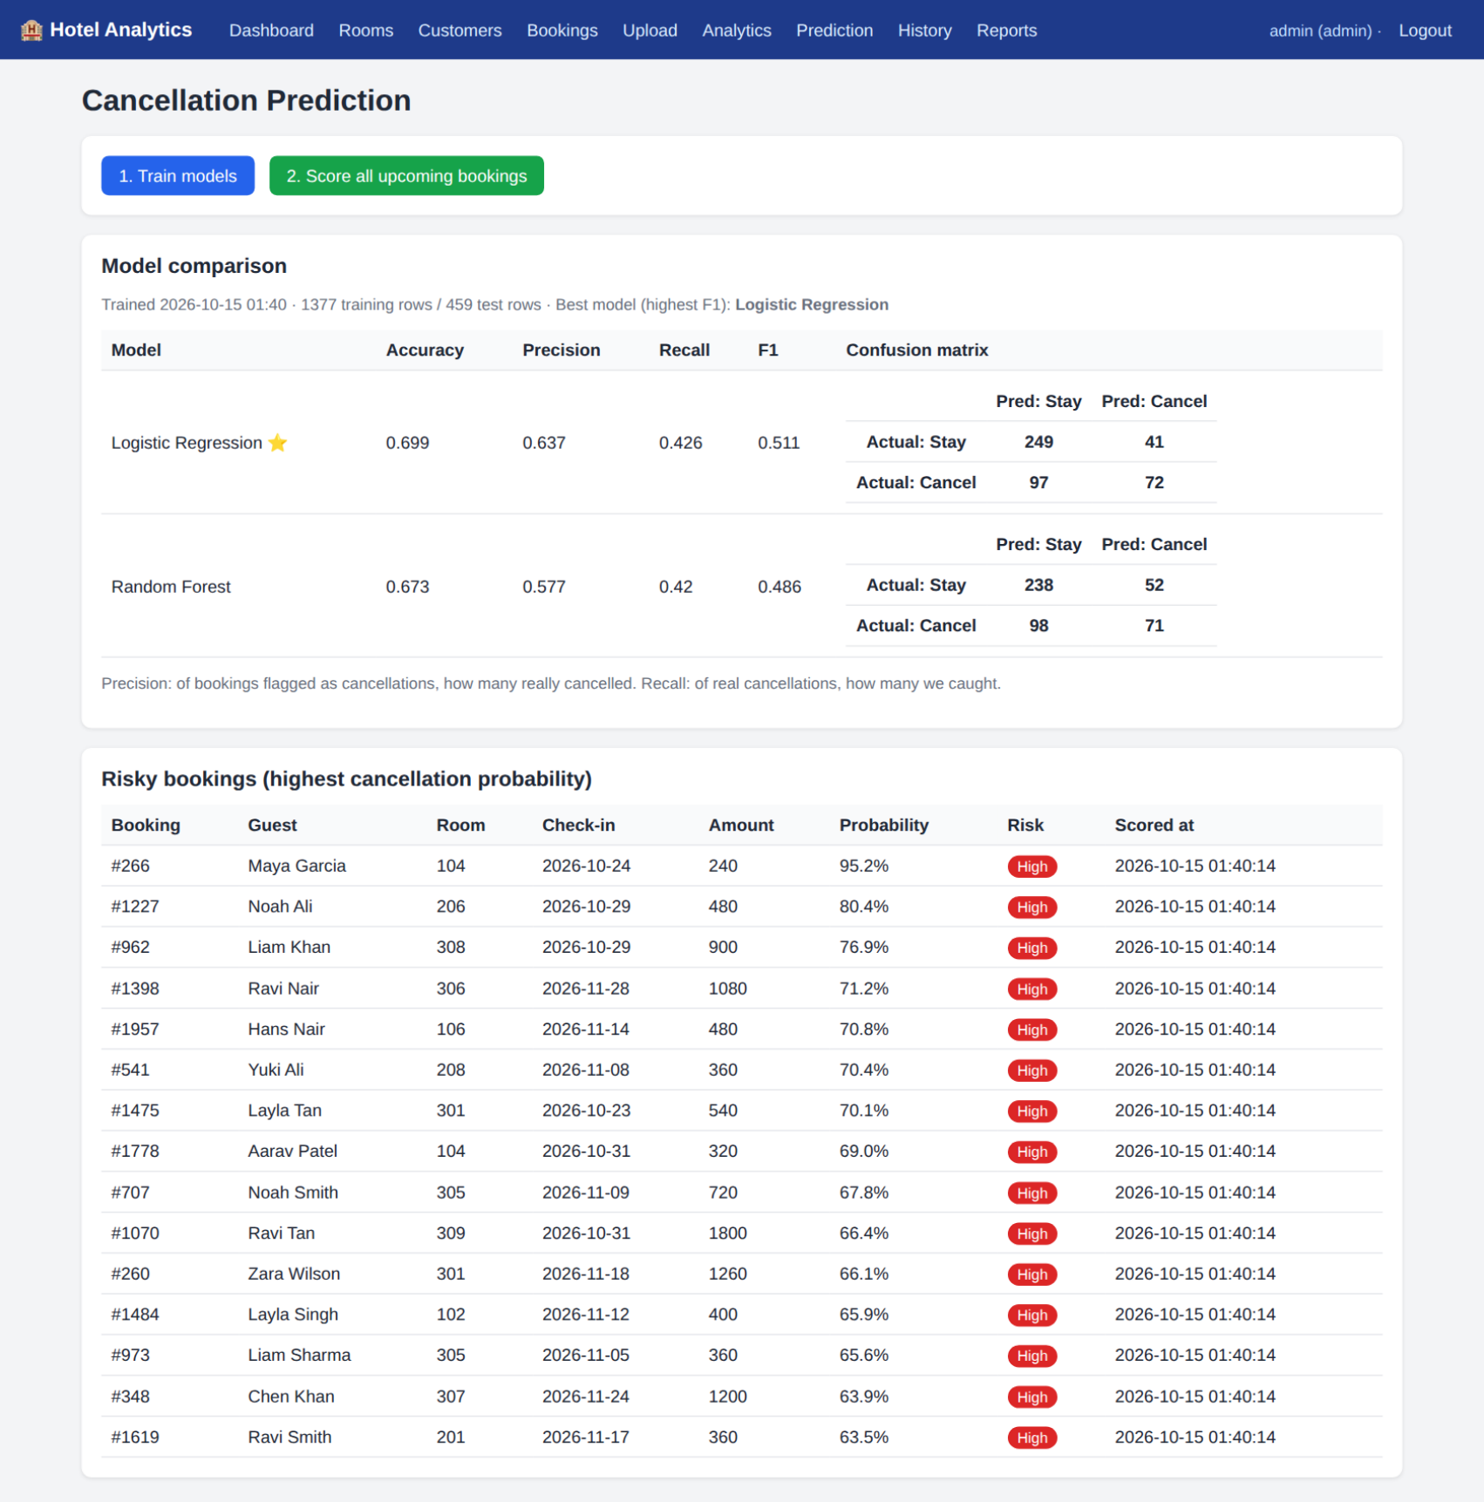
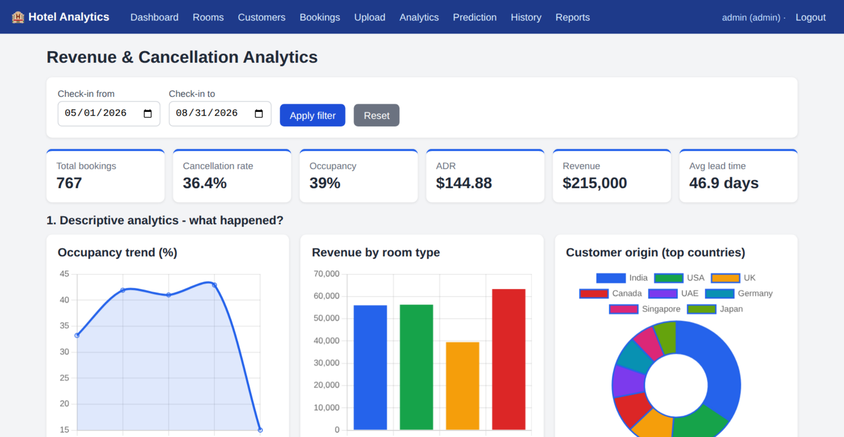
Hotel Booking Analytics & Cancellation Prediction Screenshots
Figure 21.9: Analytics page after applying the date filter 2026-05-01 to 2026-08-31 (upper part)
After pressing Apply filter, the KPIs and every chart were redrawn for the selected period without
reloading the page.
Figure 21.10: Prediction page: model comparison, confusion matrices and the risky bookings list
45

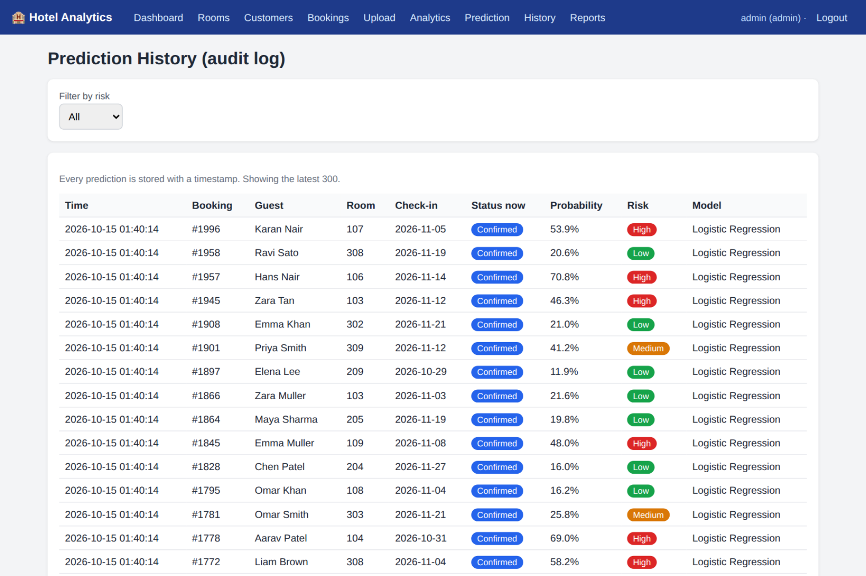
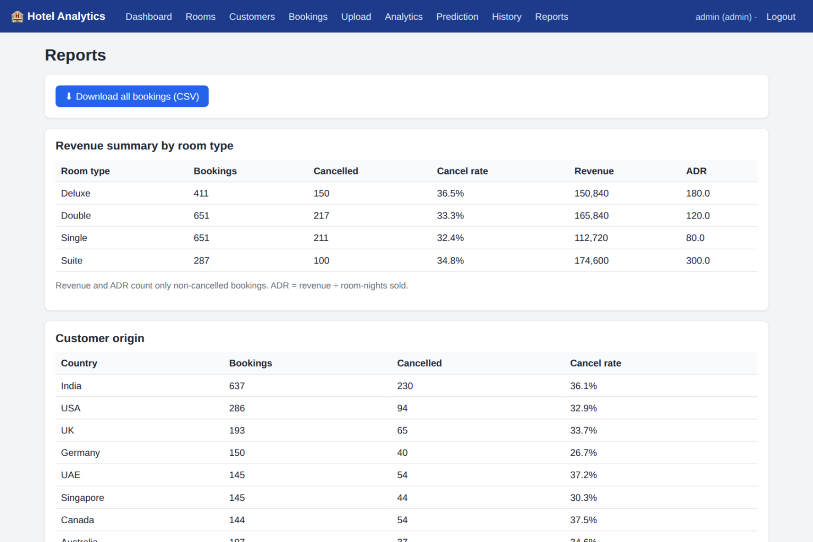
Hotel Booking Analytics & Cancellation Prediction Screenshots
Figure 21.11: Prediction history (time-stamped audit log)
Figure 21.12: Reports page: revenue by room type and customer origin
46

Hotel Booking Analytics & Cancellation Prediction Testing
CHAPTER 22
Testing
22.1 Test strategy
Testing was automated so that it can be repeated after every change. The tests are written with
Python's unittest module in t e s t s / t e s t _ a p p . p y . Each test creates its own temporary database, model
folder and upload folder through environment variables, so the real data are never touched. Most tests
use Flask's test client, which sends real HTTP requests to the application without a browser; some call
the service functions directly.
• Functional tests: login, rooms, customers, bookings, upload, reports.
• Validation and boundary tests: wrong dates, overlap, back-to-back stays, maintenance rooms,
empty fields, missing columns.
• Security tests: SQL-injection text, anonymous access, role restriction, hashed password storage,
dangerous file name and extension, file-size limit.
• Analytics correctness tests: KPIs compared with independent SQL calculations; the occupancy
formula on hand-made data.
• Machine-learning tests: training, metric validity, prediction storage with time stamp, risk levels,
missing-model error.
• Performance test: response time of the analytics API.
22.2 Result summary
Table 22.1: Automated test results by module

Module | Tests | Passed | Failed
Authentication | 8 | 8 | 0
Rooms | 5 | 5 | 0
Customers | 2 | 2 | 0
Booking | 9 | 9 | 0
Upload | 5 | 5 | 0
Analytics | 6 | 6 | 0
ML | 6 | 6 | 0
Reports | 1 | 1 | 0
Pages | 1 | 1 | 0
Performance | 1 | 1 | 0
Total | 44 | 44 | 0
All 44 tests passed (0 failures, 0 errors); the complete run took 4.78 seconds. The test cases with the
observed result of each test are listed below. The 'Actual result' column is the value recorded by the
test while it ran (it is saved in tests/test_log.json), not a hand-written statement.
47

Hotel Booking Analytics & Cancellation Prediction Testing
Table 22.2: Test cases, expected and actual results

ID | Test case | Expected result | Actual result | Status
TC-01 | Login with valid admin  credentials | HTTP 302 redirect to  dashboard | HTTP 302, Location=/ | PASS
TC-02 | Login with wrong password | HTTP 200, error message  shown, no session | HTTP 200, error shown=True | PASS
TC-03 | SQL-injection string in  username field | Login rejected  (parameterised query) | HTTP 200, rejected=True | PASS
TC-04 | Open dashboard without  logging in | Redirect to /login | HTTP 302, Location=/login | PASS
TC-05 | Register new user with valid  data | Account created, password  stored hashed, role = staff | HTTP 302, role=staff,  hash_prefix=scrypt:,  plaintext_stored=False | PASS
TC-06 | Register with password  shorter than 6 characters | Rejected with message, no  row created | HTTP 200, rows created=0 | PASS
TC-07 | Register with an existing  username | Rejected: username is  taken | HTTP 200, message shown=True | PASS
TC-08 | Logout clears the session | Dashboard redirects to  login after logout | HTTP 302 after logout | PASS
TC-09 | Staff user tries to add a room | Blocked: only admins can  add rooms | message shown=True, rooms  created=0 | PASS
TC-10 | Admin adds a new room | Room saved in database | row=[('Suite', 320.0, 'Available')] | PASS
TC-11 | Admin adds a room with  duplicate room number | Rejected (UNIQUE  constraint), no crash | HTTP 200, copies in table=1 | PASS
TC-12 | Admin deletes a room that  has bookings | Blocked by foreign key,  room remains | rooms before=31, after=31 | PASS
TC-13 | Admin sets a room to  Maintenance and updates  price | Status and price updated | row=[(350.0, 'Maintenance')] | PASS
TC-14 | Add customer with valid  details | Customer row inserted | rows found=1 | PASS
TC-15 | Add customer with empty  name | Rejected with message | message shown=True | PASS
TC-16 | Create valid booking (2  nights) | Saved; total = nights x  room price | price/night=80.0, stored  total=160.0, status=Confirmed | PASS
TC-17 | Check-out earlier than  check-in | Rejected with message | message shown=True | PASS
TC-18 | Overlapping dates on an  already booked room | Rejected: already booked | message shown=True, rows  inserted=0 | PASS
TC-19 | Back-to-back stay (new  check-in = previous  check-out) | Accepted (no overlap) | rows inserted=1 | PASS
TC-20 | Book a room under  maintenance | Rejected: under  maintenance | message shown=True | PASS
TC-21 | Booking date after check-in  date | Rejected with message | message 'Booking date cannot be  after check-in' shown | PASS
TC-22 | Cancel a confirmed booking | Status becomes Cancelled | status=Cancelled | PASS
48

Hotel Booking Analytics & Cancellation Prediction Testing

ID | Test case | Expected result | Actual result | Status
TC-23 | Cancelled dates can be  re-booked | Accepted (cancelled stays  do not block) | confirmed rows for that date=1 | PASS
TC-24 | Status filter on booking list | Only Cancelled bookings  shown | HTTP 200, 'Confirmed' badges in  page=0 | PASS
TC-25 | Upload CSV with 2 valid  rows and 1 invalid  customer_type | 2 rows imported, 1 error  listed | '2 bookings imported'=True, error  listed=True, customers created=2 | PASS
TC-26 | Upload a file with .exe  extension | Rejected: only .csv  allowed | message shown=True | PASS
TC-27 | Upload CSV missing required  columns | Rejected with list of  missing columns | message shown=True | PASS
TC-28 | Upload file larger than 2 MB  limit | HTTP 413 Request Entity  Too Large | HTTP 413 | PASS
TC-29 | Filename with path traversal  characters | Stored under a sanitised  name inside uploads folder | stored names containing '..' or '/':  0;  sample=20261015015148_bad.csv | PASS
TC-30 | Analytics API returns all  chart series and KPIs | JSON has kpis + 6 series | keys=['cancel_lead',  'cancel_trend', 'cancel_type',  'kpis', 'occupancy', 'origin',  'revenue_room'] | PASS
TC-31 | KPI values match direct SQL  calculation | Cancellation rate and  bookings equal SQL result | API: 2005 bookings, 33.9% | SQL:  2005 bookings, 33.9% | PASS
TC-32 | Date filter narrows the data | Filtered bookings < all  bookings | all=2005, June-2026 only=190 | PASS
TC-33 | Date filter with no matching  bookings | Empty series, zero KPIs,  no error | HTTP 200, total_bookings=0,  labels=[] | PASS
TC-34 | Occupancy formula on  hand-made data (2 rooms, 4  room-nights over 3 days) | 66.7 % | monthly=[66.7], overall=66.7 | PASS
TC-35 | ADR = revenue / room-nights  (non-cancelled) | API ADR equals manual  calculation | API ADR=143.31,  manual=143.31 | PASS
TC-36 | Train models | 2 models compared, best  saved to disk, metrics file  written | models=['Logistic Regression',  'Random Forest'], best=Logistic  Regression, model file exists=True | PASS
TC-37 | Metrics are valid probabilities  and confusion matrix sums to  test size | All metrics in [0,1]; matrix  sum = test rows | test_rows=460, matrix sums=[460,  460] | PASS
TC-38 | Score upcoming bookings | Predictions saved with  timestamp, probability in  [0,1] | scored now=168, rows=332, rows  with timestamp=332, prob  range=(0.0974, 0.9919) | PASS
TC-39 | Risk level thresholds (0.10,  0.30, 0.60) | Low, Medium, High | ['Low', 'Medium', 'High'] | PASS
TC-40 | Prediction before any model  exists | Clear error message, no  crash | ValueError: No trained model yet.  Train the model first. | PASS
TC-41 | Predict a single booking from  the bookings page | A new history row is added  with a timestamp | history rows for booking 14: 2 ->  3 | PASS
TC-42 | Export bookings CSV | text/csv with header and  one row per booking | content-type=text/csv, data  rows=2005, bookings in DB=2005 | PASS
49

Hotel Booking Analytics & Cancellation Prediction Results

ID | Test case | Expected result | Actual result | Status
TC-43 | Every main page loads for a  logged-in user | HTTP 200 for 11 pages | 11/11 pages returned 200 | PASS
TC-44 | Analytics API response time  on the demo dataset | Under 2 seconds | 95 ms | PASS
22.3 Observations from testing
• The overlap rule works on the boundaries: a stay that starts on the check-out day of another stay is
accepted (TC-19), and dates of a cancelled booking can be booked again (TC-23).
• The analytics were verified independently: the API's booking count, cancellation rate and ADR
equal the values calculated directly in SQL (TC-31, TC-35), and the occupancy formula returns
66.7 % on a hand-calculated example (TC-34).
• Security checks behaved as designed: the SQL-injection text was rejected, a path-traversal file
name was neutralised, a 3 MB file received HTTP 413 and a .exe file was refused.
• The analytics API answered in 95 ms on the demonstration dataset.
• The model metrics and confusion matrices were additionally recomputed outside the application
by the analysis script, which matched the stored values exactly.
The test-suite does not replace testing with real hotel staff or with real data; those are listed as future
work.
CHAPTER 23
Results
This chapter brings the measured results together and relates them to the objectives and the expected
outputs of the project.
Table 23.1: Expected outputs and the results obtained

Expected output | Where it is produced | Result on the demonstration data
Occupancy trend | Dashboard, Analytics | Monthly occupancy between 29.4 % and 44.3 % in  complete months; overall 36.9 %
Cancellation rate | Dashboard, Analytics,  Reports | Overall 33.9 %; from 19.9 % (0–7 days lead) to 64.3 %  (180+ days)
Revenue by room type | Analytics, Reports | Suite 174,600; Double 165,840; Deluxe 150,840; Single  112,720
Customer origin | Analytics, Reports | India 637, USA 286, UK 193 bookings, …
Risky bookings | Dashboard, Prediction,  History | 64 of 164 upcoming bookings rated High
50

Hotel Booking Analytics & Cancellation Prediction Results
23.1 Model results
The saved model is Logistic Regression: accuracy 0.699, precision 0.637, recall 0.426, F1-score
0.511, ROC-AUC 0.738 on 459 unseen bookings (5-fold cross-validated accuracy 0.689, ROC-AUC
0.744). Its probabilities rank bookings well enough to be useful: the actual cancellation rate was 15.7
% in the Low band, 34.9 % in the Medium band and 60.9 % in the High band. At the default threshold
the model misses many cancellations (low recall); using the risk bands, or a threshold of 0.25, raises
the recall to about 0.852 at the cost of precision.
23.2 Achievement of the objectives
Table 23.2: Achievement of the objectives

Objective | Evidence | Status
O1 Normalised database | 5 tables with primary and foreign keys; foreign keys enforced;  relationship checks in tests | Achieved
O2 Master data and roles | Rooms and customers modules; staff blocked from adding  rooms (TC-09, TC-10) | Achieved
O3 Validated entry and upload | Booking and CSV validation; tests TC-16 to TC-29 | Achieved
O4 Descriptive analytics | KPIs, occupancy, ADR, revenue, origin (Chapter 17); verified  by TC-31, TC-34, TC-35 | Achieved
O5 Diagnostic analytics | Cancellation by lead time, customer type, room type, country;  correlations | Achieved
O6 Two models compared, best  saved | Logistic Regression and Random Forest; metrics and  confusion matrices; model file saved | Achieved
O7 Risk levels with time stamp | 164 upcoming bookings scored; history table with created_at  (TC-38, TC-41) | Achieved
O8 Interactive charts, history,  reports | Six AJAX-driven charts with date filter; history and CSV  export | Achieved
O9 Real test results | 44 automated tests, 44 passed | Achieved
23.3 Performance
On the demonstration dataset the analytics API responded in 95 ms, the complete training of both
models inside the test run took 0.267 seconds, and scoring all upcoming bookings took 0.166 seconds.
These are measurements on one development computer; they show that the approach is fast enough
for a dataset of a few thousand bookings.
51

Hotel Booking Analytics & Cancellation Prediction Limitations
CHAPTER 24
Advantages
• One system for operations and analytics. The data entered at the desk feed the dashboard and
the prediction model immediately.
• Fewer booking errors. Dates, maintenance status and overlaps are checked automatically.
• Clear explanation of cancellations. The diagnostic charts show which booking groups cancel
most (long lead time, online channel).
• Early warning. Upcoming bookings carry a probability and a risk level so staff can act first on
the High-risk ones.
• Transparent and auditable. Every prediction is stored with the model name and time; metrics
and confusion matrices are visible on the Prediction page.
• Interpretable model. Logistic regression coefficients show the direction of each factor.
• Low cost and easy deployment. Open-source software, one SQLite file, no database server.
• Simple, consistent interface. The same layout on every page; interactive charts with a date fil-
ter.
• Maintainable code. Separate presentation, logic and data layers; 44 automated tests protect
against regressions.
CHAPTER 25
Limitations
• Simulated data. No real hotel records were used. The findings and the model performance de-
pend on the rules of the generator and cannot be generalised to a real hotel.
• Modest recall at the default threshold. The saved model catches only 0.426 of real cancella-
tions at a threshold of 0.5; the risk bands improve this but at lower precision.
• Few features. The model knows only eight booking attributes. Real systems also have deposit
type, previous cancellations, special requests, booking channel, number of guests and more.
• No hyper-parameter tuning and a random split. The split is random, not by date; a time-based
split would be a stricter test.
• Static prices. Each room has one price, so ADR by room type simply equals the price; seasonal
or dynamic prices are not modelled.
• Partial last month. Occupancy of the final month is low because only already-made future
bookings exist.
• Manual retraining. The model is retrained only when a user presses the button; it does not re-
train automatically or monitor drift.
• Security level. There is no CSRF protection, no password reset and no login-attempt limit; the
secret key must be set before any real use.
• SQLite and a single server. SQLite allows one writer at a time, which is enough for a small ho-
tel but not for many simultaneous users.
• Binary prediction only. The system predicts whether a booking is cancelled, not when.
52

Hotel Booking Analytics & Cancellation Prediction Conclusion
CHAPTER 26
Future Enhancement
• Real data. Import a public dataset such as the hotel booking demand data [7] or the hotel's own
history through the existing upload module, retrain and compare.
• Richer features and better models. Add deposit type, previous cancellations, booking channel,
party size and special requests; try gradient boosting and tune hyper-parameters; evaluate with a
time-based split.
• Cost-based thresholds. Choose the risk bands by the money lost per missed cancellation versus
the effort of contacting a guest.
• Overbooking and pricing support. Use the expected number of cancellations per night to sug-
gest a safe overbooking level and dynamic prices.
• Alerts. E-mail or SMS reminders and re-confirmation requests for High-risk bookings.
• Automatic retraining and monitoring. Scheduled retraining and a dashboard of model accura-
cy over time.
• Stronger security. CSRF tokens (Flask-WTF), password reset, login-attempt limits, HTTPS and
audit logging of data changes.
• Scale-out. Move to PostgreSQL or MySQL and a production web server (Gunicorn behind Ng-
inx) for several hotels and users.
• Integration. Connect to channel managers and payment gateways; provide an API for other sys-
tems.
CHAPTER 27
Conclusion
The project set out to build a hotel analytics portal that records bookings, explains what has happened,
shows why guests cancel and warns about the bookings most likely to be cancelled. A complete, work-
ing system was built with Flask, SQLite, pandas, scikit-learn and Chart.js, organised in separate pre-
sentation, logic and data layers.
On the simulated dataset of 2,000 bookings, descriptive analytics gave an overall cancellation rate of
33.9 %, an occupancy of 36.9 % and an ADR of 143.43. Diagnostic analytics showed that the cancel-
lation rate increases with booking lead time, from 19.9 % to 64.3 %, and that online bookings are can-
celled most often (46.8 %). Two classifiers were trained and compared; Logistic Regression was saved
with a test accuracy of 0.699, F1-score of 0.511 and ROC-AUC of 0.738. Although the yes/no accura-
cy is modest and recall at the default threshold is low, the predicted probabilities rank the bookings
meaningfully: the actual cancellation rate was 15.7 %, 34.9 % and 60.9 % in the Low, Medium and
High risk bands. All 44 automated tests passed.
The most important limitation is that the data are simulated, so the numerical findings describe the
simulated hotel. The value of the project lies in the working pipeline: data entry with validation, ana-
lytics, honest model evaluation, risk scoring with an audit history and a simple interface. Because up-
load and retraining are built in, the same system can be used with real booking data, which is the natu-
ral next step.
53

Hotel Booking Analytics & Cancellation Prediction BIBLIOGRAPHY
BIBLIOGRAPHY
[1] Kimes, S. E. (1989). Yield management: A tool for capacity-constrained service firms. Journal of
Operations Management, 8(4), 348–363.
[2] Talluri, K. T., & van Ryzin, G. J. (2004). The Theory and Practice of Revenue Management.
Springer.
[3] Chen, C.-C., Schwartz, Z., & Vargas, P. (2011). The search for the best deal: How hotel cancella-
tion policies affect the search and booking decisions of deal-prone customers. International
Journal of Hospitality Management, 30(1), 129–135.
[4] Falk, M., & Vieru, M. (2018). Modelling the cancellation behaviour of hotel guests. International
Journal of Contemporary Hospitality Management, 30(10), 3100–3116.
[5] Morales, D. R., & Wang, J. (2010). Forecasting cancellation rates for services booking revenue
management using data mining. European Journal of Operational Research, 202(2), 554–562.
[6] Antonio, N., de Almeida, A., & Nunes, L. (2017). Predicting hotel booking cancellations to de-
crease uncertainty and increase revenue. Tourism & Management Studies, 13(2), 25–39.
[7] Antonio, N., de Almeida, A., & Nunes, L. (2019). Hotel booking demand datasets. Data in Brief,
22, 41–49.
[8] Hosmer, D. W., Lemeshow, S., & Sturdivant, R. X. (2013). Applied Logistic Regression (3rd ed.).
Wiley.
[9] Breiman, L. (2001). Random forests. Machine Learning, 45(1), 5–32.
[10] Fawcett, T. (2006). An introduction to ROC analysis. Pattern Recognition Letters, 27(8),
861–874.
[11] Pedregosa, F., et al. (2011). Scikit-learn: Machine learning in Python. Journal of Machine Learn-
ing Research, 12, 2825–2830.
[12] McKinney, W. (2010). Data structures for statistical computing in Python. Proceedings of the 9th
Python in Science Conference, 56–61.
[13] Grinberg, M. (2018). Flask Web Development (2nd ed.). O'Reilly Media.
[14] Han, J., Kamber, M., & Pei, J. (2011). Data Mining: Concepts and Techniques (3rd ed.). Morgan
Kaufmann.
[15] Hastie, T., Tibshirani, R., & Friedman, J. (2009). The Elements of Statistical Learning (2nd ed.).
Springer.
[16] Flask documentation. https://flask.palletsprojects.com/ — SQLite documentation.
https://www.sqlite.org/docs.html — Chart.js documentation. https://www.chartjs.org/docs/ —
scikit-learn user guide. https://scikit-learn.org/stable/user_guide.html — pandas documentation.
https://pandas.pydata.org/docs/
54

Hotel Booking Analytics & Cancellation Prediction Appendix A
APPENDIX A
Installation and Execution Guide
A.1 Steps
1. Install Python 3.10 or newer.
2. Unzip the project folder h o t e l _ a p p and open a terminal inside it.
3. Install the dependencies: p i p i n s t a l l - r r e q u i r e m e n t s . t x t
4. Start the application: p y t h o n a p p . p y . On the first run the database is created, demo data are gen-
erated, the models are trained and the upcoming bookings are scored.
5. Open h t t p : / / 1 2 7 . 0 . 0 . 1 : 5 0 0 0 in a browser. The charts load Chart.js from cdnjs, so an internet
connection is needed for the charts.
6. Log in with admin / admin123 (full access) or staff / staff123. Change these passwords and set
the SECRET_KEY environment variable before any real use.
7. To run the automated tests: p y t h o n t e s t s / r u n _ t e s t s . p y (uses temporary data and writes
tests/test_log.json).
8. To reset the demo data: stop the application and delete h o t e l . d b and the files in m o d e l s / .
A.2 CSV format for bulk upload
Table A.1: Columns of the upload file

Column | Allowed values / format
customer_name | Text; a new customer is created when name and country do not exist
country | Text
customer_type | Online, Corporate, Walk-in or Repeat
room_no | Must exist in the rooms table
check_in, check_out, booking_date | YYYY-MM-DD; check_out after check_in; booking_date not after check_in
booking_status | Confirmed, Cancelled or Completed
Listing A.1: static/sample_upload.csv (the file used in the upload screenshot)
c u s t o m e r _ n a m e , c o u n t r y , c u s t o m e r _ t y p e , r o o m _ n o , c h e c k _ i n , c h e c k _ o u t , b o o k i n g _ d a t e , b o o k i n g _ s t a t u s
T e s t G u e s t , I n d i a , O n l i n e , 1 0 1 , 2 0 2 7 - 0 3 - 0 1 , 2 0 2 7 - 0 3 - 0 4 , 2 0 2 7 - 0 1 - 1 0 , C o n f i r m e d
A n o t h e r G u e s t , U K , C o r p o r a t e , 1 0 2 , 2 0 2 7 - 0 3 - 0 5 , 2 0 2 7 - 0 3 - 0 7 , 2 0 2 7 - 0 3 - 0 1 , C o n f i r m e d
B a d R o w , U K , V a c a t i o n , 1 0 2 , 2 0 2 7 - 0 4 - 0 5 , 2 0 2 7 - 0 4 - 0 7 , 2 0 2 7 - 0 3 - 0 1 , C o n f i r m e d
55

Hotel Booking Analytics & Cancellation Prediction Appendix B
APPENDIX B
Test Console Output
Output of p y t h o n t e s t s / r u n _ t e s t s . p y (unittest, verbosity 2), exactly as printed.
Listing B.1: Console output of the test run
D e m o d a t a c r e a t e d . L o g i n : a d m i n / a d m i n 1 2 3
t e s t _ 0 1 _ l o g i n _ v a l i d ( t e s t s . t e s t _ a p p . H o t e l T e s t s . t e s t _ 0 1 _ l o g i n _ v a l i d ) . . . o k
t e s t _ 0 2 _ l o g i n _ w r o n g _ p a s s w o r d ( t e s t s . t e s t _ a p p . H o t e l T e s t s . t e s t _ 0 2 _ l o g i n _ w r o n g _ p a s s w o r d ) . . . o k
t e s t _ 0 3 _ s q l _ i n j e c t i o n ( t e s t s . t e s t _ a p p . H o t e l T e s t s . t e s t _ 0 3 _ s q l _ i n j e c t i o n ) . . . o k
t e s t _ 0 4 _ p r o t e c t e d _ p a g e ( t e s t s . t e s t _ a p p . H o t e l T e s t s . t e s t _ 0 4 _ p r o t e c t e d _ p a g e ) . . . o k
t e s t _ 0 5 _ r e g i s t e r _ v a l i d ( t e s t s . t e s t _ a p p . H o t e l T e s t s . t e s t _ 0 5 _ r e g i s t e r _ v a l i d ) . . . o k
t e s t _ 0 6 _ r e g i s t e r _ s h o r t _ p a s s w o r d ( t e s t s . t e s t _ a p p . H o t e l T e s t s . t e s t _ 0 6 _ r e g i s t e r _ s h o r t _ p a s s w o r d ) . . . o k
t e s t _ 0 7 _ r e g i s t e r _ d u p l i c a t e ( t e s t s . t e s t _ a p p . H o t e l T e s t s . t e s t _ 0 7 _ r e g i s t e r _ d u p l i c a t e ) . . . o k
t e s t _ 0 8 _ l o g o u t ( t e s t s . t e s t _ a p p . H o t e l T e s t s . t e s t _ 0 8 _ l o g o u t ) . . . o k
t e s t _ 0 9 _ s t a f f _ c a n n o t _ a d d _ r o o m ( t e s t s . t e s t _ a p p . H o t e l T e s t s . t e s t _ 0 9 _ s t a f f _ c a n n o t _ a d d _ r o o m ) . . . o k
t e s t _ 1 0 _ a d m i n _ a d d _ r o o m ( t e s t s . t e s t _ a p p . H o t e l T e s t s . t e s t _ 1 0 _ a d m i n _ a d d _ r o o m ) . . . o k
t e s t _ 1 1 _ d u p l i c a t e _ r o o m ( t e s t s . t e s t _ a p p . H o t e l T e s t s . t e s t _ 1 1 _ d u p l i c a t e _ r o o m ) . . . o k
t e s t _ 1 2 _ d e l e t e _ r o o m _ w i t h _ b o o k i n g s ( t e s t s . t e s t _ a p p . H o t e l T e s t s . t e s t _ 1 2 _ d e l e t e _ r o o m _ w i t h _ b o o k i n g s ) . . .
o k
t e s t _ 1 3 _ u p d a t e _ r o o m ( t e s t s . t e s t _ a p p . H o t e l T e s t s . t e s t _ 1 3 _ u p d a t e _ r o o m ) . . . o k
t e s t _ 1 4 _ a d d _ c u s t o m e r ( t e s t s . t e s t _ a p p . H o t e l T e s t s . t e s t _ 1 4 _ a d d _ c u s t o m e r ) . . . o k
t e s t _ 1 5 _ c u s t o m e r _ e m p t y _ n a m e ( t e s t s . t e s t _ a p p . H o t e l T e s t s . t e s t _ 1 5 _ c u s t o m e r _ e m p t y _ n a m e ) . . . o k
t e s t _ 1 6 _ v a l i d _ b o o k i n g ( t e s t s . t e s t _ a p p . H o t e l T e s t s . t e s t _ 1 6 _ v a l i d _ b o o k i n g ) . . . o k
t e s t _ 1 7 _ b a d _ d a t e s ( t e s t s . t e s t _ a p p . H o t e l T e s t s . t e s t _ 1 7 _ b a d _ d a t e s ) . . . o k
t e s t _ 1 8 _ o v e r l a p ( t e s t s . t e s t _ a p p . H o t e l T e s t s . t e s t _ 1 8 _ o v e r l a p ) . . . o k
t e s t _ 1 9 _ b a c k _ t o _ b a c k ( t e s t s . t e s t _ a p p . H o t e l T e s t s . t e s t _ 1 9 _ b a c k _ t o _ b a c k ) . . . o k
t e s t _ 2 0 _ m a i n t e n a n c e _ r o o m ( t e s t s . t e s t _ a p p . H o t e l T e s t s . t e s t _ 2 0 _ m a i n t e n a n c e _ r o o m ) . . . o k
t e s t _ 2 1 _ b o o k i n g _ a f t e r _ c h e c k i n ( t e s t s . t e s t _ a p p . H o t e l T e s t s . t e s t _ 2 1 _ b o o k i n g _ a f t e r _ c h e c k i n ) . . . o k
t e s t _ 2 2 _ c a n c e l _ b o o k i n g ( t e s t s . t e s t _ a p p . H o t e l T e s t s . t e s t _ 2 2 _ c a n c e l _ b o o k i n g ) . . . o k
t e s t _ 2 3 _ r e b o o k _ a f t e r _ c a n c e l ( t e s t s . t e s t _ a p p . H o t e l T e s t s . t e s t _ 2 3 _ r e b o o k _ a f t e r _ c a n c e l ) . . . o k
t e s t _ 2 4 _ s t a t u s _ f i l t e r ( t e s t s . t e s t _ a p p . H o t e l T e s t s . t e s t _ 2 4 _ s t a t u s _ f i l t e r ) . . . o k
t e s t _ 2 5 _ u p l o a d _ c s v ( t e s t s . t e s t _ a p p . H o t e l T e s t s . t e s t _ 2 5 _ u p l o a d _ c s v ) . . . o k
t e s t _ 2 6 _ b a d _ e x t e n s i o n ( t e s t s . t e s t _ a p p . H o t e l T e s t s . t e s t _ 2 6 _ b a d _ e x t e n s i o n ) . . . o k
t e s t _ 2 7 _ m i s s i n g _ c o l u m n s ( t e s t s . t e s t _ a p p . H o t e l T e s t s . t e s t _ 2 7 _ m i s s i n g _ c o l u m n s ) . . . o k
t e s t _ 2 8 _ l a r g e _ f i l e ( t e s t s . t e s t _ a p p . H o t e l T e s t s . t e s t _ 2 8 _ l a r g e _ f i l e ) . . . o k
t e s t _ 2 9 _ s a f e _ f i l e n a m e ( t e s t s . t e s t _ a p p . H o t e l T e s t s . t e s t _ 2 9 _ s a f e _ f i l e n a m e ) . . . o k
t e s t _ 3 0 _ a p i _ s t r u c t u r e ( t e s t s . t e s t _ a p p . H o t e l T e s t s . t e s t _ 3 0 _ a p i _ s t r u c t u r e ) . . . o k
t e s t _ 3 1 _ k p i _ m a t c h e s _ s q l ( t e s t s . t e s t _ a p p . H o t e l T e s t s . t e s t _ 3 1 _ k p i _ m a t c h e s _ s q l ) . . . o k
t e s t _ 3 2 _ d a t e _ f i l t e r ( t e s t s . t e s t _ a p p . H o t e l T e s t s . t e s t _ 3 2 _ d a t e _ f i l t e r ) . . . o k
t e s t _ 3 3 _ e m p t y _ r a n g e ( t e s t s . t e s t _ a p p . H o t e l T e s t s . t e s t _ 3 3 _ e m p t y _ r a n g e ) . . . o k
t e s t _ 3 4 _ o c c u p a n c y _ f o r m u l a ( t e s t s . t e s t _ a p p . H o t e l T e s t s . t e s t _ 3 4 _ o c c u p a n c y _ f o r m u l a ) . . . o k
t e s t _ 3 5 _ a d r ( t e s t s . t e s t _ a p p . H o t e l T e s t s . t e s t _ 3 5 _ a d r ) . . . o k
t e s t _ 3 6 _ t r a i n ( t e s t s . t e s t _ a p p . H o t e l T e s t s . t e s t _ 3 6 _ t r a i n ) . . . o k
t e s t _ 3 7 _ m e t r i c s _ v a l i d ( t e s t s . t e s t _ a p p . H o t e l T e s t s . t e s t _ 3 7 _ m e t r i c s _ v a l i d ) . . . o k
t e s t _ 3 8 _ p r e d i c t ( t e s t s . t e s t _ a p p . H o t e l T e s t s . t e s t _ 3 8 _ p r e d i c t ) . . . o k
t e s t _ 3 9 _ r i s k _ l e v e l s ( t e s t s . t e s t _ a p p . H o t e l T e s t s . t e s t _ 3 9 _ r i s k _ l e v e l s ) . . . o k
t e s t _ 4 0 _ p r e d i c t _ w i t h o u t _ m o d e l ( t e s t s . t e s t _ a p p . H o t e l T e s t s . t e s t _ 4 0 _ p r e d i c t _ w i t h o u t _ m o d e l ) . . . o k
t e s t _ 4 1 _ p r e d i c t _ o n e ( t e s t s . t e s t _ a p p . H o t e l T e s t s . t e s t _ 4 1 _ p r e d i c t _ o n e ) . . . o k
t e s t _ 4 2 _ e x p o r t ( t e s t s . t e s t _ a p p . H o t e l T e s t s . t e s t _ 4 2 _ e x p o r t ) . . . o k
t e s t _ 4 3 _ a l l _ p a g e s ( t e s t s . t e s t _ a p p . H o t e l T e s t s . t e s t _ 4 3 _ a l l _ p a g e s ) . . . o k
t e s t _ 4 4 _ a p i _ s p e e d ( t e s t s . t e s t _ a p p . H o t e l T e s t s . t e s t _ 4 4 _ a p i _ s p e e d ) . . . o k
- - - - - - - - - - - - - - - - - - - - - - - - - - - - - - - - - - - - - - - - - - - - - - - - - - - - - - - - - - - - - - - - - - - - - -
R a n 4 4 t e s t s i n 4 . 7 8 4 s
O K
56

Hotel Booking Analytics & Cancellation Prediction Appendix C
APPENDIX C
Source Code Listings
The business-logic file, which contains the validation, analytics and machine-learning code, is listed in
full. The other files (app.py, db.py, seed.py, the HTML templates, style.css and charts.js) are part of
the submitted project folder; the key parts of app.py and db.py are shown in Chapters 14 and 20.
C.1 services.py (business logic layer)
Listing C.1: services.py (business logic layer)
" " " B U S I N E S S L O G I C L A Y E R - v a l i d a t i o n , a n a l y t i c s ( p a n d a s ) a n d m a c h i n e l e a r n i n g ( s c i k i t - l e a r n ) . " " "
i m p o r t j s o n
i m p o r t o s
f r o m d a t e t i m e i m p o r t d a t e , d a t e t i m e
i m p o r t j o b l i b
i m p o r t n u m p y a s n p
i m p o r t p a n d a s a s p d
f r o m s k l e a r n . c o m p o s e i m p o r t C o l u m n T r a n s f o r m e r
f r o m s k l e a r n . e n s e m b l e i m p o r t R a n d o m F o r e s t C l a s s i f i e r
f r o m s k l e a r n . l i n e a r _ m o d e l i m p o r t L o g i s t i c R e g r e s s i o n
f r o m s k l e a r n . m e t r i c s i m p o r t a c c u r a c y _ s c o r e , c o n f u s i o n _ m a t r i x , f 1 _ s c o r e , p r e c i s i o n _ s c o r e , r e c a l l _ s c o r e
f r o m s k l e a r n . m o d e l _ s e l e c t i o n i m p o r t t r a i n _ t e s t _ s p l i t
f r o m s k l e a r n . p i p e l i n e i m p o r t P i p e l i n e
f r o m s k l e a r n . p r e p r o c e s s i n g i m p o r t O n e H o t E n c o d e r , S t a n d a r d S c a l e r
i m p o r t d b
M O D E L _ D I R = o s . e n v i r o n . g e t ( " H O T E L _ M O D E L S " , o s . p a t h . j o i n ( d b . B A S E _ D I R , " m o d e l s " ) )
M O D E L _ P A T H = o s . p a t h . j o i n ( M O D E L _ D I R , " b e s t _ m o d e l . j o b l i b " )
M E T R I C S _ P A T H = o s . p a t h . j o i n ( M O D E L _ D I R , " m e t r i c s . j s o n " )
C U S T O M E R _ T Y P E S = [ " O n l i n e " , " C o r p o r a t e " , " W a l k - i n " , " R e p e a t " ]
B O O K I N G _ S T A T U S E S = [ " C o n f i r m e d " , " C a n c e l l e d " , " C o m p l e t e d " ]
R O O M _ T Y P E S = [ " S i n g l e " , " D o u b l e " , " D e l u x e " , " S u i t e " ]
# = = = = = = = = = = = = = = = = = = = = = = = = = = = = = = = = = = = = = = = = = = = = = = = = = = = = = = = = = = = = = = = = = = = = =
# 1 . V A L I D A T I O N
# = = = = = = = = = = = = = = = = = = = = = = = = = = = = = = = = = = = = = = = = = = = = = = = = = = = = = = = = = = = = = = = = = = = = =
d e f p a r s e _ d a t e ( t e x t ) :
t r y :
r e t u r n d a t e . f r o m i s o f o r m a t ( s t r ( t e x t ) . s t r i p ( ) [ : 1 0 ] )
e x c e p t V a l u e E r r o r :
r e t u r n N o n e
d e f v a l i d a t e _ b o o k i n g ( r o o m , c h e c k _ i n , c h e c k _ o u t , b o o k i n g _ d a t e , s t a t u s = " C o n f i r m e d " ) :
" " " R e t u r n s ( e r r o r _ m e s s a g e , t o t a l _ a m o u n t ) . e r r o r _ m e s s a g e i s N o n e w h e n e v e r y t h i n g i s f i n e . " " "
c i , c o , b d = p a r s e _ d a t e ( c h e c k _ i n ) , p a r s e _ d a t e ( c h e c k _ o u t ) , p a r s e _ d a t e ( b o o k i n g _ d a t e )
i f n o t ( c i a n d c o a n d b d ) :
r e t u r n " D a t e s m u s t l o o k l i k e Y Y Y Y - M M - D D . " , 0
i f c o < = c i :
r e t u r n " C h e c k - o u t m u s t b e a f t e r c h e c k - i n . " , 0
i f b d > c i :
r e t u r n " B o o k i n g d a t e c a n n o t b e a f t e r c h e c k - i n . " , 0
i f r o o m i s N o n e :
r e t u r n " R o o m n o t f o u n d . " , 0
i f r o o m [ " s t a t u s " ] ! = " A v a i l a b l e " :
r e t u r n f " R o o m { r o o m [ ' r o o m _ n o ' ] } i s u n d e r m a i n t e n a n c e . " , 0
i f s t a t u s ! = " C a n c e l l e d " a n d d b . r o o m _ i s _ b o o k e d ( r o o m [ " r o o m _ i d " ] , c i . i s o f o r m a t ( ) , c o . i s o f o r m a t ( ) ) :
r e t u r n f " R o o m { r o o m [ ' r o o m _ n o ' ] } i s a l r e a d y b o o k e d f o r t h o s e d a t e s . " , 0
r e t u r n N o n e , ( c o - c i ) . d a y s * r o o m [ " p r i c e " ]
d e f i m p o r t _ b o o k i n g s _ c s v ( p a t h ) :
" " " R e a d s a n u p l o a d e d C S V a n d i n s e r t s v a l i d r o w s . R e t u r n s ( i m p o r t e d _ c o u n t , l i s t _ o f _ e r r o r s ) . " " "
n e e d e d = [ " c u s t o m e r _ n a m e " , " c o u n t r y " , " c u s t o m e r _ t y p e " , " r o o m _ n o " ,
" c h e c k _ i n " , " c h e c k _ o u t " , " b o o k i n g _ d a t e " , " b o o k i n g _ s t a t u s " ]
t r y :
d f = p d . r e a d _ c s v ( p a t h , d t y p e = s t r ) . f i l l n a ( " " )
e x c e p t E x c e p t i o n :
r e t u r n 0 , [ " F i l e c o u l d n o t b e r e a d a s C S V . " ]
d f . c o l u m n s = [ c . s t r i p ( ) . l o w e r ( ) f o r c i n d f . c o l u m n s ]
m i s s i n g = [ c f o r c i n n e e d e d i f c n o t i n d f . c o l u m n s ]
57

Hotel Booking Analytics & Cancellation Prediction Appendix C
i f m i s s i n g :
r e t u r n 0 , [ f " M i s s i n g c o l u m n s : { ' , ' . j o i n ( m i s s i n g ) } " ]
i m p o r t e d , e r r o r s = 0 , [ ]
f o r i , r o w i n d f . h e a d ( 5 0 0 0 ) . i t e r r o w s ( ) :
l i n e = i + 2
i f r o w [ " c u s t o m e r _ t y p e " ] n o t i n C U S T O M E R _ T Y P E S :
e r r o r s . a p p e n d ( f " L i n e { l i n e } : c u s t o m e r _ t y p e m u s t b e o n e o f { C U S T O M E R _ T Y P E S } " )
c o n t i n u e
i f r o w [ " b o o k i n g _ s t a t u s " ] n o t i n B O O K I N G _ S T A T U S E S :
e r r o r s . a p p e n d ( f " L i n e { l i n e } : b o o k i n g _ s t a t u s m u s t b e o n e o f { B O O K I N G _ S T A T U S E S } " )
c o n t i n u e
r o o m = d b . f i n d _ r o o m _ b y _ n o ( r o w [ " r o o m _ n o " ] . s t r i p ( ) )
e r r , t o t a l = v a l i d a t e _ b o o k i n g ( r o o m , r o w [ " c h e c k _ i n " ] , r o w [ " c h e c k _ o u t " ] ,
r o w [ " b o o k i n g _ d a t e " ] , r o w [ " b o o k i n g _ s t a t u s " ] )
i f e r r :
e r r o r s . a p p e n d ( f " L i n e { l i n e } : { e r r } " )
c o n t i n u e
c i d = d b . f i n d _ o r _ c r e a t e _ c u s t o m e r ( r o w [ " c u s t o m e r _ n a m e " ] . s t r i p ( ) , r o w [ " c o u n t r y " ] . s t r i p ( ) ,
r o w [ " c u s t o m e r _ t y p e " ] )
d b . a d d _ b o o k i n g ( c i d , r o o m [ " r o o m _ i d " ] , r o w [ " c h e c k _ i n " ] [ : 1 0 ] , r o w [ " c h e c k _ o u t " ] [ : 1 0 ] ,
r o w [ " b o o k i n g _ d a t e " ] [ : 1 0 ] , r o w [ " b o o k i n g _ s t a t u s " ] , t o t a l )
i m p o r t e d + = 1
r e t u r n i m p o r t e d , e r r o r s [ : 2 0 ]
# = = = = = = = = = = = = = = = = = = = = = = = = = = = = = = = = = = = = = = = = = = = = = = = = = = = = = = = = = = = = = = = = = = = = =
# 2 . D A T A P R E P A R A T I O N ( o n e d a t a f r a m e u s e d b y a n a l y t i c s A N D t h e M L m o d e l )
# = = = = = = = = = = = = = = = = = = = = = = = = = = = = = = = = = = = = = = = = = = = = = = = = = = = = = = = = = = = = = = = = = = = = =
d e f b o o k i n g s _ d f ( s t a r t = N o n e , e n d = N o n e ) :
s q l = " " " S E L E C T b . b o o k i n g _ i d , b . c h e c k _ i n , b . c h e c k _ o u t , b . b o o k i n g _ d a t e , b . b o o k i n g _ s t a t u s ,
b . t o t a l _ a m o u n t , r . r o o m _ n o , r . r o o m _ t y p e , r . p r i c e ,
c . n a m e , c . c o u n t r y , c . c u s t o m e r _ t y p e
F R O M b o o k i n g s b
J O I N r o o m s r O N r . r o o m _ i d = b . r o o m _ i d
J O I N c u s t o m e r s c O N c . c u s t o m e r _ i d = b . c u s t o m e r _ i d " " "
d f = p d . r e a d _ s q l _ q u e r y ( s q l , d b . g e t _ d b ( ) )
f o r c o l i n [ " c h e c k _ i n " , " c h e c k _ o u t " , " b o o k i n g _ d a t e " ] :
d f [ c o l ] = p d . t o _ d a t e t i m e ( d f [ c o l ] )
d f [ " l e a d _ t i m e " ] = ( d f [ " c h e c k _ i n " ] - d f [ " b o o k i n g _ d a t e " ] ) . d t . d a y s
d f [ " n i g h t s " ] = ( d f [ " c h e c k _ o u t " ] - d f [ " c h e c k _ i n " ] ) . d t . d a y s
d f [ " c h e c k _ i n _ m o n t h " ] = d f [ " c h e c k _ i n " ] . d t . m o n t h
d f [ " c a n c e l l e d " ] = ( d f [ " b o o k i n g _ s t a t u s " ] = = " C a n c e l l e d " ) . a s t y p e ( i n t )
i f s t a r t :
d f = d f [ d f [ " c h e c k _ i n " ] > = p d . t o _ d a t e t i m e ( s t a r t ) ]
i f e n d :
d f = d f [ d f [ " c h e c k _ i n " ] < = p d . t o _ d a t e t i m e ( e n d ) ]
r e t u r n d f
# = = = = = = = = = = = = = = = = = = = = = = = = = = = = = = = = = = = = = = = = = = = = = = = = = = = = = = = = = = = = = = = = = = = = =
# 3 . A N A L Y T I C S ( d e s c r i p t i v e + d i a g n o s t i c )
# = = = = = = = = = = = = = = = = = = = = = = = = = = = = = = = = = = = = = = = = = = = = = = = = = = = = = = = = = = = = = = = = = = = = =
d e f _ p c t ( a , b ) :
r e t u r n r o u n d ( 1 0 0 * a / b , 1 ) i f b e l s e 0 . 0
d e f _ s e r i e s ( s ) :
r e t u r n { " l a b e l s " : [ s t r ( i ) f o r i i n s . i n d e x ] , " v a l u e s " : [ f l o a t ( v ) f o r v i n s . v a l u e s ] }
d e f _ o c c u p a n c y _ m o n t h l y ( a c t i v e , t o t a l _ r o o m s ) :
" " " O c c u p a n c y % p e r m o n t h = r o o m - n i g h t s s o l d / ( r o o m s x d a y s ) . " " "
i f a c t i v e . e m p t y o r t o t a l _ r o o m s = = 0 :
r e t u r n p d . S e r i e s ( d t y p e = f l o a t ) , 0 . 0
s t a y s = [ p d . d a t e _ r a n g e ( c i , p e r i o d s = n ) f o r c i , n i n z i p ( a c t i v e [ " c h e c k _ i n " ] , a c t i v e [ " n i g h t s " ] ) ]
d a y s = p d . S e r i e s ( n p . c o n c a t e n a t e ( [ s . v a l u e s f o r s i n s t a y s ] ) )
d a i l y = d a y s . v a l u e _ c o u n t s ( ) . s o r t _ i n d e x ( )
d a i l y = d a i l y . r e i n d e x ( p d . d a t e _ r a n g e ( d a i l y . i n d e x . m i n ( ) , d a i l y . i n d e x . m a x ( ) ) , f i l l _ v a l u e = 0 )
m o n t h = d a i l y . i n d e x . t o _ p e r i o d ( " M " )
n i g h t s = d a i l y . g r o u p b y ( m o n t h ) . s u m ( )
n _ d a y s = d a i l y . g r o u p b y ( m o n t h ) . s i z e ( )
o c c = ( n i g h t s / ( n _ d a y s * t o t a l _ r o o m s ) * 1 0 0 ) . c l i p ( u p p e r = 1 0 0 ) . r o u n d ( 1 )
o v e r a l l = r o u n d ( 1 0 0 * d a i l y . s u m ( ) / ( l e n ( d a i l y ) * t o t a l _ r o o m s ) , 1 )
r e t u r n o c c , o v e r a l l
d e f g e t _ a n a l y t i c s ( s t a r t = N o n e , e n d = N o n e ) :
d f = b o o k i n g s _ d f ( s t a r t , e n d )
t o t a l _ r o o m s = d b . c o u n t _ r o o m s ( )
e m p t y = { " l a b e l s " : [ ] , " v a l u e s " : [ ] }
i f d f . e m p t y :
r e t u r n { " k p i s " : d i c t ( t o t a l _ b o o k i n g s = 0 , c a n c e l _ r a t e = 0 , r e v e n u e = 0 , a d r = 0 , o c c u p a n c y = 0 ,
a v g _ l e a d _ t i m e = 0 ) ,
" o c c u p a n c y " : e m p t y , " c a n c e l _ t r e n d " : e m p t y , " r e v e n u e _ r o o m " : e m p t y ,
58

Hotel Booking Analytics & Cancellation Prediction Appendix C
" o r i g i n " : e m p t y , " c a n c e l _ l e a d " : e m p t y , " c a n c e l _ t y p e " : e m p t y }
a c t i v e = d f [ d f [ " c a n c e l l e d " ] = = 0 ] # b o o k i n g s t h a t r e a l l y g e n e r a t e s t a y
r e v e n u e = f l o a t ( a c t i v e [ " t o t a l _ a m o u n t " ] . s u m ( ) )
r o o m _ n i g h t s = i n t ( a c t i v e [ " n i g h t s " ] . s u m ( ) )
o c c , o v e r a l l _ o c c = _ o c c u p a n c y _ m o n t h l y ( a c t i v e , t o t a l _ r o o m s )
# D e s c r i p t i v e : w h a t h a p p e n e d ?
c a n c e l _ t r e n d = ( d f . g r o u p b y ( d f [ " c h e c k _ i n " ] . d t . t o _ p e r i o d ( " M " ) ) [ " c a n c e l l e d " ] . m e a n ( ) * 1 0 0 ) . r o u n d ( 1 )
r e v e n u e _ r o o m = a c t i v e . g r o u p b y ( " r o o m _ t y p e " ) [ " t o t a l _ a m o u n t " ] . s u m ( ) . r o u n d ( 0 )
o r i g i n = d f [ " c o u n t r y " ] . v a l u e _ c o u n t s ( ) . h e a d ( 8 )
# D i a g n o s t i c : w h y d o c a n c e l l a t i o n s h a p p e n ?
b u c k e t s = p d . c u t ( d f [ " l e a d _ t i m e " ] , [ - 1 , 7 , 3 0 , 9 0 , 1 8 0 , 1 0 0 0 0 ] ,
l a b e l s = [ " 0 - 7 d a y s " , " 8 - 3 0 d a y s " , " 3 1 - 9 0 d a y s " , " 9 1 - 1 8 0 d a y s " , " 1 8 0 + d a y s " ] )
c a n c e l _ l e a d = ( d f . g r o u p b y ( b u c k e t s , o b s e r v e d = T r u e ) [ " c a n c e l l e d " ] . m e a n ( ) * 1 0 0 ) . r o u n d ( 1 )
c a n c e l _ t y p e = ( d f . g r o u p b y ( " c u s t o m e r _ t y p e " ) [ " c a n c e l l e d " ] . m e a n ( ) * 1 0 0 ) . r o u n d ( 1 )
r e t u r n {
" k p i s " : {
" t o t a l _ b o o k i n g s " : i n t ( l e n ( d f ) ) ,
" c a n c e l _ r a t e " : _ p c t ( d f [ " c a n c e l l e d " ] . s u m ( ) , l e n ( d f ) ) ,
" r e v e n u e " : r o u n d ( r e v e n u e ) ,
" a d r " : r o u n d ( r e v e n u e / r o o m _ n i g h t s , 2 ) i f r o o m _ n i g h t s e l s e 0 , # A v e r a g e D a i l y R a t e
" o c c u p a n c y " : o v e r a l l _ o c c ,
" a v g _ l e a d _ t i m e " : r o u n d ( f l o a t ( d f [ " l e a d _ t i m e " ] . m e a n ( ) ) , 1 ) ,
} ,
" o c c u p a n c y " : _ s e r i e s ( o c c ) ,
" c a n c e l _ t r e n d " : _ s e r i e s ( c a n c e l _ t r e n d ) ,
" r e v e n u e _ r o o m " : _ s e r i e s ( r e v e n u e _ r o o m ) ,
" o r i g i n " : _ s e r i e s ( o r i g i n ) ,
" c a n c e l _ l e a d " : _ s e r i e s ( c a n c e l _ l e a d ) ,
" c a n c e l _ t y p e " : _ s e r i e s ( c a n c e l _ t y p e ) ,
}
d e f r o o m _ t y p e _ r e p o r t ( ) :
" " " T a b l e f o r t h e R e p o r t s p a g e : p e r r o o m t y p e b o o k i n g s , c a n c e l l a t i o n s , r e v e n u e , A D R . " " "
d f = b o o k i n g s _ d f ( )
r o w s = [ ]
f o r r t y p e , g i n d f . g r o u p b y ( " r o o m _ t y p e " ) :
a c t = g [ g [ " c a n c e l l e d " ] = = 0 ]
n i g h t s = i n t ( a c t [ " n i g h t s " ] . s u m ( ) )
r e v = f l o a t ( a c t [ " t o t a l _ a m o u n t " ] . s u m ( ) )
r o w s . a p p e n d ( { " r o o m _ t y p e " : r t y p e , " b o o k i n g s " : l e n ( g ) , " c a n c e l l e d " : i n t ( g [ " c a n c e l l e d " ] . s u m ( ) ) ,
" c a n c e l _ r a t e " : _ p c t ( g [ " c a n c e l l e d " ] . s u m ( ) , l e n ( g ) ) , " r e v e n u e " : r o u n d ( r e v ) ,
" a d r " : r o u n d ( r e v / n i g h t s , 2 ) i f n i g h t s e l s e 0 } )
r e t u r n r o w s
d e f c o u n t r y _ r e p o r t ( ) :
d f = b o o k i n g s _ d f ( )
o u t = d f . g r o u p b y ( " c o u n t r y " ) . a g g ( b o o k i n g s = ( " b o o k i n g _ i d " , " c o u n t " ) , c a n c e l l e d = ( " c a n c e l l e d " , " s u m " ) )
o u t [ " c a n c e l _ r a t e " ] = ( o u t [ " c a n c e l l e d " ] / o u t [ " b o o k i n g s " ] * 1 0 0 ) . r o u n d ( 1 )
r e t u r n o u t . s o r t _ v a l u e s ( " b o o k i n g s " , a s c e n d i n g = F a l s e ) . r e s e t _ i n d e x ( ) . t o _ d i c t ( " r e c o r d s " )
# = = = = = = = = = = = = = = = = = = = = = = = = = = = = = = = = = = = = = = = = = = = = = = = = = = = = = = = = = = = = = = = = = = = = =
# 4 . M A C H I N E L E A R N I N G ( p r e d i c t i v e )
# = = = = = = = = = = = = = = = = = = = = = = = = = = = = = = = = = = = = = = = = = = = = = = = = = = = = = = = = = = = = = = = = = = = = =
N U M _ F E A T U R E S = [ " l e a d _ t i m e " , " n i g h t s " , " p r i c e " , " t o t a l _ a m o u n t " , " c h e c k _ i n _ m o n t h " ]
C A T _ F E A T U R E S = [ " r o o m _ t y p e " , " c o u n t r y " , " c u s t o m e r _ t y p e " ]
F E A T U R E S = N U M _ F E A T U R E S + C A T _ F E A T U R E S
d e f r i s k _ l e v e l ( p ) :
r e t u r n " L o w " i f p < 0 . 2 5 e l s e " M e d i u m " i f p < 0 . 4 5 e l s e " H i g h "
d e f t r a i n _ m o d e l s ( ) :
" " " T r a i n 2 m o d e l s o n b o o k i n g s w i t h a k n o w n o u t c o m e , c o m p a r e t h e m , s a v e t h e b e s t o n e . " " "
d f = b o o k i n g s _ d f ( )
d f = d f [ d f [ " b o o k i n g _ s t a t u s " ] . i s i n ( [ " C a n c e l l e d " , " C o m p l e t e d " ] ) ]
i f l e n ( d f ) < 1 0 0 o r d f [ " c a n c e l l e d " ] . n u n i q u e ( ) < 2 :
r a i s e V a l u e E r r o r ( " N e e d a t l e a s t 1 0 0 f i n i s h e d b o o k i n g s ( c a n c e l l e d + c o m p l e t e d ) t o t r a i n . " )
X _ t r a i n , X _ t e s t , y _ t r a i n , y _ t e s t = t r a i n _ t e s t _ s p l i t (
d f [ F E A T U R E S ] , d f [ " c a n c e l l e d " ] , t e s t _ s i z e = 0 . 2 5 , r a n d o m _ s t a t e = 4 2 , s t r a t i f y = d f [ " c a n c e l l e d " ] )
# s c a l e n u m b e r s , o n e - h o t e n c o d e t e x t c o l u m n s
d e f m a k e _ p i p e l i n e ( m o d e l ) :
p r e p = C o l u m n T r a n s f o r m e r ( [ ( " n u m " , S t a n d a r d S c a l e r ( ) , N U M _ F E A T U R E S ) ,
( " c a t " , O n e H o t E n c o d e r ( h a n d l e _ u n k n o w n = " i g n o r e " ) , C A T _ F E A T U R E S ) ] )
r e t u r n P i p e l i n e ( [ ( " p r e p " , p r e p ) , ( " m o d e l " , m o d e l ) ] )
c a n d i d a t e s = {
59

Hotel Booking Analytics & Cancellation Prediction Appendix C
" L o g i s t i c R e g r e s s i o n " : L o g i s t i c R e g r e s s i o n ( m a x _ i t e r = 1 0 0 0 ) ,
" R a n d o m F o r e s t " : R a n d o m F o r e s t C l a s s i f i e r ( n _ e s t i m a t o r s = 1 5 0 , m i n _ s a m p l e s _ l e a f = 5 , r a n d o m _ s t a t e = 4 2 ) ,
}
r e s u l t s , f i t t e d = [ ] , { }
f o r n a m e , m o d e l i n c a n d i d a t e s . i t e m s ( ) :
p i p e = m a k e _ p i p e l i n e ( m o d e l ) . f i t ( X _ t r a i n , y _ t r a i n )
p r e d = p i p e . p r e d i c t ( X _ t e s t )
r e s u l t s . a p p e n d ( {
" n a m e " : n a m e ,
" a c c u r a c y " : r o u n d ( a c c u r a c y _ s c o r e ( y _ t e s t , p r e d ) , 3 ) ,
" p r e c i s i o n " : r o u n d ( p r e c i s i o n _ s c o r e ( y _ t e s t , p r e d , z e r o _ d i v i s i o n = 0 ) , 3 ) ,
" r e c a l l " : r o u n d ( r e c a l l _ s c o r e ( y _ t e s t , p r e d , z e r o _ d i v i s i o n = 0 ) , 3 ) ,
" f 1 " : r o u n d ( f 1 _ s c o r e ( y _ t e s t , p r e d , z e r o _ d i v i s i o n = 0 ) , 3 ) ,
" c o n f u s i o n _ m a t r i x " : c o n f u s i o n _ m a t r i x ( y _ t e s t , p r e d ) . t o l i s t ( ) , # [ [ T N , F P ] , [ F N , T P ] ]
} )
f i t t e d [ n a m e ] = p i p e
b e s t = m a x ( r e s u l t s , k e y = l a m b d a r : r [ " f 1 " ] )
o s . m a k e d i r s ( M O D E L _ D I R , e x i s t _ o k = T r u e )
j o b l i b . d u m p ( f i t t e d [ b e s t [ " n a m e " ] ] , M O D E L _ P A T H )
i n f o = { " b e s t " : b e s t [ " n a m e " ] , " r e s u l t s " : r e s u l t s , " t r a i n _ r o w s " : l e n ( X _ t r a i n ) ,
" t e s t _ r o w s " : l e n ( X _ t e s t ) , " t r a i n e d _ a t " : d a t e t i m e . n o w ( ) . s t r f t i m e ( " % Y - % m - % d % H : % M " ) }
w i t h o p e n ( M E T R I C S _ P A T H , " w " ) a s f :
j s o n . d u m p ( i n f o , f , i n d e n t = 2 )
r e t u r n i n f o
d e f l o a d _ m e t r i c s ( ) :
i f o s . p a t h . e x i s t s ( M E T R I C S _ P A T H ) :
w i t h o p e n ( M E T R I C S _ P A T H ) a s f :
r e t u r n j s o n . l o a d ( f )
r e t u r n N o n e
d e f p r e d i c t _ b o o k i n g s ( b o o k i n g _ i d s ) :
" " " S c o r e b o o k i n g s a n d s t o r e e v e r y r e s u l t ( w i t h t i m e s t a m p ) i n t h e p r e d i c t i o n s t a b l e . " " "
i n f o = l o a d _ m e t r i c s ( )
i f n o t i n f o o r n o t o s . p a t h . e x i s t s ( M O D E L _ P A T H ) :
r a i s e V a l u e E r r o r ( " N o t r a i n e d m o d e l y e t . T r a i n t h e m o d e l f i r s t . " )
p i p e = j o b l i b . l o a d ( M O D E L _ P A T H )
d f = b o o k i n g s _ d f ( )
d f = d f [ d f [ " b o o k i n g _ i d " ] . i s i n ( b o o k i n g _ i d s ) ]
i f d f . e m p t y :
r e t u r n 0
p r o b s = p i p e . p r e d i c t _ p r o b a ( d f [ F E A T U R E S ] ) [ : , 1 ]
f o r b i d , p i n z i p ( d f [ " b o o k i n g _ i d " ] , p r o b s ) :
d b . s a v e _ p r e d i c t i o n ( i n t ( b i d ) , r o u n d ( f l o a t ( p ) , 4 ) , r i s k _ l e v e l ( p ) , i n f o [ " b e s t " ] )
r e t u r n l e n ( d f )
d e f p r e d i c t _ u p c o m i n g ( ) :
r e t u r n p r e d i c t _ b o o k i n g s ( d b . u p c o m i n g _ c o n f i r m e d _ i d s ( d a t e . t o d a y ( ) . i s o f o r m a t ( ) ) )
60

